Synchronous Reserve Deployment Task Force
WebEx
April 8, 2021
1:00 p.m. – 5:00 p.m. EPT

Administration (1:00-1:05)
Ilyana Dropkin, PJM, will provide welcome and announcements. Andrew Gledhill, PJM, will review Antitrust, Code of Conduct, and Public Meeting/Media Participation Guidelines.

Task Force Initiation (1:05-1:30)
Mike Zhang, PJM, will lead a review of the Synchronous Reserve Deployment Task Force Opportunity Statement and Issue Charge approved by the Operating Committee at its March 11, 2021 meeting.
Ilyana Dropkin, PJM, will lead a discussion of the work plan and meeting schedule for the SRDTF. An overview of how to sign up for the roster and email distribution list will also be provided.

Education & Next Steps (1:30-4:50)
David Kimmel, PJM, will review education on what synchronized reserves are and how PJM measures performance. This includes both PJM actions and expected Member actions during a synchronized reserve event.
- Brian Oakes, PJM, will review education on synchronized reserves practices, how PJM deploys reserves in Real Time Operations, and how PJM’s Control Center handles synchronized reserve events.
- Mike Zhang will provide education on synchronized reserve deployment and measurement practices used by other ISOs and RTOs.
- Aaron Baizman will provide education on how the implementation of long term SCED changes will affect options around synchronized reserve events.
- Siva Josyula, Monitoring Analytics, will provide education on unit response statistics during spin events.
Ilyana Dropkin, PJM, will engage stakeholders in a discussion on next steps within the CBIR process.

Future Agenda Items (4:50-5:00)
Andrew Gledhill, PJM, will review meeting action items and discuss future agenda items.

Future Meeting Dates
April 30, 2021 | 1:00 p.m. – 4:00 p.m. | Webex
June 3, 2021 | 1:00 p.m. – 4:00 p.m. | Webex
July 1, 2021 | 9:00 a.m. – 12:00 p.m. | Webex
August 6, 2021 | 9:00 a.m. – 12:00 p.m. | Webex
August 30, 2021 | 1:00 p.m. – 4:00 p.m. | Webex
Author: Andrew Gledhill

Antitrust:
You may not discuss any topics that violate, or that might appear to violate, the antitrust laws including but not limited to agreements between or among competitors regarding prices, bid and offer practices, availability of service, product design, terms of sale, division of markets, allocation of customers or any other activity that might unreasonably restrain competition. If any of these items are discussed the chair will re-direct the conversation. If the conversation still persists, parties will be asked to leave the meeting or the meeting will be adjourned.

Code of Conduct:
As a mandatory condition of attendance at today's meeting, attendees agree to adhere to the PJM Code of Conduct as detailed in PJM Manual M-34 section 4.5, including, but not limited to, participants' responsibilities and rules regarding the dissemination of meeting discussion and materials.
Public Meetings/Media Participation:
Unless otherwise noted, PJM stakeholder meetings are open to the public and to members of the media. Members of the media are asked to announce their attendance at all PJM stakeholder meetings at the beginning of the meeting or at the point they join a meeting already in progress. Members of the Media are reminded that speakers at PJM meetings cannot be quoted without explicit permission from the speaker. PJM Members are reminded that "detailed transcriptional meeting notes" and white board notes from "brainstorming sessions" shall not be disseminated. Stakeholders are also not allowed to create audio, video or online recordings of PJM meetings. PJM may create audio, video or online recordings of stakeholder meetings for internal and training purposes, and your participation at such meetings indicates your consent to the same.
Participant Identification in Webex:
When logging into the Webex desktop client, please enter your real first and last name as well as a valid email address. Be sure to select the “call me” option.
PJM support staff continuously monitors Webex connections during stakeholder meetings. Anonymous users or those using false usernames or emails will be dropped from the teleconference.



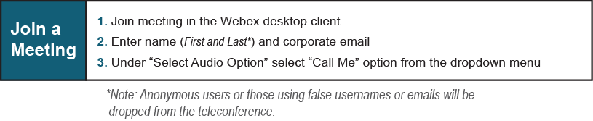

Provide feedback on the progress of this group: Facilitator Feedback Form
Visit learn.pjm.com, an easy-to-understand resource about the power industry and PJM’s role.

