- Non-Binding Polling
  - Can be utilized at Subcommittees, Task Forces, and Lower Level Standing Committees for informational purposes and is non-binding
  - All stakeholders (including Voting Members, affiliates and non-members) may participate in polls
  - Only one person per company may submit a poll response
    - Poll participants should coordinate internally to determine who will submit the response for a company
  - One person can submit a poll response for multiple companies
  - You do not need to be on the group’s roster to participate in the poll
  - Polling information is sent to the group’s email list and doesn’t require additional access
  - Results can be used by the group’s members to test consensus on a single package solution, or to narrow the number of packages
  - Final polling results will be included in the group’s report to the Standing Committee for informational purposes

- Standing Committee Voting
  - Can be utilized at Standing Committees and is binding.
  - Voting Members and Affiliate Members may vote
  - Each Member can submit one vote per proposal
  - One representative per company may vote for all of its affiliated companies
  - The company representative that intends to vote must be on the Standing Committee roster and must have access to the voting application
  - The proposal that receives the highest percentage vote above 50% and is preferred over the status quo by greater than 50% becomes the primary or Main Motion at the Standing Committee
    - Other proposals, that received both greater than 50% support AND greater than 50% preference over the status quo, will become Alternative Motions ranked from highest percentage to lowest.

- Senior Standing Committee Voting
  - Can be utilized at Senior Standing Committees and is binding.
  - Only Voting Members may vote
  - Each Member can submit one vote per proposal
  - One representative per company may vote
  - The company representative that intends to vote must be on the Senior Standing Committee roster and must have access to the voting application
  - Voting results are sector weighted and must receive two thirds (2/3) support to pass
  - Voting at the Senior Standing Committees is truncated and stops once a Motion passes. If the Main Motion passes, Alternate Motions will not be voted

Appendix – Voting References
Non-Binding Polling: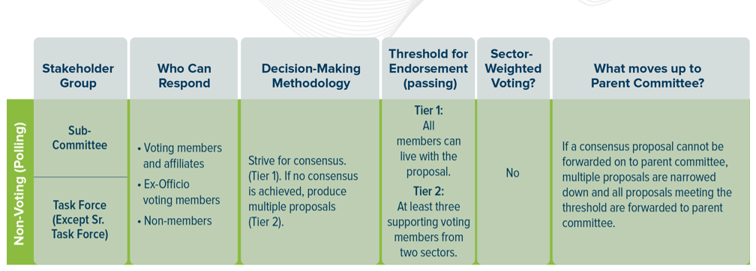
Standing Committee Voting:
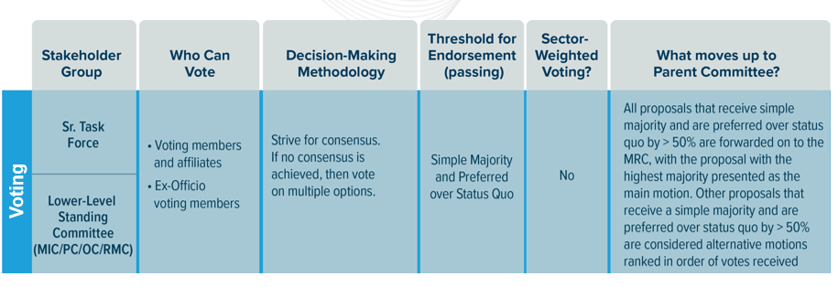
Senior Standing Committee Voting: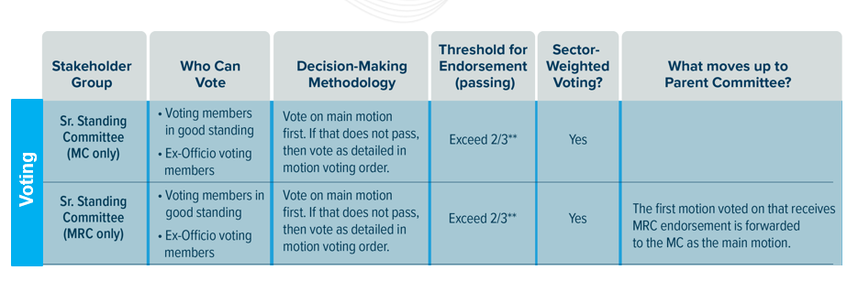
Voting Example:
