Carbon Pricing Senior Task Force (CPSTF)
PJM Conference and Training Center
November 15, 2019
9:00 a.m. – 4:00 p.m. EPT

Administration (9:00-9:05)
Ms. Jen Tribulski and Ms. Suzanne Coyne will provide welcome, announcements, and review of the Antitrust, Code of Conduct, and Public Meetings/Media Participation Guidelines Text. Stakeholders will be asked to approve the draft minutes from the October 24, 2019 meeting.

Work Plan (9:05-9:10)
Ms. Suzanne Coyne will review the Carbon Pricing Senior Task Force stakeholder process Stage 1 work plan.

Education (9:10-3:30)
Jurisdictional Considerations (9:10–10:30)
- Mr. Avi Zevin, Institute for Policy Integrity/New York University, will provide education on the legal principles and jurisdictional considerations relevant to aspects of a carbon pricing construct.
- Mr. Steve Shparber, Nelson Mullins Riley & Scarborough on behalf of the American Wind Energy Association and the Solar Energy Industries Association, will provide education on jurisdictional considerations related to carbon pricing in PJM.
State Perspectives Panel (10:30–12:00)
Mr. Asim Haque, PJM, will moderate a panel discussion on state perspectives regarding carbon mitigation programs and policies.
The following panelists will participate in the discussion.
- Tom Ballou, Manager, Air Data Analysis & Planning, Virginia Department of Environmental Quality
- Cynthia Holland, Director, Office of Federal and Regional Policy, New Jersey Board of Public Utilities
- Andrew Place, Commissioner, Pennsylvania Public Utility Commission
- Scott Weaver, Director Air Quality Services, American Electric Power, representing vertically integrated states
Carbon Pricing in New York (1:00–2:00)
Dr. Nicole Bouchez, New York ISO, will provide education on the carbon pricing initiative in New York.

California ISO GHG Market Design (2:00–3:00)
Mr. Don Tretheway, California ISO, will provide education on the California ISO GHG market design.
Work Plan Update, Education Takeaways, and Areas for Additional Exploration (3:00–3:30)
Ms. Natalie Tacka, PJM, will lead a discussion on the CPSTF work activities. Stakeholders will be asked to provide feedback on key takeaways from education received to-date and additional areas of exploration.

Future Agenda Items (3:30-3:40)
Ms. Jen Tribulski will review meeting action items and discuss future agenda items.

Future Meeting Dates
December 20, 2019 | 9:00 a.m. | PJM Conference & Training Center/ WebEx
January 14, 2020 | 9:00 a.m. | PJM Conference & Training Center/ WebEx
February 26, 2020 | 9:00 a.m. | PJM Conference & Training Center/ WebEx
April 2, 2020 | 9:00 a.m. | PJM Conference & Training Center/ WebEx
May 19, 2020 | 9:00 a.m. | PJM Conference & Training Center/ WebEx
June 25, 2020 | 9:00 a.m. | PJM Conference & Training Center/ WebEx
Author: Suzanne Coyne

Antitrust:
You may not discuss any topics that violate, or that might appear to violate, the antitrust laws including but not limited to agreements between or among competitors regarding prices, bid and offer practices, availability of service, product design, terms of sale, division of markets, allocation of customers or any other activity that might unreasonably restrain competition. If any of these items are discussed the chair will re-direct the conversation. If the conversation still persists, parties will be asked to leave the meeting or the meeting will be adjourned.

Code of Conduct:
As a mandatory condition of attendance at today's meeting, attendees agree to adhere to the PJM Code of Conduct as detailed in PJM Manual M-34 section 4.5, including, but not limited to, participants' responsibilities and rules regarding the dissemination of meeting discussion and materials.

Public Meetings/Media Participation:
Unless otherwise noted, PJM stakeholder meetings are open to the public and to members of the media. Members of the media are asked to announce their attendance at all PJM stakeholder meetings at the beginning of the meeting or at the point they join a meeting already in progress. Members of the Media are reminded that speakers at PJM meetings cannot be quoted without explicit permission from the speaker. PJM Members are reminded that "detailed transcriptional meeting notes" and white board notes from "brainstorming sessions" shall not be disseminated. Stakeholders are also not allowed to create audio, video or online recordings of PJM meetings. PJM may create audio, video or online recordings of stakeholder meetings for internal and training purposes, and your participation at such meetings indicates your consent to the same.

Participant Identification in WebEx:
When logging into the WebEx desktop client, please enter your real first and last name as well as a valid email address. Be sure to select the “call me” option.
PJM support staff continuously monitors WebEx connections during stakeholder meetings. Anonymous users or those using false usernames or emails will be dropped from the teleconference.



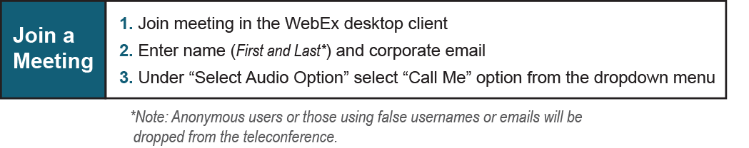

Provide feedback on the progress of this group: Facilitator Feedback Form
Visit learn.pjm.com, an easy-to-understand resource about the power industry and PJM’s role.

