Capacity Capability Senior Task Force
WebEx
August 7, 2020
9:00 a.m. – 4:00 p.m. EPT

Administration (9:00-9:15)
Lauren Strella Wahba, PJM, will provide welcome, announcements, and review of the Antitrust, Code of Conduct, and Public Meetings/Media Participation Guidelines. Stakeholders will be asked to approve draft minutes from the July 27, 2020 meeting.
Melissa Pilong, PJM, will review the updated Work Plan.

Education (9:15-10:45)
Andrew Levitt, PJM, to provide what impacts the ELCC policy would have on the Capacity Market and provide additional detail on the method of calculating average ELCC as distinct from marginal ELCC. (9:15 – 9:45)
  - Andrew Levitt, PJM, Andrew Levitt will discuss the 200 coincident peak hour performance adjustment metric.
(9:45 – 10:00)
Zachary Ming, E3, will present a method for allocating ELCCMW from the portfolio to the classes. (10:00 – 10:45)
Break (10:45 – 11:00)

CBIR (11:00 – 3:40)
Melissa Pilong, PJM, will lead the group in a discussion on the CBIR process and solicit feedback from stakeholders on additional solution options.
  - Kevin Carden, Astrape, will present approaches to ELCC Modeling.
  - Andrew Levitt, PJM, will present a revised approach to simulating storage dispatch in the ELCC model.
  - Andrew Levitt, PJM, will discuss solution options for units that do not sell all of their capacity, that sell some of their capacity to other Planning Authorities, or that have firm contracts to serve behind the meter load. Andrew will also describe several other miscellaneous additions and clarifications for existing solution options.
Melissa Pilong, PJM, will lead the group in a discussion on the CBIR process for identifying packages.
  - Brock Ondayko, AEP Energy, will present an overview along with updates to the AEP Energy package.
  - Betty Watson, Modern Energy, will present a Joint Stakeholder package for stakeholder consideration.
  - John Hyatt, IMM, will provide a presentation on the IMM package.
Break for lunch (12:00 – 12:30)

Future Agenda Items (3:40-4:00)
Lauren Strella Wahba, PJM, will review meeting action items and discuss future agenda items.

Informational Updates
8. Updated CCSTF July Poll Results.

Future Meeting Dates
August 12, 2020 | 9am – 4pm | Teleconference
August 31, 2020 | 1pm – 4pm | Teleconference
September 11, 2020 | 9am – 4pm | Teleconference
September 24, 2020 | 9am – 4pm | Teleconference
October 14, 2020 | 9am – 4pm | Teleconference

Author: Lauren Strella Wahba

Antitrust:
You may not discuss any topics that violate, or that might appear to violate, the antitrust laws including but not limited to agreements between or among competitors regarding prices, bid and offer practices, availability of service, product design, terms of sale, division of markets, allocation of customers or any other activity that might unreasonably restrain competition. If any of these items are discussed the chair will re-direct the conversation. If the conversation still persists, parties will be asked to leave the meeting or the meeting will be adjourned.

Code of Conduct:
As a mandatory condition of attendance at today's meeting, attendees agree to adhere to the PJM Code of Conduct as detailed in PJM Manual M-34 section 4.5, including, but not limited to, participants' responsibilities and rules regarding the dissemination of meeting discussion and materials.

Public Meetings/Media Participation:
Unless otherwise noted, PJM stakeholder meetings are open to the public and to members of the media. Members of the media are asked to announce their attendance at all PJM stakeholder meetings at the beginning of the meeting or at the point they join a meeting already in progress. Members of the Media are reminded that speakers at PJM meetings cannot be quoted without explicit permission from the speaker. PJM Members are reminded that "detailed transcriptional meeting notes" and white board notes from "brainstorming sessions" shall not be disseminated. Stakeholders are also not allowed to create audio, video or online recordings of PJM meetings. PJM may create audio, video or online recordings of stakeholder meetings for internal and training purposes, and your participation at such meetings indicates your consent to the same.
Participant Identification in WebEx:
When logging into the WebEx desktop client, please enter your real first and last name as well as a valid email address. Be sure to select the “call me” option.
PJM support staff continuously monitors WebEx connections during stakeholder meetings. Anonymous users or those using false usernames or emails will be dropped from the teleconference.



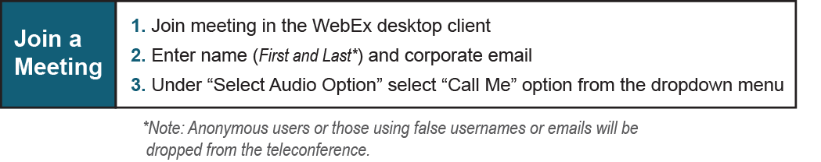
Provide feedback on the progress of this group: Facilitator Feedback Form
Visit learn.pjm.com, an easy-to-understand resource about the power industry and PJM’s role.

