Demand Response Subcommittee
PJM Conference and Training Center
March 27, 2018
9:30 a.m. – 12:30 p.m. EPT

Administration (9:30-9:40)
- Welcome, Announcements and Anti-trust and Code of Conduct announcement
- Roll call: in-person only
- Review prior minutes – 2/12/2018 meeting
- Request for any additional agenda items
- Brief update/discussion of DR related activity in other stakeholder groups – MIC, OC, PC, or other

5 minute settlement compliance filing update (9:40 – 10:00)
- Ms. Masha Nyemko will review recent PJM 5 minute settlement compliance filing and associated impact on DR energy settlements.

Review of Load Management deadlines for upcoming BRA and discussion of any issues with existing registration process (10:00 – 10:20)
- Mr. Jack O’Neill will review upcoming Load Management deadlines and highlight any issues or questions received to date regarding the current registration process. This is intended as quick review and an open discussion on current registration process.

DR CP Winter Peak Load Calculation (10:20-10:50)
- Stakeholders will continue to discuss solutions and incorporate into packages. If there is enough time we will do verbal polling to get indication of stakeholder support or concerns for different packages.

Break (10:50-11:00)

Seasonal DR Aggregation Registration Rules (11:00-11:45)
- Stakeholders will discuss packages and asked to communicate their support/concerns with packages. Stakeholders will also be verbally polled at meeting to help DRS focus future efforts toward consensus.

DR Hub Update (11:45-12:00)
- Ms. Andrea Yeaton, PJM, will give an update on DR Hub (recent release and upcoming future release)

Energy Offer Limits in Markets Gateway (12:00-12:15)
- Ms. Masha Nyemko will review Markets Gateway change to limit energy offers to DR Hub maximum load reduction amount.

Brief Review of Non-interval Metered Customer Experience with M&V Rules (12:15-12:30)
- Mr. James McAnany, PJM, will review the non-interval metered customer experience with M&V rules implemented in 2015.

Future Agenda Items
Participants will have the opportunity to request the addition of any new item(s) to the agenda of a future meeting.

Future Meeting Dates
Wednesday | 4/18/2018 | 9:30 am – 12:00 pm | PJM Conference & Training Center/ Webex
Monday | 5/21/2018 | 9:30 am – 4:00 pm | PJM Conference & Training Center/ Webex
Friday | 6/22/2018 | 9:30 am – 4:00 pm | PJM Conference & Training Center/ Webex
Monday | 7/16/2018 | 9:30 am – 4:00 pm | PJM Conference & Training Center/ Webex
Thursday | 8/30/2018 | 9:30 am – 4:00 pm | PJM Conference & Training Center/ Webex
Tuesday | 9/25/2018 | 9:30 am – 4:00 pm | PJM Conference & Training Center/ Webex
Wednesday | 10/24/2018 | 9:30 am – 4:00 pm | PJM Conference & Training Center/ Webex
Friday | 11/16/2018 | 9:30 am – 4:00 pm | PJM Conference & Training Center/ Webex
Monday | 12/10/2018 | 9:30 am – 4:00 pm | PJM Conference & Training Center/ Webex

Author: Andrea Yeaton

Antitrust:
You may not discuss any topics that violate, or that might appear to violate, the antitrust laws including but not limited to agreements between or among competitors regarding prices, bid and offer practices, availability of service, product design, terms of sale, division of markets, allocation of customers or any other activity that might unreasonably restrain competition. If any of these items are discussed the chair will re-direct the conversation. If the conversation still persists, parties will be asked to leave the meeting or the meeting will be adjourned.

Code of Conduct:
As a mandatory condition of attendance at today's meeting, attendees agree to adhere to the PJM Code of Conduct as detailed in PJM Manual M-34 section 4.5, including, but not limited to, participants' responsibilities and rules regarding the dissemination of meeting discussion and materials.

Public Meetings/Media Participation:
Unless otherwise noted, PJM stakeholder meetings are open to the public and to members of the media. Members of the media are asked to announce their attendance at all PJM stakeholder meetings at the beginning of the meeting or at the point they join a meeting already in progress. Members of the Media are reminded that speakers at PJM meetings cannot be quoted without explicit permission from the speaker. PJM Members are reminded that "detailed transcriptional meeting notes" and white board notes from "brainstorming sessions" shall not be disseminated. Stakeholders are also not allowed to create audio, video or online recordings of PJM meetings.

Participant Identification in WebEx:
When logging into the WebEx desktop client, please enter your real first and last name as well as a valid email address. Be sure to select the “call me” option.
PJM support staff continuously monitors WebEx connections during stakeholder meetings. Anonymous users or those using false usernames or emails will be dropped from the teleconference.



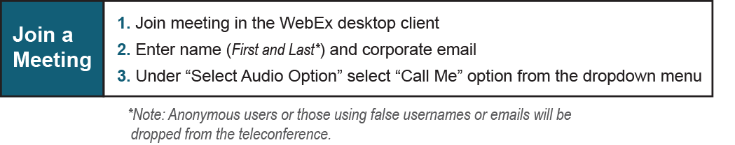

Provide feedback on the progress of this group: Facilitator Feedback Form
Visit learn.pjm.com an easy-to-understand resource about the power industry and PJM’s role.

