DER and Inverter-based Resources Subcommittee – EDC Workshop
WebEx Only
December 9, 2021
3:00 p.m. – 5:00 p.m. ET

Administration (3:00 – 3:05)
Scott Baker, chair, will open the meeting and review the agenda.
Hamad Ahmed, secretary, will review the meeting participation guidelines.

Order 2222 – EDC Coordination (3:05 – 4:45)
- PJM and electric distribution company staff will discuss the data needs during the registration process for properly associating individual DER and a DER Aggregation with the appropriate pricing node in the PJM market model.
- PJM and electric distribution company staff will discuss metering requirements associated with use cases that include retail load and interaction with retail programs.

Action items (4:45 – 5:00)
- The facilitation team will review action items from the meeting and take requests for future agenda items.
Future Meeting Dates and Materials |  |  | Materials Due  to Secretary | Materials Published
Date | Time | Location | 5 p.m. | 4 p.m.
December 21, 2021 | 9:00 – 4:00 | WebEx | December 13, 2021 | December 16, 2021
January 5, 2022 | 9:00 – 3:00 | WebEx | December 27, 2021 | December 30, 2021
January 7, 2022 – EDC Coordination Workshop | 1:00 – 4:00 | WebEx | December 29, 2021 | January 4, 2021
January 18, 2022 | 9:00 – 12:00 | WebEx | January 7, 2021 | January 12, 2021
February 25, 2022 | 9:00 – 4:00 | WebEx | February 16, 2022 | February 22, 2022
March 28, 2022 | 9:00 – 4:00 | WebEx | March 18, 2022 | March 23, 2022
April 29, 2022 | 9:00 – 4:00 | WebEx | April 22, 2022 | April 27, 2022
May 31, 2022 | 9:00 – 4:00 | WebEx | May 23, 2022 | May 26, 2022
June 23, 2022 | 9:00 – 4:00 | WebEx | June 15, 2022 | June 20, 2022

Author: Hamad Ahmed

Antitrust:
You may not discuss any topics that violate, or that might appear to violate, the antitrust laws including but not limited to agreements between or among competitors regarding prices, bid and offer practices, availability of service, product design, terms of sale, division of markets, allocation of customers or any other activity that might unreasonably restrain competition. If any of these items are discussed the chair will re-direct the conversation. If the conversation still persists, parties will be asked to leave the meeting or the meeting will be adjourned.

Code of Conduct:
As a mandatory condition of attendance at today's meeting, attendees agree to adhere to the PJM Code of Conduct as detailed in PJM Manual M-34 section 4.5, including, but not limited to, participants' responsibilities and rules regarding the dissemination of meeting discussion and materials.

Public Meetings/Media Participation:
Unless otherwise noted, PJM stakeholder meetings are open to the public and to members of the media. Members of the media are asked to announce their attendance at all PJM stakeholder meetings at the beginning of the meeting or at the point they join a meeting already in progress. Members of the Media are reminded that speakers at PJM meetings cannot be quoted without explicit permission from the speaker. PJM Members are reminded that "detailed transcriptional meeting notes" and white board notes from "brainstorming sessions" shall not be disseminated. Stakeholders are also not allowed to create audio, video or online recordings of PJM meetings. PJM may create audio, video or online recordings of stakeholder meetings for internal and training purposes, and your participation at such meetings indicates your consent to the same.
Participant Identification in Webex:
When logging into the Webex desktop client, please enter your real first and last name as well as a valid email address. Be sure to select the “call me” option.
PJM support staff continuously monitors Webex connections during stakeholder meetings. Anonymous users or those using false usernames or emails will be dropped from the teleconference.



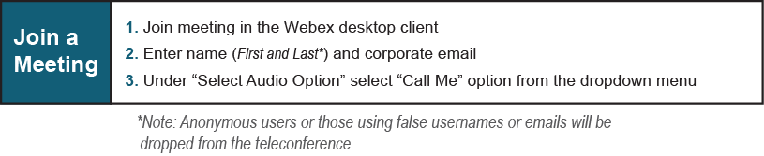

Provide feedback on the progress of this group: Facilitator Feedback Form
Visit learn.pjm.com, an easy-to-understand resource about the power industry and PJM’s role.

