Credit Subcommittee
WebEx/In Person
October 31, 2018
2:00 p.m. – 4:30 p.m. EPT

Administration (2:00 – 2:05)
In lieu of an attendance roll call, PJM will use WebEx registrations to record attendance. Participants not registered on WebEx may email PJM after the meeting and indicate their participation.
PJM will ask for comments and or questions on the October 23, 2018 CS meeting minutes.
Members are requested to adhere to the Anti-Trust Policy, Code of Conduct, Public Meetings/Media Participation and Participant Identification guidelines listed below.

Working Issues (2:05 – 4:30)
FTR Mark-to-Auction Credit Requirement
PJM will present the results of the poll which was opened after the October 23 CS meeting to gauge the level of support for various MTA option packages presented at that meeting. The results will be submitted to the MIC for a first read at its November 7, 2018 meeting.
FTR Mark-to-Auction Issue Tracking
Minimum Capital Requirements
PJM will lead a discussion of proposal packages for possible changes to PJM’s minimum capital requirements. Members are encouraged to submit proposal packages to PJM before the meeting in order to facilitate discussion at the meeting.

Future Agenda Items (information only)
- Credit Subcommittee Work Plan
RPM Credit Requirements for At-Risk Existing Resources (Issue Tracking: RPM Credit Requirement for At-Risk Existing Resources)
- Default Liquidation Provisions for RPM
RPM Credit and Deliverability Requirements for External Resources (to conform to changes in deliverability requirements for pseudo-tied external resources)
Members are welcome to request additional discussion items at this or any future meeting.

Future Meeting Dates
October 31, 2018 2:00 p.m. – 4:30 p.m. On-site/Teleconference
November 20, 2018 9:00 a.m. – 11:00 a.m. On-site/Teleconference
December 19, 2018 9:00 a.m. – 11:00 a.m. On-site/Teleconference

Author: Mark Million
Antitrust:
You may not discuss any topics that violate, or that might appear to violate, the antitrust laws including but not limited to agreements between or among competitors regarding prices, bid and offer practices, availability of service, product design, terms of sale, division of markets, allocation of customers or any other activity that might unreasonably restrain competition. If any of these items are discussed the chair will re-direct the conversation. If the conversation still persists, parties will be asked to leave the meeting or the meeting will be adjourned.

Code of Conduct:
As a mandatory condition of attendance at today's meeting, attendees agree to adhere to the PJM Code of Conduct as detailed in PJM Manual M-34 section 4.5, including, but not limited to, participants' responsibilities and rules regarding the dissemination of meeting discussion and materials.

Public Meetings/Media Participation:
Unless otherwise noted, PJM stakeholder meetings are open to the public and to members of the media. Members of the media are asked to announce their attendance at all PJM stakeholder meetings at the beginning of the meeting or at the point they join a meeting already in progress. Members of the Media are reminded that speakers at PJM meetings cannot be quoted without explicit permission from the speaker. PJM Members are reminded that "detailed transcriptional meeting notes" and white board notes from "brainstorming sessions" shall not be disseminated. Stakeholders are also not allowed to create audio, video or online recordings of PJM meetings. PJM may create audio, video or online recordings of stakeholder meetings for internal and training purposes, and your participation at such meetings indicates your consent to the same.
Participant Identification in WebEx:
When logging into the WebEx desktop client, please enter your real first and last name as well as a valid email address. Be sure to select the “call me” option.
PJM support staff continuously monitors WebEx connections during stakeholder meetings. Anonymous users or those using false usernames or emails will be dropped from the teleconference.

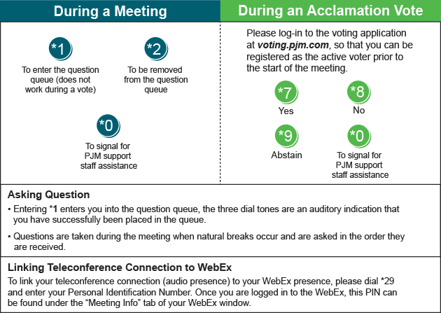
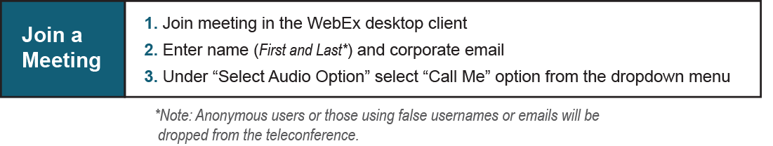
Provide feedback on the progress of this group: Facilitator Feedback Form
Visit learn.pjm.com, an easy-to-understand resource about the power industry and PJM’s role.

