October Planning Committee
Teleconference / WebEx
October 6, 2020
9:00 a.m. – 12:00 p.m. EPT

Administration (9:00 – 9:15)
- Welcome, announcements and review of the Anti-trust, Code of Conduct, and Media Participation Guidelines.
- Approve Planning Committee (PC) Agenda for this meeting
- Approve draft minutes from the September 1st, 2020 PC meeting
- Review of the PC Work Plan

Endorsements (9:15 – 9:35)
- 2020 Installed Reserve Margin Study Results
Patricio Rocha Garrido, PJM, will review the 2020 Reserve Requirement Study results including the Installed Reserve Margin and Forecast Pool Requirement (IRM, FPR). A first read and endorsement request for the Winter Weekly Reserve Target (WWRT) will also be reviewed. The Committee will be requested to endorse the Installed Reserve Requirement and Forecast Pool Requirement results at today’s meeting. The Committee will also be requested to endorse the Winter Weekly Reserve Target at today’s meeting.

First Reads (9:35– 9:55)
- Manual 14C Update
Mark Sims, PJM, will provide a first read of changes to Manual 14C: Generation and Transmission Interconnection Facility Construction, as part of the biennial cover-to-cover review. The committee will be asked to approve the changes at the next PC meeting.

Informational Updates (9:55 – 12:00)
- Recent Load Impacts and Load Forecast Model Development
- Andrew Gledhill, PJM, will present the estimated Covid-19 impacts on recent loads.
- Andrew Gledhill, will review proposed revisions to the load forecasting model.
- FERC Update
Thomas DeVita, PJM Legal, will discuss Order No. 2222 regarding DER aggregation.
- Interconnection Queue Initiative
Ken Seiler, PJM, will discuss an initiative to review existing Interconnection Queue rules in an effort to create a more efficient and effective processes.

- Critical Infrastructure Stakeholder Update
Christina Stotesbury, PJM, will provide an update on CISO activities.
Issue Tracking: Critical Infrastructure Stakeholder Oversight
- Storage As Transmission Asset Update
Michele Greening, PJM will discuss work being done at the most recent Storage As Transmission Asset Special Planning Committee sessions.
Issue Tracking: Storage As a Transmssion Asset
- Capacity Capability Senior Task Force Update
Andrew Levitt, PJM, will provide an overview on the Effective Load Carrying Capability (ELCC) data submission requirements and applicable deadlines by delivery year for intermittent and limited duration resources.

Informational Posting
Model Build Activity Update
2020 Series MMWG
- Powerflow – PJM to approve final cases by Friday October 2, 2020; Powertech to post final cases by Friday October 9, 2020
2021 Series RTEP
- Powerflow – PJM to send request for tie line updates by Wednesday October 7, 2020; PJM to send Trial 1 cases for review by Friday October 16, 2020
- Short Circuit – Transmission Owners to submit Trial 0 case updates by Friday October 2, 2020

System Planning 201
PJM will hold a System Planning 201 course via teleconference/webex on Monday, October 19, 2020. Link for more information and registration: System Planning 201

Manual 03 Updates
Updates to PJM Manual 03 – Transmission Operations are posted as informational only with meeting materials.
Manual 03 Attachment E Updates
The PJM Manual 03 Attachment E Automatic Sectionalizing Schemes Pending Approval and Recent Changes document has been posted as an information only item.

Future Meeting Dates
Friday, October 09, 2020 | 9:00 a.m. – 12:00 p.m. | Special PC: Storage As a Transmission Asset | WebEx
Tuesday, October 20, 2020 | 9:00 a.m. – 12:00 p.m. | Special PC: Critical Infrastructure Stakeholder Oversight | WebEx
Thursday, October 22, 2020 | 1:00 p.m. – 4:00 p.m. | Special PC: Storage As a Transmission Asset | WebEx
Wednesday, November 04, 2020 | 9:00 a.m. – 12:00 p.m. | Planning Committee | WebEx
Tuesday, December 01, 2020 | 9:00 a.m. – 12:00 p.m. | Planning Committee | WebEx
Author: Molly Mooney

Antitrust:
You may not discuss any topics that violate, or that might appear to violate, the antitrust laws including but not limited to agreements between or among competitors regarding prices, bid and offer practices, availability of service, product design, terms of sale, division of markets, allocation of customers or any other activity that might unreasonably restrain competition. If any of these items are discussed the chair will re-direct the conversation. If the conversation still persists, parties will be asked to leave the meeting or the meeting will be adjourned.

Code of Conduct:
As a mandatory condition of attendance at today's meeting, attendees agree to adhere to the PJM Code of Conduct as detailed in PJM Manual M-34 section 4.5, including, but not limited to, participants' responsibilities and rules regarding the dissemination of meeting discussion and materials.

Public Meetings/Media Participation:
Unless otherwise noted, PJM stakeholder meetings are open to the public and to members of the media. Members of the media are asked to announce their attendance at all PJM stakeholder meetings at the beginning of the meeting or at the point they join a meeting already in progress. Members of the Media are reminded that speakers at PJM meetings cannot be quoted without explicit permission from the speaker. PJM Members are reminded that "detailed transcriptional meeting notes" and white board notes from "brainstorming sessions" shall not be disseminated. Stakeholders are also not allowed to create audio, video or online recordings of PJM meetings. PJM may create audio, video or online recordings of stakeholder meetings for internal and training purposes, and your participation at such meetings indicates your consent to the same.
Participant Identification in WebEx:
When logging into the WebEx desktop client, please enter your real first and last name as well as a valid email address. Be sure to select the “call me” option.
PJM support staff continuously monitors WebEx connections during stakeholder meetings. Anonymous users or those using false usernames or emails will be dropped from the teleconference.

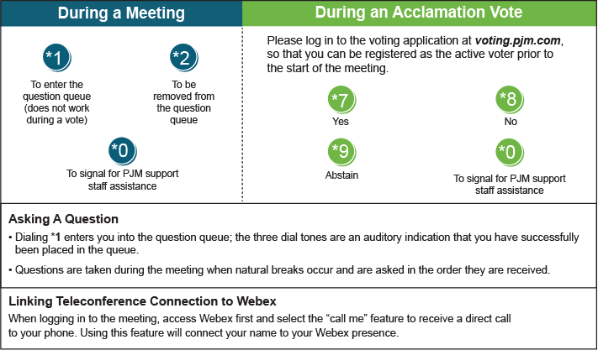

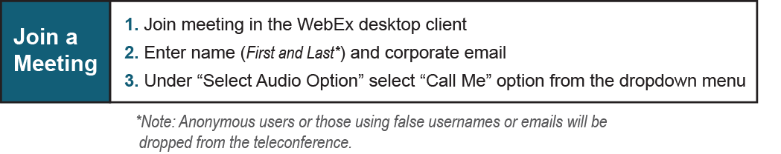

Provide feedback on the progress of this group: Facilitator Feedback Form
Visit learn.pjm.com, an easy-to-understand resource about the power industry and PJM’s role.

