Market Implementation Committee

WebEx Only

June 9, 2021

9:00 a.m. – 12:25 p.m. EPT

Administration (9:00 – 9:10)

Nicholas DiSciullo will review the Antitrust, Code of Conduct, Public Meetings/Media Participation and the WebEx Participant Identification Requirements.

The Committee will be asked to approve the draft minutes from the May 13, 2021 Market Implementation Committee meeting.

Nicholas DiSciullo will provide an update on the MIC Work Plan.

Phil D’Antonio will provide a Fast-Start Pricing update.

Endorsements/Approvals (9:10 – 9:50)

1. Reactive Supply and Voltage Control Compensation (9:10 – 9:30)

Jim Davis, Dominion Energy, and Joe Bowring, IMM, will review the combined Dominion and IMM Problem Statement and Issue Charge addressing Compensation for Reactive Supply and Voltage Control service.

The committee will be asked to approve the Issue Charge at this meeting.

1. Market Suspension (9:30 – 9:50)

Stefan Starkov will review the PJM proposal addressing the Rules Related to Market Suspension issue.

The committee will be asked to endorse the proposal at this meeting.

Materials have been updated to capture a provision for scenario 5 where there is no DA or RT > 6 consecutive hours and the prices are set to $0/MWh. The title slide was updated to remove “First Read” as this is a voting item.

[Issue Tracking: Rules Related to Market Suspension](https://www.pjm.com/committees-and-groups/issue-tracking/issue-tracking-details.aspx?Issue=%7b214DF9C5-DB87-4A02-84BE-B917C118D6ED%7d)

First Readings (9:50 – 10:50)

1. Regulation Mileage Ratio (9:50 – 10:20)

Michael Olaleye provide a second first read of the Problem Statement and Issue Charge addressing Regulation Mileage Ratio. The committee will be asked to approve the Issue Charge at its next meeting.

1. Manual 6 Revisions (10:20 – 10:30)

Emmy Messina will provide a first read of revisions to Manual 6: Financial Transmission Rights as part of the periodic review. The committee will be asked to endorse the revisions at its next meeting.

1. Manual 28 Revisions (10:30 – 10:50)

Rebecca Stadelmeyer will provide a first read of revisions to Manual 28: Operating Agreement Accounting as part of the periodic review. The committee will be asked to endorse the revisions at its next meeting.

Working Items (10:50 – 11:20)

1. RPM Capacity Transfer Rights (10:50 – 11:20)

Lisa Morelli will facilitate a discussion to gather solution options from the committee. Additional interests and design components can be provided in advance of the meeting or during the meeting.

[Issue Tracking: Capacity](https://www.pjm.com/committees-and-groups/issue-tracking/issue-tracking-details.aspx?Issue=%7b459A68BA-82B9-4199-8CCF-950FA0C74DDF%7d) Transfer Rights in RPM

Additional Items – (11:20 – 12:25)

1. Reserve Price Formation ORDCs (11:20 – ~~12:00~~ 12:10)

Patricio Rocha Garrido and Angelo Marcino will provide education on the new Reserve Price Formation Operating Reserve Demand Curves (ORDCs). They will provide a brief overview of proposed changes to Manual 33: Administrative Services for the PJM Interconnection Operating Agreement.

1. ~~Manual 33 Revisions (12:00 – 12:10)~~

~~Chris Grady will provide an overview of proposed changes to Manual 33: Administrative Services for the PJM Interconnection Operating Agreement around the Operating Reserve Demand Curve (ORDC) data in accordance with FERC transparency requirements. These revisions will be brought to the June MRC for a first read.~~

1. 2022/2023 Base Residual Auction Results (12:10 – 12:25)

Pete Langbein will provide an update on the 2022/2023 Base Residual Auction (BRA) results.

Informational Section

**ARR FTR Market Task Force (AFMTF)**   
Meeting materials are posted to the [AFMTF website](https://www.pjm.com/committees-and-groups/task-forces/afmtf).

**Cost Development Subcommittee (CDS)**   
Meeting materials are posted to the [CDS website](https://www.pjm.com/committees-and-groups/subcommittees/cds).

**Demand Response Subcommittee (DRS)**   
Meeting materials are posted to the [DRS website](http://www.pjm.com/committees-and-groups/subcommittees/drs.aspx).

**DER & Inverter-based Resources Subcommittee (DIRS)**

Meeting materials are posted to the [DIRS website.](https://www.pjm.com/committees-and-groups/subcommittees/dirs.aspx)

**Market Settlements Subcommittee (MSS)**

Meeting materials are posted to the [MSS website](http://www.pjm.com/committees-and-groups/subcommittees/mss.aspx).

Report on Market Operations

The Report on Market Operations will be reviewed during the [MC Webinar](http://www.pjm.com/committees-and-groups/committees/mc.aspx).

|  |  |  |  |  |
| --- | --- | --- | --- | --- |
| **Future Meeting Dates and Materials** | | | **Materials Due  to Secretary** | **Materials Published** |
| Date | Time | Location | 5 p.m. | 4 p.m. |
| July 14 | 9 a.m. | WebEx | July 1 | July 7 |
| August 11 | 9 a.m. | WebEx | July 30 | August 4 |
| September 9 | 9 a.m. | WebEx | August 30 | September 2 |
| October 6 | 9 a.m. | WebEx | September 24 | September 29 |
| November 3 | 9 a.m. | WebEx | October 22 | October 27 |
| December 1 | 9 a.m. | WebEx | November 19 | November 24 |

Author: Nicholas DiSciullo

Antitrust:

You may not discuss any topics that violate, or that might appear to violate, the antitrust laws including but not limited to agreements between or among competitors regarding prices, bid and offer practices, availability of service, product design, terms of sale, division of markets, allocation of customers or any other activity that might unreasonably restrain competition. If any of these items are discussed the chair will re-direct the conversation. If the conversation still persists, parties will be asked to leave the meeting or the meeting will be adjourned.

Code of Conduct:

As a mandatory condition of attendance at today's meeting, attendees agree to adhere to the PJM Code of Conduct as detailed in PJM Manual M-34 section 4.5, including, but not limited to, participants' responsibilities and rules regarding the dissemination of meeting discussion and materials.

Public Meetings/Media Participation:

Unless otherwise noted, PJM stakeholder meetings are open to the public and to members of the media. Members of the media are asked to announce their attendance at all PJM stakeholder meetings at the beginning of the meeting or at the point they join a meeting already in progress. Members of the Media are reminded that speakers at PJM meetings cannot be quoted without explicit permission from the speaker. PJM Members are reminded that "detailed transcriptional meeting notes" and white board notes from "brainstorming sessions" shall not be disseminated. Stakeholders are also not allowed to create audio, video or online recordings of PJM meetings. PJM may create audio, video or online recordings of stakeholder meetings for internal and training purposes, and your participation at such meetings indicates your consent to the same.

Participant Identification in WebEx:

When logging into the WebEx desktop client, please enter your real first and last name as well as a valid email address. Be sure to select the “call me” option.

PJM support staff continuously monitors WebEx connections during stakeholder meetings. Anonymous users or those using false usernames or emails will be dropped from the teleconference.

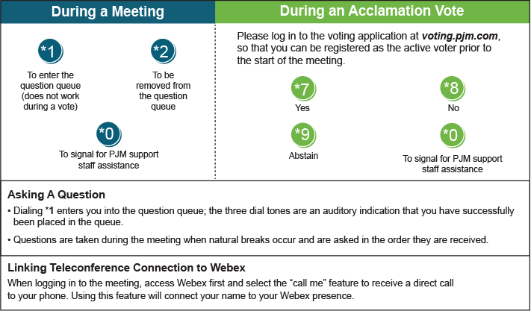

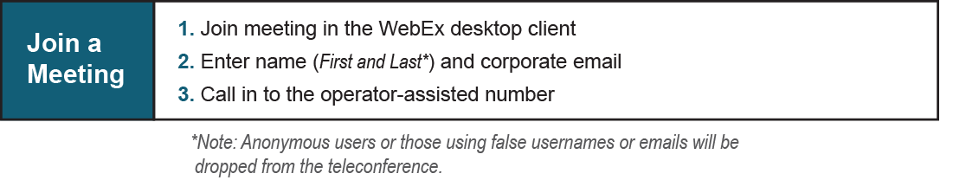

Provide feedback on the progress of this group: [*Facilitator Feedback Form*](https://www.pjm.com/committees-and-groups/committees/form-facilitator-feedback.aspx)   
Visit [*learn.pjm.com*](https://learn.pjm.com/), an easy-to-understand resource about the power industry and PJM’s role.