Market Implementation Committee
PJM Conference & Training Center, Audubon, PA
May 15, 2019
9:00 a.m. – 2:00 p.m. EPT

Administration (9:00-9:10)
Ms. Bhavana Keshavamurthy and Ms. Chantal Hendrzak will provide announcements; review the Antitrust, Code of Conduct, Public Meetings/Media Participation, the WebEx Participant Identification Requirement, and Issue Tracking.

The Committee will be asked to approve the draft minutes from the April 10, 2019 MIC meeting.

Endorsements/Approvals (9:10-9:30)
- Manual 11 and 13 revisions for impact of Gas Contingencies on Reserves (9:10-9:20)
Ms.Natalie Tacka, PJM, will provide an overview of revisions to Manual 11 and 13 to clarify the impact of operationalizing gas contingencies on reserve requirements and reserve market eligibility.
The committee will be asked to endorse these revisions.

- Cover to Cover Review of Manual 6 (9:20-9:30)
Ms.Emmy Messina, PJM, will provide an overview of updates to Manual 6 as part of the cover to cover review.
The committee will be asked to endorse these revisions.

First Readings (9:30-10:00)
- Five Minute Dispatch and Pricing ( 9:30-10:00)
Mr.Siva Josyula, Monitoring Analytics, will present a first read on a problem statement and issue charge related to Five Minute dispatch and pricing.

Working Issues (10:00-1:20)
- Modified Must Offer Exception Process Issue Charge (10:00-10:20)
Mr Pat Bruno, PJM, will review updates to the existing Must Offer Exception Process Issue Charge to address relinquishment of CIRs.
Issue Tracking: Must Offer Exception Process

- Fast Start Pricing Order (10:20-10:50)
Mr. Adam Keech, PJM, will review the recently issued FERC Order to address fast start pricing and discuss implementation details.

- Carbon Pricing Update (10:50 - 11:30)
Mr. Gary Helm, PJM, will provide an update on the assumptions of the Carbon Pricing study.

- Gas Contingency Compensation (11:30 - 12:00)
Mr. Thomas DeVita, PJM, will provide an update on next steps related to the FERC Order
ER19-664 and will review the Emergency Operating Instruction Compensation Problem Statement and
Issue Charge.

- Market Seller Offer Cap (12:00- 12:10)
Mr. Chen Lu, PJM, will provide an update on the pending Market Seller Offer Cap complaints and discuss potential future stakeholder consideration of a revised Market Seller Offer Cap.

Lunch (12:10-1:10)

Additional Items (1:10-2:00)
- NYISO/PJM JOA Language Updates (1:10-1:25)
Ms. Nikki Militello, PJM, will provide an update on the NYISO/PJM JOA.

- ComEd SPS/RAS Retirement (1:25-1:40)
Mr. Mohit Singh, ComEd, will present on the retirement of the SPS/RAS at Quad Cities substation.

- VOM Update (1:40-2:00)
Mr. Tom Hauske, PJM, will provide an informational update on requirements for Operating Costs, Maintenance Adders, and Fuel Cost Policies resulting from VOM Order Docket No. ER19-210-001.

Informational Section
Credit Subcommittee (CS)
Meeting materials will be posted to the CS website.

Demand Response Subcommittee (DRS)
Meeting materials will be posted to the DRS web site.

Intermittent Resources Subcommittee (IRS)
Meeting materials will be posted to the IRS web site.

Net Energy Injections Quarterly Report
Materials are posted as informational only.

Interregional Coordination Update
Materials are posted as informational only.

Market Settlements Subcommittee (MSS)
Meeting materials are posted to the MSS web site.

Report on Market Operations
The Report on Market Operations will be reviewed during the MC Webinar.

Future Meeting Dates
June 12, 2019 | 9:00 a.m. | PJM Conference & Training Center/ WebEx
July 10, 2019 | 9:00 a.m. | PJM Conference & Training Center/ WebEx
August 7, 2019 | 9:00 a.m. | PJM Conference & Training Center/ WebEx
September 11, 2019 | 9:00 a.m. | PJM Conference & Training Center/ WebEx
October 16, 2019 | 9:00 a.m. | PJM Conference & Training Center/ WebEx
November 13, 2019 | 9:00 a.m. | PJM Conference & Training Center/ WebEx
December 11, 2019 | 9:00 a.m. | PJM Conference & Training Center/ WebEx

Author: Bhavana Keshavamurthy

Antitrust:
You may not discuss any topics that violate, or that might appear to violate, the antitrust laws including but not limited to agreements between or among competitors regarding prices, bid and offer practices, availability of service, product design, terms of sale, division of markets, allocation of customers or any other activity that might unreasonably restrain competition. If any of these items are discussed the chair will re-direct the conversation. If the conversation still persists, parties will be asked to leave the meeting or the meeting will be adjourned.

Code of Conduct:
As a mandatory condition of attendance at today's meeting, attendees agree to adhere to the PJM Code of Conduct as detailed in PJM Manual M-34 section 4.5, including, but not limited to, participants' responsibilities and rules regarding the dissemination of meeting discussion and materials.

Public Meetings/Media Participation:
Unless otherwise noted, PJM stakeholder meetings are open to the public and to members of the media. Members of the media are asked to announce their attendance at all PJM stakeholder meetings at the beginning of the meeting or at the point they join a meeting already in progress. Members of the Media are reminded that speakers at PJM meetings cannot be quoted without explicit permission from the speaker. PJM Members are reminded that "detailed transcriptional meeting notes" and white board notes from "brainstorming sessions" shall not be disseminated. Stakeholders are also not allowed to create audio, video or online recordings of PJM meetings. PJM may create audio, video or online recordings of stakeholder meetings for internal and training purposes, and your participation at such meetings indicates your consent to the same.

Participant Identification in WebEx:
When logging into the WebEx desktop client, please enter your real first and last name as well as a valid email address. Be sure to select the “call me” option.
PJM support staff continuously monitors WebEx connections during stakeholder meetings. Anonymous users or those using false usernames or emails will be dropped from the teleconference.

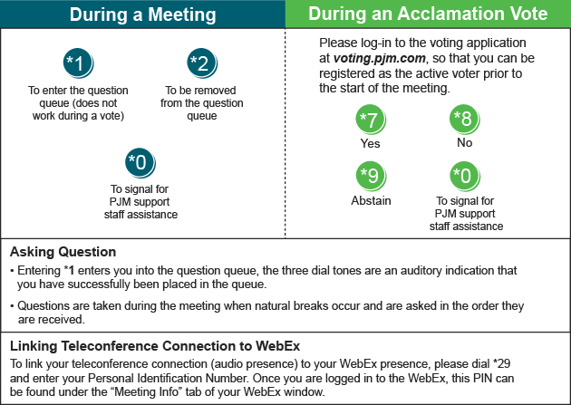

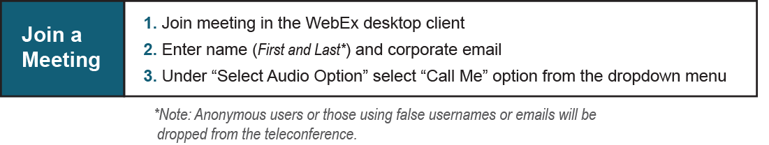

Provide feedback on the progress of this group: Facilitator Feedback Form
Visit learn.pjm.com, an easy-to-understand resource about the power industry and PJM’s role.

