Market Implementation Committee: Special Session: Electric Storage Resource Cost Offers
PJM Conference & Training Center, Audubon, PA
March 15, 2019
1:00 p.m. – 3:00 p.m. EPT

Administration (1:00-1:05)
Ms Janell Fabiano and Ms. Chantal Hendrzak will provide announcements; review the Antitrust, Code of Conduct, Public Meetings/Media Participation and the WebEx Participant Identification Requirement
Issue Tracking: Electric Storage Participation FERC Order 841

Education (1:05-1:55)
- Timing of offers into the Day Ahead and Real Time Markets and a Review of Cost offers
Ms. Gabby Genuario, PJM, will review the timing of entry of cost offers and current Manual 15: Cost Development Guidelines.

- Review of ESR participation model and FAQ update
Ms, Laura Walter, PJM, will review the ESR participation model. PJM is also providing an updated FAQ on Order 841 and hybrid resources; additional questions can be sent to esr@pjm.com

- Pumped Storage Costs
Ms. Catherine Tyler, Monitoring Analytics, will present proposed modifications to pumped storage hydro cost offers.

Working Issues (1:55-2:55)
- Development of Cost Offers for Energy Storage Resources
Ms. Janell Fabiano, PJM, will review the Cost Offer matrix and will seek stakeholder feedback.

Action Items and Next Steps (2:55-3:00)
- Action Items
Ms Fabiano and Ms. Hendrzak will review action items and discuss next steps.

Future Special Session Meeting
TBD

Author:

Antitrust:
You may not discuss any topics that violate, or that might appear to violate, the antitrust laws including but not limited to agreements between or among competitors regarding prices, bid and offer practices, availability of service, product design, terms of sale, division of markets, allocation of customers or any other activity that might unreasonably restrain competition. If any of these items are discussed the chair will re-direct the conversation. If the conversation still persists, parties will be asked to leave the meeting or the meeting will be adjourned.

Code of Conduct:
As a mandatory condition of attendance at today's meeting, attendees agree to adhere to the PJM Code of Conduct as detailed in PJM Manual M-34 section 4.5, including, but not limited to, participants' responsibilities and rules regarding the dissemination of meeting discussion and materials.

Public Meetings/Media Participation:
Unless otherwise noted, PJM stakeholder meetings are open to the public and to members of the media. Members of the media are asked to announce their attendance at all PJM stakeholder meetings at the beginning of the meeting or at the point they join a meeting already in progress. Members of the Media are reminded that speakers at PJM meetings cannot be quoted without explicit permission from the speaker. PJM Members are reminded that "detailed transcriptional meeting notes" and white board notes from "brainstorming sessions" shall not be disseminated. Stakeholders are also not allowed to create audio, video or online recordings of PJM meetings. PJM may create audio, video or online recordings of stakeholder meetings for internal and training purposes, and your participation at such meetings indicates your consent to the same.

Participant Identification in WebEx:
When logging into the WebEx desktop client, please enter your real first and last name as well as a valid email address. Be sure to select the “call me” option.
PJM support staff continuously monitors WebEx connections during stakeholder meetings. Anonymous users or those using false usernames or emails will be dropped from the teleconference.

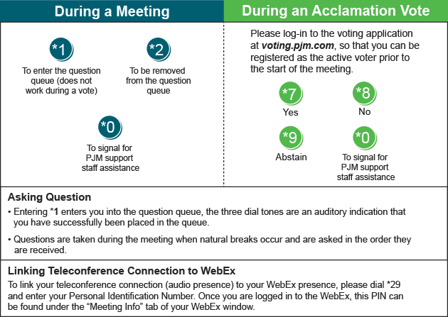

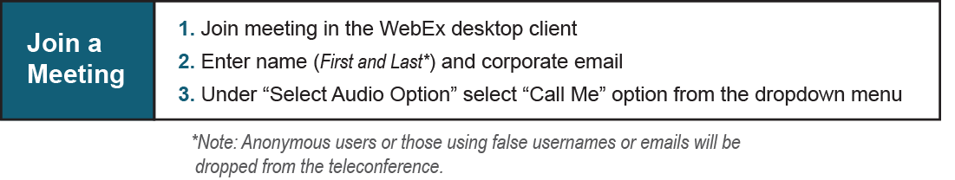

Provide feedback on the progress of this group: Facilitator Feedback Form
Visit learn.pjm.com, an easy-to-understand resource about the power industry and PJM’s role.

