Market Implementation Committee
PJM Conference & Training Center, Audubon, PA
September 12, 2018
9:00 a.m. – 4:00 p.m. EPT

Administration (9:00-9:45)
Ms. Bhavana Keshavamurthy and Ms. Chantal Hendrzak will provide announcements; review the Antitrust, Code of Conduct, Public Meetings/Media Participation, the WebEx Participant Identification Requirement, and Issue Tracking.

The Committee will be asked to approve the draft minutes from the August 8, 2018 MIC meeting.

        - Mr. Stan Williams, PJM, will provide an update on the Opportunity Cost Calculator.
        - Mr. Jeff Bastian, PJM will provide an update on the Quadrennial Review.

Endorsements/Approvals (9:45-11:00)
- Fuel Cost Policy- Problem Statement & Issue Charge (9:45-10:00)
Mr. John Rohrbach, ACES Power, on behalf of SMECO, ODEC and PPGI, will present a problem statement and issue charge to address enhancements to the Fuel Cost Policy rules and process.
The committee will be asked to approve the problem statement and issue charge.

- RPM Credit Requirement Reduction Clarifications (10:00-10:15)
Mr. Hal Loomis, PJM, will present draft Tariff language to remove an apparent overlapping credit reduction provision for Qualified Transmission Upgrades, to clarify milestone documentation requirements for internally financed projects, and to clarify that Capacity Market Sellers should submit requests for reductions.
The committee will be asked to endorse the Tariff changes.

- Transmission Constraint Penalty Factor (10:15-10:30)
Mr. Angelo Marcino, PJM, will review the joint PJM/IMM package developed at the Special MIC sessions related to Transmission Constraint Penalty Factors, and present draft Manual 11 language.
The committee will be asked to endorse the M11 changes.
Issue Tracking: Transmission Penalty Factor

- FERC Order 831 – Offer Caps (10:30-10:45)
Ms. Susan Kenney, PJM, will present draft Manual 11 language that describes the long term automated process for Price-Based Offers greater than $1,000/MWh.
The committee will be asked to endorse the M11 changes.

- Biennial Review of Manual 15 (10:45-11:00)
Ms. Gabrielle Genuario, PJM, will review updates to Manual 15 as part of the Biennial Review.
The committee will be asked to endorse the M15 changes.

First Readings (11:00-12:00)
- Must Offer Exception Process (11:00-11:30)
        - Mr. Pat Bruno, PJM, will present a first read of the PJM package.
        - Ms. Sharon Midgley, Exelon, will present a first read of the Exelon package.
Issue Tracking: Must Offer Exemption Process

- Pseudo Tie Overlapping Congestion (11:30-11:50)
        - Ms.Nikki Militello, PJM, will present a first read on changes to Manual 11 related to Pseudo Tie Overlapping Congestion.
        - Mr. Ray Fernandez, PJM, will present a first read on changes to Manual 28 related to Pseudo Tie Overlapping Congestion.

- Annual Review of Manual 6 (11:50-12:10)
Mr. Brian Chmielewski, PJM, will present a first read on changes to Manual 6 as part of the Annual Review.
Lunch (12:10-1:00)

- Surety Bonds (1:00-1:20)
        - Mr. Hal Loomis, PJM, will present the results of a Credit Subcommittee poll on accepting Surety Bonds as an additional form of collateral.
        - Ms. Sharon Midgley, Exelon, will present the Exelon proposal.
Issue Tracking: Surety Bonds Opportunity

- FTR Forfeiture Rule (1:20-1:35)
Mr. Brian Chmielewski, PJM, will present a first read of the FTR Forfeiture Rule proposal. Members are encouraged to review the posted matrix and provide additional packages to: FTRGroup@pjm.com.
Issue Tracking: FTR Forfeiture Rule Changes

Additional Items (1:35-2:20)
- Markets Updates (1:35-1:50)
        - Mr. Adam Keech, PJM, will present an update on Day Ahead Market Timeline.
        - Mr. Keech will also review a proposed solution to the regulation market clearing price spikes issue and solicit stakeholder feedback.
- PA Central Reactive Transfer Interface Review (1:50-2:00)
Ms. Christina Catalano, PJM, will provide a review of the new PA Central Reactive Transfer Interface.

- Western Reactive Transfer Interface Review (2:00-2:10)
Ms. Christina Catalano, PJM, will provide a review of the definition change to the Western Reactive Transfer Interface.

- Contact Management Update (2:10-2:20)
Ms. Amanda Egan, PJM, will provide an update on the Contact Management feature in the Membership Management Community.

Informational Section
Credit Subcommittee (CS)
Meeting materials will be posted to the CS website.

Demand Response Subcommittee (DRS)
Meeting materials will be posted to the DRS web site.

Intermittent Resources Subcommittee (IRS)
Meeting materials will be posted to the IRS web site.

Interregional Coordination Update
Materials are posted as informational only.

Market Settlements Subcommittee (MSS)
Meeting materials are posted to the MSS web site.

Report on Market Operations
The Report on Market Operations will be reviewed during the MC Webinar.

Future Meeting Dates
October 10, 2018 | 9:00 a.m. | PJM Conference & Training Center/ WebEx
November 7, 2018 | 9:00 a.m. | PJM Conference & Training Center/ WebEx
December 12, 2018 | 9:00 a.m. | PJM Conference & Training Center/ WebEx

Author: Bhavana Keshavamurthy

Antitrust:
You may not discuss any topics that violate, or that might appear to violate, the antitrust laws including but not limited to agreements between or among competitors regarding prices, bid and offer practices, availability of service, product design, terms of sale, division of markets, allocation of customers or any other activity that might unreasonably restrain competition. If any of these items are discussed the chair will re-direct the conversation. If the conversation still persists, parties will be asked to leave the meeting or the meeting will be adjourned.

Code of Conduct:
As a mandatory condition of attendance at today's meeting, attendees agree to adhere to the PJM Code of Conduct as detailed in PJM Manual M-34 section 4.5, including, but not limited to, participants' responsibilities and rules regarding the dissemination of meeting discussion and materials.

Public Meetings/Media Participation:
Unless otherwise noted, PJM stakeholder meetings are open to the public and to members of the media. Members of the media are asked to announce their attendance at all PJM stakeholder meetings at the beginning of the meeting or at the point they join a meeting already in progress. Members of the Media are reminded that speakers at PJM meetings cannot be quoted without explicit permission from the speaker. PJM Members are reminded that "detailed transcriptional meeting notes" and white board notes from "brainstorming sessions" shall not be disseminated. Stakeholders are also not allowed to create audio, video or online recordings of PJM meetings. PJM may create audio, video or online recordings of stakeholder meetings for internal and training purposes, and your participation at such meetings indicates your consent to the same.

Participant Identification in WebEx:
When logging into the WebEx desktop client, please enter your real first and last name as well as a valid email address. Be sure to select the “call me” option.
PJM support staff continuously monitors WebEx connections during stakeholder meetings. Anonymous users or those using false usernames or emails will be dropped from the teleconference.

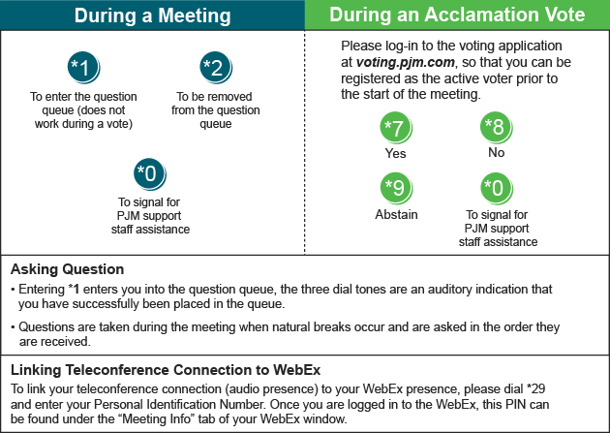

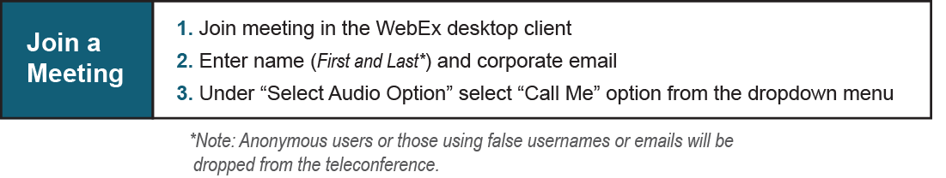

Provide feedback on the progress of this group: Facilitator Feedback Form
Visit learn.pjm.com, an easy-to-understand resource about the power industry and PJM’s role.

