Market Implementation Committee
PJM Conference & Training Center, Audubon, PA
February 7, 2018
9:00 a.m. – 4:00 p.m. EPT

Administration (9:00-9:05)
Ms. Christina Stotesbury and Ms. Chantal Hendrzak will provide announcements; review the Antitrust, Code of Conduct, and Public Meetings/Media Participation Guidelines, and Issue Tracking.

The committee will be asked to approve the draft minutes from the January 10, 2018 Market Implementation Committee meeting.

Endorsements/Approvals (9:05-10:20)
- Revisions to Manual 11: Energy & Ancillary Services Market Operations (9:05-9:20)
Mr. Rami Dirani, PJM, will review conforming revisions to Manual 11: Energy & Ancillary Services Market Operations to clarify the Energy Offer Verification process. The committee will be asked to endorse the manual 11 revisions.

- Revisions to Manual 12: Balancing Operations (9:20-9:35)
Ms. Nicole Militello, PJM, will review conforming revisions to Manual 12: Balancing Operations to address PJM’s External Capacity filing. The committee will be asked to endorse the manual 12 revisions.

- Tariff Revisions to address Overlapping Congestion (9:35-9:50)
Ms. Nicole Militello, PJM, will review revisions to the PJM Tariff and Operating Agreement to address overlapping congestion. The committee will be asked to endorse the governing document revisions.

- Market Path/Interface Pricing Point Alignment (9:50-10:20)
Mr. Tim Horger, PJM, will review the final proposals to address the Market Path/Interface Pricing Point Alignment issue. The committee will be asked to endorse a proposal.

Break (10:20-10:30)

First Readings (10:30-11:30)
- FTR Forfeiture Rule - Problem Statement & Issue Charge (10:30-10:45)
Ms. Sharon Midgley, Exelon, will provide a first read of a problem statement and issue charge to address the FTR Forfeiture Rule. The committee will be asked to approve the problem statement and issue charge at the March meeting.

- Must Offer Exemption Process - Problem Statement & Issue Charge (10:45-11:00)
Ms. Midgley, Exelon, will also provide a first read of a problem statement and issue charge to address the Must Offer Exemption process. The committee will be asked to approve the problem statement and issue charge at the March meeting.
- Variable Operations & Maintenance Packages (11:00-11:30)
Mr. Tom Hauske, PJM, will provide a first read of the solution packages to address Variable Operations & Maintenance Costs that were proposed in the MIC Special Sessions on this topic. The committee will be asked to endorse a package at March meeting.

Working Issues (11:30-12:30)
- FTR Nodal Remapping (11:30-11:50)
Mr. Brian Chmielewski, PJM, will present education on the FTR Nodal Remapping issue that was approved at the January MIC.

- Long Term FTR Auction (11:50-12:10)
- Mr. Brian Chmielewski, PJM, will present follow-up education on the Long Term FTR issue.
- Education from the perspective of market participants related to the Long Term FTR Market will be presented.

- Market Seller Offer Cap Balancing Ratio (12:10-12:30)
Mr. Pat Bruno, PJM, will provide an overview and education on the Market Seller Offer Cap Balancing Ratio issue approved at the October MRC.

Lunch (12:30-1:30)

Additional Updates (1:30-2:40)
- Cost-Based & Market-based Energy Offers greater than $1,000/MWh (1:30-1:50)
- Mr. Jeff Schmitt, PJM, will provide a summary of cost-based offers that exceeded $1,000/MWh during the extreme cold weather experienced in the PJM region the first week of January 2018.
- Ms. Susan Kenney, PJM, will provide an update on a Markets Gateway enhancement to prevent market-based offers greater than cost-based offers exceeding $1,000/MWh.

- Net Energy Injections Report (1:50-2:05)
Mr. Ken Schuyler, PJM, will provide a summary of the 4th Quarter 2017 Net Energy Injections Report.

- Load Management Report (2:05-2:20)
Mr. Jack O’Neill, PJM, will provide a summary of the 2017-2018 Load Management Report.

- Regional Transmission Expansion Process Incremental Auction Revenue Rights (2:20-2:40)
Mr. Asanga Perera, PJM, will provide an update on the Regional Transmission Expansion Process (RTEP) Incremental Auction Revenue Rights (IARRs) for the 2018/2019 planning period.

Informational Section
Credit Subcommittee (CS)
Meeting materials will be posted to the CS website.

Demand Response Subcommittee (DRS)
Meeting materials will be posted to the DRS web site.

Intermittent Resources Subcommittee (IRS)
Meeting materials will be posted to the IRS web site.

Interregional Coordination Update
Materials will be posted as informational only. Mr. Tim Horger, PJM, will be available in-person for questions.

Market Settlements Subcommittee (MSS)
Meeting materials are posted to the MSS web site.

Report on Market Operations
The Report on Market Operations will be reviewed during the MC Webinar.

Future Meeting Dates
March 7, 2018 | 9:00 a.m. | PJM Conference & Training Center/ WebEx
April 4, 2018 | 9:00 a.m. | PJM Conference & Training Center/ WebEx
May 2, 2018 | 9:00 a.m. | PJM Conference & Training Center/ WebEx
June 6, 2018 | 9:00 a.m. | PJM Conference & Training Center/ WebEx
July 11, 2018 | 9:00 a.m. | PJM Conference & Training Center/ WebEx
August 8, 2018 | 9:00 a.m. | PJM Conference & Training Center/ WebEx
September 12, 2018 | 9:00 a.m. | PJM Conference & Training Center/ WebEx
October 10, 2018 | 9:00 a.m. | PJM Conference & Training Center/ WebEx
November 7, 2018 | 9:00 a.m. | PJM Conference & Training Center/ WebEx
December 12, 2018 | 9:00 a.m. | PJM Conference & Training Center/ WebEx

Author: Christina Stotesbury

Antitrust:
You may not discuss any topics that violate, or that might appear to violate, the antitrust laws including but not limited to agreements between or among competitors regarding prices, bid and offer practices, availability of service, product design, terms of sale, division of markets, allocation of customers or any other activity that might unreasonably restrain competition. If any of these items are discussed the chair will re-direct the conversation. If the conversation still persists, parties will be asked to leave the meeting or the meeting will be adjourned.

Code of Conduct:
As a mandatory condition of attendance at today's meeting, attendees agree to adhere to the PJM Code of Conduct as detailed in PJM Manual M-34 section 4.5, including, but not limited to, participants' responsibilities and rules regarding the dissemination of meeting discussion and materials.

Public Meetings/Media Participation:
Unless otherwise noted, PJM stakeholder meetings are open to the public and to members of the media. Members of the media are asked to announce their attendance at all PJM stakeholder meetings at the beginning of the meeting or at the point they join a meeting already in progress. Members of the Media are reminded that speakers at PJM meetings cannot be quoted without explicit permission from the speaker. PJM Members are reminded that "detailed transcriptional meeting notes" and white board notes from "brainstorming sessions" shall not be disseminated. Stakeholders are also not allowed to create audio, video or online recordings of PJM meetings. PJM may create audio, video or online recordings of stakeholder meetings for internal and training purposes, and your participation at such meetings indicates your consent to the same.

Participant Identification in WebEx:
When logging into the WebEx desktop client, please enter your real first and last name as well as a valid email address. Be sure to select the “call me” option.
PJM support staff continuously monitors WebEx connections during stakeholder meetings. Anonymous users or those using false usernames or emails will be dropped from the teleconference.

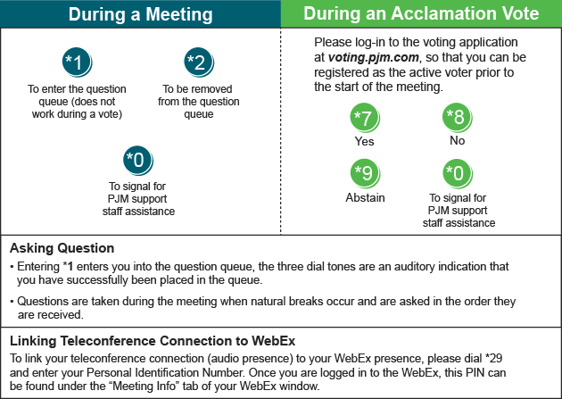

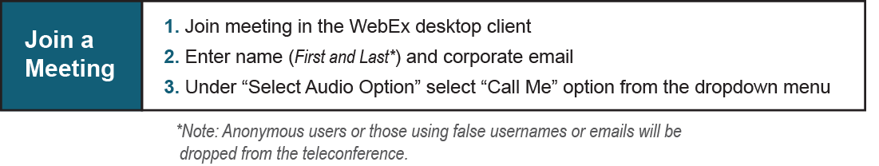

Provide feedback on the progress of this group: Facilitator Feedback Form
Visit learn.pjm.com, an easy-to-understand resource about the power industry and PJM’s role.

