Market Implementation Committee
PJM Conference & Training Center, Audubon, PA
March 8, 2017
9:00 a.m. – 4:00 p.m. EPT

Administration (9:00-9:15)
Welcome, announcements and review of the Antitrust, Code of Conduct, and Public Meetings/Media Participation Guidelines – Ms. Christina Stotesbury

The committee will be asked to approve draft minutes from the February 8, 2017 Market Implementation Committee meeting.

Review MIC Issue Tracking

Endorsements/Approvals (9:15-9:30)
Annual Revenue Requirements for new Black Start Units – Phase 2 (9:15-9:30)
Mr. Tom Hauske, PJM, will review an amended problem statement and issue charge to address Minimum Tank Suction Level (MTSL) costs as Phase 2 of the Annual Revenue Requirements for new Black Start units. The committee will be asked to approve the amended problem statement and issue charge.

Working Issues (9:30-10:15)
Annual Revenue Requirements for new Black Start Units (9:30-10:00)
- Mr. Tom Hauske, PJM, will continue the discussion on Annual Revenue Requirements for new Black Start units as part of Phase 1 and present the solution packages for consideration.
- Dr. Joe Bowring, Monitoring Analytics, will provide information the Minimum Tank Suction Level costs as part of the Phase 2 discussion.
Issue tracking: Annual Revenue Requirements for new Black Start Units

Spot-in Transmission Service for Energy Imports from NYISO (10:00-10:15)
Mr. Chris Pacella, PJM, will review the package proposals previously presented.
Issue Tracking: Spot-in Transmission Service for Energy Imports from NYISO

Additional Updates (10:15-2:00)
- Fuel Cost Policy FAQ’s and Transition Process (10:15-10:35)
- Mr. Jeff Schmitt, PJM, will provide an update on the status of Fuel Cost Policies, and speak to the FAQ document and transition process to have all policies approved by May 15.
- Dr. Joe Bowring, and Dr. Catherine Tyler Mooney, Monitoring Analytics, will review suggested edits to Manual 15 as part of the Fuel Cost Policy discussion.

Break (10:35-10:45)

- NOPR: Uplift Cost Allocation & Transparency (10:45-11:05)
Ms. Rebecca Stadelmeyer, PJM, will provide an update on the FERC Notice of Proposed Rulemaking addressing Uplift Cost Allocation and Transparency.

- NOPR: Fast Start Resources (11:05-11:25)
Ms. Lisa Morelli, PJM, will provide an update on the PJM response to the FERC Notice of Proposed Rulemaking addressing pricing for Fast Start Resources.

- Yorktown Pricing Interface (11:25-11:35)
Mr. Chris Callaghan, PJM, will provide an update on the new Yorktown Pricing Interface that becomes effective on April 1, 2017.

- SPS Removal (11:35-11:45)
Mr. Paul Santarelli, PPL, will provide an update on the removal of the Jenkins Special Protection Scheme.

- FTR Auction Results (11:45-11:55)
Mr. Asanga Perera, PJM, will provide an update on the delay to post results for the March 2017 FTR Auction.

- FTR Forfeiture Update (11:55-12:15)
Mr. Asanga Perera, PJM, will provide an update on FTR forfeitures.

Lunch (12:15-1:00)

- FTR/ARR Order (1:00-1:30)
- Mr. Brian Chmielewski, PJM, will provide an update on the recent FERC Order impacting the annual ARR/FTR process.
- Mr. Ray Fernandez, PJM, will provide an update on settlement impacts of the FTR Congestion issue.

- MSS – Pseudo-tied Generators and Dynamic Schedules Meter Correction Proposal (1:30-1:40)
Mr. Ray Fernandez, PJM, will provide an update on the Pseudo-tied Generators and Dynamic Schedules Meter Correction proposal stakeholders agreed to at the February Markets Settlements Subcommittee meeting. Updated manual language will be presented for a first read in April.

- Inter-Regional Coordination (1:40-2:00)
Mr. Tim Horger, PJM, will provide an update on Inter-Regional Coordination activity.

Informational Section
Transmission Constraint Control Logic Paper
A paper describing the logic used in PJM’s market clearing engines to control transmission constraints and the impact of transmission constraint penalty factors on constraint shadow prices has been posted. This is a follow-up to the presentation on transmission constraint penalty factors at the October 26, 2016 MIC Special Session. Ms. Lisa Morelli, PJM, will be available in-person to answer questions.

Credit Subcommittee (CS)
Meeting materials will be posted to the CS website.

Demand Response Subcommittee (DRS)
Meeting materials will be posted to the DRS web site.

Intermittent Resources Subcommittee (IRS)
Meeting materials will be posted to the IRS web site.

Market Settlements Subcommittee (MSS)
Meeting materials are posted to the MSS web site.

Report on Market Operations
The Report on Market Operations will be reviewed during the MC Webinar.

Future Meeting Dates
April 12, 2017 | 9:00 a.m. | PJM Interconnection – Conference & Training Center
May 3, 2017 | 9:00 a.m. | PJM Interconnection – Conference & Training Center
June 7, 2017 | 9:00 a.m. | PJM Interconnection – Conference & Training Center
July 12, 2017 | 9:00 a.m. | PJM Interconnection – Conference & Training Center
August 9, 2017 | 9:00 a.m. | PJM Interconnection – Conference & Training Center
September 13, 2017 | 9:00 a.m. | PJM Interconnection – Conference & Training Center
October 11, 2017 | 9:00 a.m. | PJM Interconnection – Conference & Training Center
November 8, 2017 | 9:00 a.m. | PJM Interconnection – Conference & Training Center
December 13, 2017 | 9:00 a.m. | PJM Interconnection – Conference & Training Center

Author: Christina Stotesbury

Antitrust:
You may not discuss any topics that violate, or that might appear to violate, the antitrust laws including but not limited to agreements between or among competitors regarding prices, bid and offer practices, availability of service, product design, terms of sale, division of markets, allocation of customers or any other activity that might unreasonably restrain competition. If any of these items are discussed the chair will re-direct the conversation. If the conversation still persists, parties will be asked to leave the meeting or the meeting will be adjourned.

Code of Conduct:
As a mandatory condition of attendance at today's meeting, attendees agree to adhere to the PJM Code of Conduct as detailed in PJM Manual 34 Section 4.5, including, but not limited to, participants' responsibilities and rules regarding the dissemination of meeting discussion and materials.

Public Meetings/Media Participation:
Unless otherwise noted, PJM stakeholder meetings are open to the public and to members of the media. Members of the media are asked to announce their attendance at all PJM stakeholder meetings at the beginning of the meeting or at the point they join a meeting already in progress. Members of the Media are reminded that speakers at PJM meetings cannot be quoted without explicit permission from the speaker. PJM Members are reminded that "detailed transcriptional meeting notes" and white board notes from "brainstorming sessions" shall not be disseminated. Stakeholders are also not allowed to create audio, video or online recordings of PJM meetings.

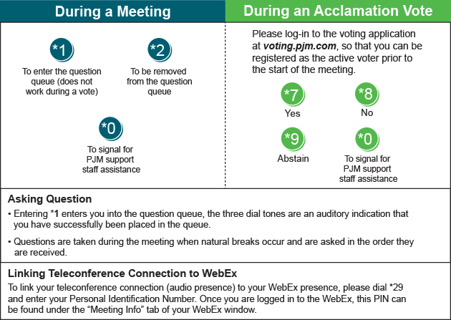
Facilitator Feedback Form: http://www.pjm.com/committees-and-groups/committees/form-facilitator-feedback.aspx

