Planning Committee
PJM Conference and Training Center, Audubon, PA
December 15, 2016
9:30 a.m. – 12:15 p.m. [EPT]

Administration (9:30 – 9:35)
- Welcome, announcements and review of the Anti-trust, Code of Conduct, and Media Participation Guidelines. - Mr. Steve Herling
- Approve draft minutes from the November 3rd, 2016 Planning Committing (PC) meeting.

Endorsements (9:35 – 9:55)
- Manual 14C Updates
Ms. Sue Glatz, PJM, will present a first read for changes to Section 6.1.6 of Manual 14C (Generation and Transmission Interconnection Facility Construction). The committee will be asked to endorse these updates.

First Readings (9:55 – 10:15)
- Transmission and Substation Subcommittee (TSS) Charter Revisions
Mr. Ray Rouault, TSS Chairman, will present modifications to the TSS Charter regarding Annual EHV/Bulk Equipment Record and the bulk transformer failure tracking sheet. The committee will be asked to endorse the proposed revisions at its next meeting.

Informational Updates (10:15 – 12:15)
- NERC/RRO Update
Mr. Mark Kuras, PJM, will provide an update to the membership on the activities, issues and items of interest at NERC, SERC, and RFC.
- Regional Transmission Expansion Plan (RTEP) Case Updates
Mr. Kyle Clifford, PJM, will provide an update on the Regional Transmission Expansion Plan (RTEP) base case build schedule.
- Designated Entity Design Senior Task Force (DEDSTF) Update
Mr. Mike Herman, PJM, will provide an update on the progress of the DEDSTF.
- JOA Deactivation Update
Mr. Aaron Berner, PJM, will provide an update on the JOA Deactivation work being conducted at the PJM/MISO Joint and Common Market meetings.

- New Service Request Study Methods
Mr. Berner, PJM, will provide an update on items under discussion at the Special PC Sessions for New Service Request Study Methods.
- New Services Queue Application Process
Mr. Berner, PJM, will provide an overview of a new system and details regarding the New Services Queue Application Process.
- Load Forecast Report
Mr. John Reynolds, PJM, will review the 2017 Load Forecast Report.
- Winter Season Resource Adequacy and Capacity Requirements
Mr. Tom Falin, PJM, will discuss the problem statement recently approved by the MRC regarding winter season resource adequacy and capacity requirements.
- PJM/NYISO Wheel Modeling
Mr. Sims, PJM, will provide an update regarding the operational and planning protocols related to the termination of the ConEd Wheel. The discussion will focus on the status of the whitepaper, JOA changes and schedule.
- First Energy Local Planning Criteria Update
Mr. John Syner, FirstEnergy Solutions Corp., will provide an update on First Energy’s Local Planning Criteria pertaining to terminology related to the new TPL Standard.
- Review of Market Efficiency Project Selection Guidelines
Mr. Asanga Perera, PJM, will review the draft guidelines for Market Efficiency Project Selection.

Informational Section
Order 1000 Update
Special PC Sessions on Order 1000 was held on November 11. An additional session is scheduled for December, 2016 (9am – 12 Noon). At the most recent session, the following was discussed: (1) TEAC Redesign and (2) RTEP Schedule. The Market Efficiency Project Selection Guidelines were finalized and will be presented to the Planning Committee for endorsement.
TO Pro Forma Wires to Wires Interconnection Agreement
The Transmission Owners provided an update at the November TOAAC regarding the status of the pro forma wires to wires interconnection agreement that is under development. The draft agreement is largely complete with two remaining topics still being discussed and finalized.

Future Meeting Dates
December 15, 2016 | 9:30 a.m. | Planning Committee | PJM Conference and Training Center, Audubon, PA
January 12, 2017 | 9:30 a.m. | Planning Committee | PJM Conference and Training Center, Audubon, PA
January 13, 2017 | 9:00 a.m. | Special PC Session: TEAC Redesign and RTEP Cycle | PJM Conference and Training Center, Audubon, PA
February 9, 2017 | 9:30 a.m. | Planning Committee | PJM Conference and Training Center, Audubon, PA
February 10, 2017 | 9:00 a. m. | Special PC Session: TEAC Redesign and RTEP Cycle | PJM Conference and Training Center, Audubon, PA
March 9, 2017 | 9:30 a.m. | Planning Committee | PJM Conference and Training Center, Audubon, PA
April 13, 2017 | 9:30 a.m. | Planning Committee | PJM Conference and Training Center, Audubon, PA
May 4, 2017 | 9:30 a.m. | Planning Committee | PJM Conference and Training Center, Audubon, PA
June 8, 2017 | 9:30 a.m. | Planning Committee | PJM Conference and Training Center, Audubon, PA
July 13, 2017 | 9:30 a.m. | Planning Committee | PJM Conference and Training Center, Audubon, PA
August 10, 2017 | 9:30 a.m. | Planning Committee | PJM Conference and Training Center, Audubon, PA
September 14, 2017 | 9:30 a.m. | Planning Committee | PJM Conference and Training Center, Audubon, PA
October 12, 2017 | 9:30 a.m. | Planning Committee | PJM Conference and Training Center, Audubon, PA
November 9, 2017 | 9:30 a.m. | Planning Committee | PJM Conference and Training Center, Audubon, PA
December 14, 2017 | 9:30 a.m. | Planning Committee | PJM Conference and Training Center, Audubon, PA

Author: Bridgid Cummings

Anti-trust:
You may not discuss any topics that violate, or that might appear to violate, the antitrust laws including but not limited to agreements between or among competitors regarding prices, bid and offer practices, availability of service, product design, terms of sale, division of markets, allocation of customers or any other activity that might unreasonably restrain competition. If any of these items are discussed the chair will re-direct the conversation. If the conversation still persists, parties will be asked to leave the meeting or the meeting will be adjourned.

Code of Conduct:
As a mandatory condition of attendance at today's meeting, attendees agree to adhere to the PJM Code of Conduct as detailed in PJM Manual M-34 section 4.5, including, but not limited to, participants' responsibilities and rules regarding the dissemination of meeting discussion and materials.

Public Meetings/Media Participation:
Unless otherwise noted, PJM stakeholder meetings are open to the public and to members of the media. Members of the media are asked to announce their attendance at all PJM stakeholder meetings at the beginning of the meeting or at the point they join a meeting already in progress. Members of the Media are reminded that speakers at PJM meetings cannot be quoted without explicit permission from the speaker. PJM Members are reminded that "detailed transcriptional meeting notes" and white board notes from "brainstorming sessions" shall not be disseminated. Stakeholders are also not allowed to create audio, video or online recordings of PJM meetings.
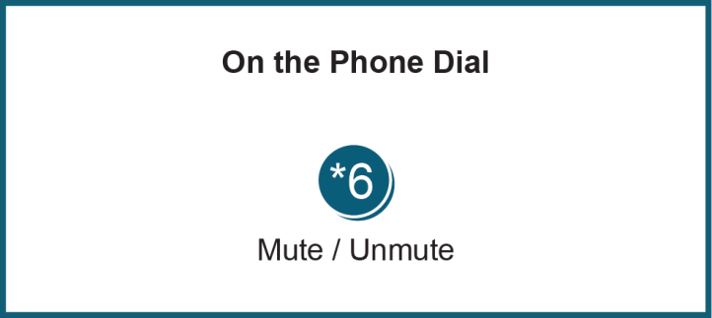

Facilitator Feedback Form: http://www.pjm.com/committees-and-groups/committees/form-facilitator-feedback.aspx

