Market Implementation Committee
PJM Conference & Training Center, Audubon, PA
November 2, 2016
9:30 a.m. – 4:00 p.m. EPT

Administration (9:30-9:45)
Welcome, announcements and review of the Antitrust, Code of Conduct, and Public Meetings/Media Participation Guidelines – Ms. Christina Stotesbury

The committee will be asked to approve draft minutes from the October 5, 2016 Market Implementation Committee meeting.

Review MIC Issue Tracking

Endorsements/Approvals (9:45-10:40)
Manual 15 – Fuel Cost Policy Revisions (9:45-10:10)
Mr. Jeff Schmitt, PJM, will review proposed revisions to Manual 15 – Cost Development Guidelines regarding Fuel Cost Policies contingent upon FERC approval of PJM’s related compliance filing.
The committee will be asked to endorse these manual revisions.

- Manual 28 – Operating Agreement Accounting Revisions (10:10-10:25)
Mr. Ray Fernandez, PJM, will review proposed revisions to Manual 28 to better describe a fully metered EDC.
The committee will be asked to endorse these manual revisions.

- Governing document language for Operating Parameters (10:25-10:40)
Mr. Tom Hauske, PJM, will review proposed revisions to the PJM Tariff, and Manuals 11, 12 and 28.
The committee will be asked to endorse these manual revisions.

Break (10:40-10:50)

Working Issues (10:50-12:30)
Annual Revenue Requirements for new Black Start Units (10:50-11:10)
Mr. Tom Hauske, PJM, will continue discussion on Annual Revenue Requirements for new Black Start units and gather stakeholder interests and options for consideration.
Issue tracking: Annual Revenue Requirements for new Black Start Units

Spot-in Transmission Service for Energy Imports from NYISO (11:10-11:30)
Mr. Chris Pacella, PJM, and Mr. Joe Wadsworth, Vitol, will review a proposal to address spot-in transmission service for energy imports from NYISO, and provide an update on communication with NYISO.
Issue Tracking: Spot-in Transmission Service for Energy Imports from NYISO

FERC Order 825 – Settlement Intervals & Shortage Pricing (11:30-12:30)
- Mr. Ray Fernandez, PJM, will provide an update on Order 825 5-minute settlements.
- Ms. Rebecca Stadelmeyer, PJM, will provide a review of the October 26 MIC Special Session and current proposal. Stakeholders will be requested to provide interests, options and packages for consideration.

Lunch (12:30-1:15)

First Readings (1:15-1:30)
Residual ARR Enhancements (1:15-1:30)
Mr. Brian Chmielewski, PJM, will review the Residual ARR Enhancements issue, provide additional education requested at the October meeting investigating a larger residual negative ARR in February 2016, and present an updated package as a first read.
The committee will be asked to endorse this package at the December meeting.

Additional Updates (1:30-3:45)
Fuel Cost Policy Clarifications (1:30-2:00)
Dr. Joe Bowring, Monitoring Analytics, will discuss gas penalties as part of Fuel Cost Policies.

- FTR FERC Order (2:00-2:45)
Mr. Asanga Perera, PJM, will provide an update on the FERC Order addressing the PJM filing Docket ER16-121-000, and issues brought forward at the technical conference on February 4, 2016.

- Inter-Regional Coordination Activity (2:45-3:15)
Mr. Tim Horger, PJM, will provide an update on Inter-Regional Coordination activity, including an update on the PSE&G/ConEd Wheel Modeling.

- Net Energy Metering Report (3:15-3:30)
Mr. Ken Schuyler, PJM, will provide an update on the 2016 third quarter Net Energy Metering Report.

- Credit Subcommittee (3:30-3:45)
Mr. Hal Loomis, PJM, will provide an update on the FTR Credit Analysis that was previewed in September.

Informational Section
Credit Subcommittee (CS)
Meeting materials will be posted to the CS website.

Demand Response Subcommittee (DRS)
Meeting materials will be posted to the DRS web site.

Intermittent Resources Subcommittee (IRS)
Meeting materials will be posted to the IRS web site.

Market Settlements Subcommittee (MSS)
Meeting materials are posted to the MSS web site.

Report on Market Operations
The Report on Market Operations will be reviewed during the MC Webinar.

Future Meeting Dates
December 14, 2016 | 9:30 a.m. | PJM Interconnection – Conference & Training Center
January 11, 2017 | 9:30 a.m. | PJM Interconnection – Conference & Training Center
February 8, 2017 | 9:30 a.m. | PJM Interconnection – Conference & Training Center
March 8, 2017 | 9:30 a.m. | PJM Interconnection – Conference & Training Center
April 12, 2017 | 9:30 a.m. | PJM Interconnection – Conference & Training Center
May 3, 2017 | 9:30 a.m. | PJM Interconnection – Conference & Training Center
June 7, 2017 | 9:30 a.m. | PJM Interconnection – Conference & Training Center

Author: Christina Stotesbury

Antitrust:
You may not discuss any topics that violate, or that might appear to violate, the antitrust laws including but not limited to agreements between or among competitors regarding prices, bid and offer practices, availability of service, product design, terms of sale, division of markets, allocation of customers or any other activity that might unreasonably restrain competition. If any of these items are discussed the chair will re-direct the conversation. If the conversation still persists, parties will be asked to leave the meeting or the meeting will be adjourned.

Code of Conduct:
As a mandatory condition of attendance at today's meeting, attendees agree to adhere to the PJM Code of Conduct as detailed in PJM Manual M-34 section 4.5, including, but not limited to, participants' responsibilities and rules regarding the dissemination of meeting discussion and materials.

Public Meetings/Media Participation:
Unless otherwise noted, PJM stakeholder meetings are open to the public and to members of the media. Members of the media are asked to announce their attendance at all PJM stakeholder meetings at the beginning of the meeting or at the point they join a meeting already in progress. Members of the Media are reminded that speakers at PJM meetings cannot be quoted without explicit permission from the speaker. PJM Members are reminded that "detailed transcriptional meeting notes" and white board notes from "brainstorming sessions" shall not be disseminated. Stakeholders are also not allowed to create audio, video or online recordings of PJM meetings.

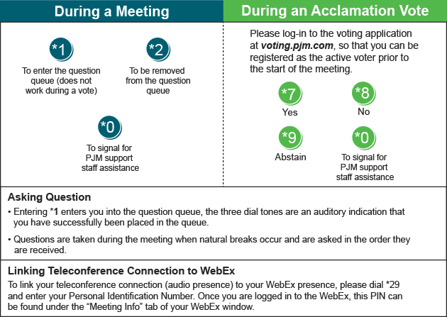
Facilitator Feedback Form: http://www.pjm.com/committees-and-groups/committees/form-facilitator-feedback.aspx

