Financial Risk Mitigation Senior Task Force (FRMSTF)
PJM Conference and Training Center
September 5, 2019; 9:00 a.m. – 12:00 p.m. EPT

Administration (9:00-9:15)
- Ms. Michele Greening will provide welcome, announcements and review of the Antitrust, Code of Conduct, and Public Meetings/Media Participation Guidelines. Stakeholders will be asked to approve draft minutes from the August 14, 2019 meeting.
- Ms. Nigeria Bolczynski will provide an update on her vision for the credit work stream of the FRMSTF.

Work Plan (9:15-9:30)
- Ms. Anita Patel will review the Financial Risk Mitigation Senior Task Force stakeholder process work plan and voting schedule.

Discussion Papers and Proposals (9:30-12:00)
- Events of Default and Market Participation Termination (9:30–10:00)
Ms. Nigeria Bloczynski will provide an overview of a discussion paper addressing default and termination events.
Break 10:00 – 10:15
- Establishing Financial Criteria Assessment and Credit Policy Enhancements for FTR Market Participation (10:15–11:00)
Ms. Nigeria Bloczynski will provide an overview of a position paper addressing financial criteria for market participation.
- Mr. Seth Hayik, Monitoring Analytics, will present education on FTR Auction Prices and DA CLMP Differences (11:00-11:15)
- PJM Proposal for Changes to FTR Product Range and Auction Process (11:15–11:45)
Mr. Brian Chmielewski will review PJM’s proposal and stakeholder alternatives on the FTR Product Range and Auction Process populated into a solutions matrix.
Stakeholders will be asked to vote on this item via the Voting Application following this meeting.
- Ms. Megan McLaverty will review the process and preparation for using the Voting Application. (11:45–12:00)

Future Agenda Items (12:00)
PJM Report: Results of Risk Model Quantitative Analysis
PJM Discussion Paper: External Clearing Options

Future Meeting Dates
September 24-25, 2019 | 9:00 a.m. | PJM Conference & Training Center/ WebEx
October 18, 2019 | 9:00 a.m. | PJM Conference & Training Center/ WebEx
November 7, 2019 | 9:00 a.m. | PJM Conference & Training Center/ WebEx
November 21, 2019 | 9:00 a.m. | PJM Conference & Training Center/ WebEx
December 18, 2019 | 9:00 a.m. | PJM Conference & Training Center/ WebEx
Author: M. Greening

Antitrust:
You may not discuss any topics that violate, or that might appear to violate, the antitrust laws including but not limited to agreements between or among competitors regarding prices, bid and offer practices, availability of service, product design, terms of sale, division of markets, allocation of customers or any other activity that might unreasonably restrain competition. If any of these items are discussed the chair will re-direct the conversation. If the conversation still persists, parties will be asked to leave the meeting or the meeting will be adjourned.

Code of Conduct:
As a mandatory condition of attendance at today's meeting, attendees agree to adhere to the PJM Code of Conduct as detailed in PJM Manual M-34 section 4.5, including, but not limited to, participants' responsibilities and rules regarding the dissemination of meeting discussion and materials.

Public Meetings/Media Participation:
Unless otherwise noted, PJM stakeholder meetings are open to the public and to members of the media. Members of the media are asked to announce their attendance at all PJM stakeholder meetings at the beginning of the meeting or at the point they join a meeting already in progress. Members of the Media are reminded that speakers at PJM meetings cannot be quoted without explicit permission from the speaker. PJM Members are reminded that "detailed transcriptional meeting notes" and white board notes from "brainstorming sessions" shall not be disseminated. Stakeholders are also not allowed to create audio, video or online recordings of PJM meetings. PJM may create audio, video or online recordings of stakeholder meetings for internal and training purposes, and your participation at such meetings indicates your consent to the same.
Participant Identification in WebEx:
When logging into the WebEx desktop client, please enter your real first and last name as well as a valid email address. Be sure to select the “call me” option.
PJM support staff continuously monitors WebEx connections during stakeholder meetings. Anonymous users or those using false usernames or emails will be dropped from the teleconference.



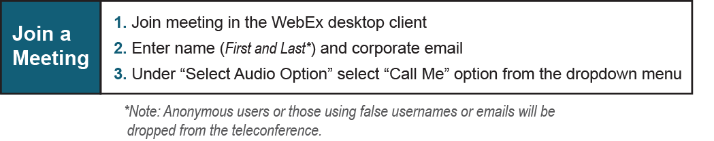
Provide feedback on the progress of this group: Facilitator Feedback Form
Visit learn.pjm.com, an easy-to-understand resource about the power industry and PJM’s role.

