Market Settlements Subcommittee
Conference Call
May 15, 2023 (canceled)

Informational updates
- FRR Capacity Resource Deficiency Settlements
Billing Line Items 1681 and 2681 for FRR LSE Capacity Resource Deficiency, which have not been active since 2011, will be populated again with the 2023/2024 delivery year. Please review the presentation linked below for billing details and supporting MSRS report details. PJM will provide additional review at the June 2023 MSS meeting.
FRR Capacity Resource Deficiency Settlements
- Reminder: ARR Target Credits MSRS Report Update
Please review updates to the ARR Target Credits report that will be effective June 1, 2023.
ARR Target Credits MSRS Report Update
- Settlement C Tracking
No adjustments were processed in the April 2023 billing cycle.
2023 Settlement C Tracking

Future Meeting Dates
June 12, 2023 | 1:00 p.m. – 2:30 p.m. | Conference Call
July 17, 2023 | 1:00 p.m. – 2:30 p.m. | Conference Call
August 14, 2023 | 1:00 p.m. – 2:30 p.m. | Conference Call
September 11, 2023 | 1:00 p.m. – 2:30 p.m. | Conference Call

Author: Sean Flamm

Antitrust:
You may not discuss any topics that violate, or that might appear to violate, the antitrust laws including but not limited to agreements between or among competitors regarding prices, bid and offer practices, availability of service, product design, terms of sale, division of markets, allocation of customers or any other activity that might unreasonably restrain competition. If any of these items are discussed the chair will re-direct the conversation. If the conversation still persists, parties will be asked to leave the meeting or the meeting will be adjourned.

Code of Conduct:
As a mandatory condition of attendance at today's meeting, attendees agree to adhere to the PJM Code of Conduct as detailed in PJM Manual M-34 section 4.5, including, but not limited to, participants' responsibilities and rules regarding the dissemination of meeting discussion and materials.

Public Meetings/Media Participation:
Unless otherwise noted, PJM stakeholder meetings are open to the public and to members of the media. Members of the media are asked to announce their attendance at all PJM stakeholder meetings at the beginning of the meeting or at the point they join a meeting already in progress. Members of the Media are reminded that speakers at PJM meetings cannot be quoted without explicit permission from the speaker. PJM Members are reminded that "detailed transcriptional meeting notes" and white board notes from "brainstorming sessions" shall not be disseminated. Stakeholders are also not allowed to create audio, video or online recordings of PJM meetings. PJM may create audio, video or online recordings of stakeholder meetings for internal and training purposes, and your participation at such meetings indicates your consent to the same.
Participant Identification in WebEx:
When logging into the WebEx desktop client, please enter your real first and last name as well as a valid email address. Be sure to select the “call me” option.
PJM support staff continuously monitors WebEx connections during stakeholder meetings. Anonymous users or those using false usernames or emails will be dropped from the teleconference.



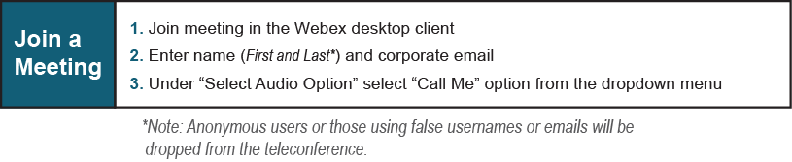
Provide feedback on the progress of this group: Facilitator Feedback Form
Visit learn.pjm.com, an easy-to-understand resource about the power industry and PJM’s role.

