Market Settlements Subcommittee
Conference Call
November 18, 2022
11:00 a.m. – 12:00 p.m. EPT

Administration (11:00 – 11:10)
Welcome, review of Anti-Trust Policy, Code of Conduct, Public Meetings/Media Participation and Participant Identification guidelines, and roll call.
Approval of Agenda and the October 18, 2022 draft MSS minutes.

Working Issues (1:10 – 2:00)
1. 2023 PowerMeter and Inschedule Holiday Deadline extension calendar (11:10 – 11:20)
John McComb, PJM, will review the 2023 tools holiday submission deadline extension calendar.
2. Reserve Price Formation Manual 28 Clarifications (11:20 – 11:30)
Lisa Morelli, PJM, will review clarifications to Manual 28 related to the Reserve Price Formation implementation.
3. PJM Schedule 9 – PSI Settlement Approval (11:30 – 11:40)
Sean Flamm, PJM, will review impacts related to FERC’s approval of ER22-26 for updates to PJM’s Schedule 9-PSI methodology.

Informational Updates
- Settlement C Updates
Three adjustments were processed in the October 2022 billing cycle impacting the Dayton zone.

Settlement C Adjustment Tracking

- 2022 November Holiday Submission Deadline Extensions guide
Please review guidelines for submissions for dates affected by November 2022 holidays.

2022 PowerMeter & Inschedule Holiday Extensions

Future Agenda Items
Participants will have the opportunity to request the addition of any new item(s) to the agenda of a future meeting.

Future Meeting Dates
December 13, 2022 | 1:00 p.m. – 2:30 p.m. | Conference Call

Author: Sean Flamm

Antitrust:
You may not discuss any topics that violate, or that might appear to violate, the antitrust laws including but not limited to agreements between or among competitors regarding prices, bid and offer practices, availability of service, product design, terms of sale, division of markets, allocation of customers or any other activity that might unreasonably restrain competition. If any of these items are discussed the chair will re-direct the conversation. If the conversation still persists, parties will be asked to leave the meeting or the meeting will be adjourned.

Code of Conduct:
As a mandatory condition of attendance at today's meeting, attendees agree to adhere to the PJM Code of Conduct as detailed in PJM Manual M-34 section 4.5, including, but not limited to, participants' responsibilities and rules regarding the dissemination of meeting discussion and materials.

Public Meetings/Media Participation:
Unless otherwise noted, PJM stakeholder meetings are open to the public and to members of the media. Members of the media are asked to announce their attendance at all PJM stakeholder meetings at the beginning of the meeting or at the point they join a meeting already in progress. Members of the Media are reminded that speakers at PJM meetings cannot be quoted without explicit permission from the speaker. PJM Members are reminded that "detailed transcriptional meeting notes" and white board notes from "brainstorming sessions" shall not be disseminated. Stakeholders are also not allowed to create audio, video or online recordings of PJM meetings. PJM may create audio, video or online recordings of stakeholder meetings for internal and training purposes, and your participation at such meetings indicates your consent to the same.
Participant Identification in WebEx:
When logging into the WebEx desktop client, please enter your real first and last name as well as a valid email address. Be sure to select the “call me” option.
PJM support staff continuously monitors WebEx connections during stakeholder meetings. Anonymous users or those using false usernames or emails will be dropped from the teleconference.



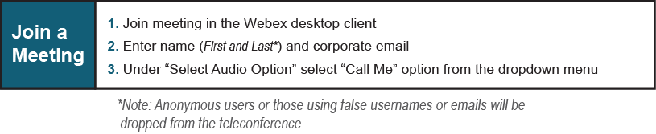
Provide feedback on the progress of this group: Facilitator Feedback Form
Visit learn.pjm.com, an easy-to-understand resource about the power industry and PJM’s role.

