Planning Committee
PJM Conference and Training Center
July 11, 2019
9:00 a.m. – 12:00 p.m. EPT

Administration (9:00-9:15)
- Welcome, announcements and review of the Anti-trust, Code of Conduct, and Media Participation Guidelines
- Approve Planning Committee (PC) Agenda for this meeting
- Approve draft minutes from the June 13th, 2019 PC meeting
- Review of the PC Work Plan

Endorsements (9:15-9:30)
- Manual 21 Revisions
Mr. Jerry Bell, PJM, will present revisions to PJM Manual 21 Rules & Procedures for Determination of Generating Capability. The Committee will be requested to endorse these revisions today.

First Reads (9:30-10:00)
- Load Model Selection
Mr. Patricio Rocha-Garrido, PJM, will present the results of the Load Model selection process for the 2019 Reserve Requirement Study. The Load Model selection remains unchanged from last year. The Committee will be requested to endorse this Load Model selection at today’s meeting following the First Read.

Informational Updates (10:00-12:00)
Merchant Transmission and Off-Shore Wind Update
Mr. John Reynolds, PJM, will provide an update on the activities of the Merchant Transmission and Off Shore Wind Special sessions.
Issue Tracking: Merchant Transmission and Off-Shore Wind
RTEP Process Enhancements Update
Mr. Aaron Berner, PJM, will provide an update on the RTEP Process Enhancement discussions. Two additional Special PC meetings have been scheduled as noted below under Future Meeting dates.
Cost Containment Effort
Mr. Sims, PJM, will discuss the status and next steps for the cost containment effort.
Issue Tracking: Cost Containment
Designated Entity Pre-Qualification Process
Mr. Mark Sims, PJM, will provide an update on the PJM RTEP 2019 competitive window pre-qualification process for Designated Entity status.
- Model Build Activity Update
Mr. Peter Lamaina, PJM, will provide an update regarding current model build activities, including the 2019 series MMWG/MOD-032 cases.
- Reliability Compliance Update
Mr. Preston Walker, PJM, will provide an update on the activities, issues and items of interest at NERC, SERC, and RF.

Informational Posting
Stakeholder Notice on Proposed Amendment to Schedule 12 of PJM Tariff
Pursuant to section 7.3.2 of the Consolidated Transmission Owners Agreement (“CTOA”), the CTOA Administrative Committee hereby initiates consultation with the PJM Members Committee with regard to a proposed change to Schedule 12 of the PJM Interconnection, L.L.C. (“PJM”) Tariff. As discussed herein, the PJM Transmission Owners are proposing revisions to Schedule 12, section (b)(xviii), which governs the assignment of cost responsibility for Required Transmission Enhancements that relieve stability related reliability issues (“Stability Projects”) for inclusion in the PJM Regional Transmission Planning Process (“RTEP”).
The PJM Transmission Owners have included as Attachment A to this stakeholder notice a revised version of Schedule 12, section (b)(xviii) showing the proposed changes. The PJM Transmission Owners are proposing that the proposed revisions be made effective 60 days after filing.
Written comments on the proposed provisions may be submitted for consideration by email to: (Comments_for_Transmission_Owners@pjm.com) on or before August 5, 2019.

Future Meeting Dates
July12, 2019 | 9:00 a.m. – 12:00 p.m. | Special PC: M-3 Process Lessons Learned | PJM Conference & Training Center/ WebEx
July 12, 2019 | 1:00 p.m. – 4:00 p.m. | Special PC: RTEP Process Enhancements | PJM Conference & Training Center/ WebEx
July 15, 2019 | 1:00 p.m. – 4:00 p.m. | Special PC: Merchant Transmission and Off-Shore Wind | PJM Conference & Training Center/ WebEx
July 18, 2019 | 1:00 p.m. – 4:00 p.m. | Special PC: RTEP Process Enhancements | PJM Conference & Training Center/ WebEx
August 8, 2019 | 9:00 a.m. – 12:00 p.m. | Planning Committee | PJM Conference & Training Center/ WebEx
August 23, 2019 | 9:00 a.m. – 12:00 p.m. | Special PC: Merchant Transmission and Off-Shore Wind | PJM Conference & Training Center/ WebEx
September 12, 2019 | 9:00 a.m. – 12:00 p.m. | Planning Committee | PJM Conference & Training Center/ WebEx
September 20, 2019 | 9:00 a.m. – 12:00 p.m. | Special PC: Merchant Transmission and Off-Shore Wind | PJM Conference & Training Center/ WebEx
October 11, 2019 | 9:00 a.m. – 12:00 p.m. | Special PC: M-3 Process Lessons Learned | PJM Conference & Training Center/ WebEx
October 17, 2019 | 9:00 a.m. – 12:00 p.m. | Planning Committee | PJM Conference & Training Center/ WebEx
October 24, 2019 | 9:00 a.m. – 12:00 p.m. | Special PC: Merchant Transmission and Off-Shore Wind | PJM Conference & Training Center/ WebEx
November 14, 2019 | 9:00 a.m. – 12:00 p.m. | Planning Committee | PJM Conference & Training Center/ WebEx
November 15, 2019 | 9:00 a.m. – 12:00 p.m. | Special PC: Merchant Transmission and Off-Shore Wind | PJM Conference & Training Center/ WebEx
December 12, 2019 | 9:00 a.m. – 12:00 p.m. | Planning Committee | PJM Conference & Training Center/ WebEx
December 13, 2019 | 9:00 a.m. – 12:00 p.m. | Special PC: Merchant Transmission and Off-Shore Wind | PJM Conference & Training Center/ WebEx

Author: Anisha Fernandes

Antitrust:
You may not discuss any topics that violate, or that might appear to violate, the antitrust laws including but not limited to agreements between or among competitors regarding prices, bid and offer practices, availability of service, product design, terms of sale, division of markets, allocation of customers or any other activity that might unreasonably restrain competition. If any of these items are discussed the chair will re-direct the conversation. If the conversation still persists, parties will be asked to leave the meeting or the meeting will be adjourned.

Code of Conduct:
As a mandatory condition of attendance at today's meeting, attendees agree to adhere to the PJM Code of Conduct as detailed in PJM Manual M-34 section 4.5, including, but not limited to, participants' responsibilities and rules regarding the dissemination of meeting discussion and materials.

Public Meetings/Media Participation:
Unless otherwise noted, PJM stakeholder meetings are open to the public and to members of the media. Members of the media are asked to announce their attendance at all PJM stakeholder meetings at the beginning of the meeting or at the point they join a meeting already in progress. Members of the Media are reminded that speakers at PJM meetings cannot be quoted without explicit permission from the speaker. PJM Members are reminded that "detailed transcriptional meeting notes" and white board notes from "brainstorming sessions" shall not be disseminated. Stakeholders are also not allowed to create audio, video or online recordings of PJM meetings. PJM may create audio, video or online recordings of stakeholder meetings for internal and training purposes, and your participation at such meetings indicates your consent to the same.
Participant Identification in WebEx:
When logging into the WebEx desktop client, please enter your real first and last name as well as a valid email address. Be sure to select the “call me” option.
PJM support staff continuously monitors WebEx connections during stakeholder meetings. Anonymous users or those using false usernames or emails will be dropped from the teleconference.

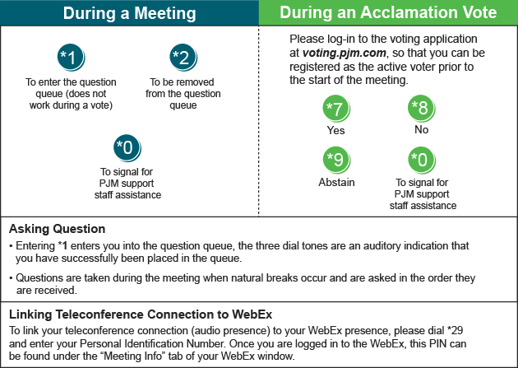

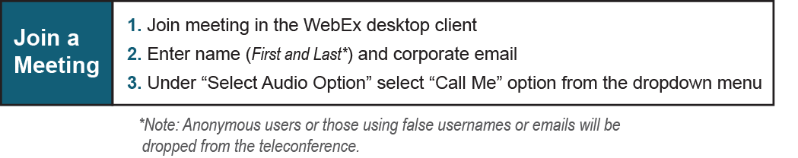
Provide feedback on the progress of this group: Facilitator Feedback Form
Visit learn.pjm.com, an easy-to-understand resource about the power industry and PJM’s role.

