Planning Committee
PJM Conference and Training Center
October 11, 2018
9:00 a.m. – 12:00 p.m. EPT

Administration (9:00-9:20)
- Welcome, announcements and review of the Anti-trust, Code of Conduct, and Media Participation Guidelines
- Approve Planning Committee (PC) Agenda for this meeting
- Approve draft minutes from the September 13th, 2018 PC meeting
- Review of the PC Work Plan
- Discuss Manual 21 Proposed Changes

Endorsements (9:20-9:40)
- 2018 Installed Reserve Margin Study Results
Mr. Andrew Gledhill, PJM, will review the 2018 Reserve Requirement Study results (IRM, FPR). The committee will be requested to endorse the study results.

First Reads
No First Reads this month

Informational Updates (9:40-12:00)
DER Ride Through Problem Statement & Issue Charge
Dr. Emanuel Bernabeu, PJM, will present updates and comments received on the inverter-based DER Ride Through Problem Statement and Issue Charge, and the revised IEEE 1547-2018 standard.
Cost Commitment Status and Next Steps
Mr. Mark Sims, PJM, will discuss the status and next steps for the Consideration of Cost Commitment for Evaluation of Competitive Transmission Proposals.
Electric Storage Participation: FERC Order 841
Ms. Laura Walter, PJM, will present the PJM straw proposal for compliance with FERC Order 841 Electric Storage Resource Participation Model. PJM must submit a compliance filing by December 3, 2018.
- Bright Ideas
Ms. Rebecca Stadelmeyer, PJM, will review the Bright Ideas initiative, which recommendations have been implemented to date and which recommendations are scheduled for future releases.
- Axway Upgrade Project – Status Update
Ms. Bhavana Gagrani, PJM, will provide an update on changes to the secure transport tool (Axway).
- PJM.com Update
Mr. Martelle Pitts, PJM, will review metrics that are planned for the Planning page on PJM.com.
Mr. Jon Ruffin and Ms. Tawnya Luna, PJM, will provide a demo of the new web-based agreements that have been added to PJM.com.
Model Build Activity Update
Mr. Kyle Clifford, PJM, will provide an update regarding current model build activities, including the 2018 series MMWG/MOD-032 cases.
Reliability Compliance Update
Mr. Preston Walker, PJM, will provide an update on the activities, issues and items of interest at NERC, SERC, and RFC.
PC Special Session: Order 845 Compliance Requirements
Ms. Susan McGill, PJM, will provide an update on the activities of the PC Special Session.
BGE RAS Retirement
Mr. Caleb Kim, BGE, will provide a presentation on the retirement of the Mount Washington Remedial Action Scheme (RAS).
Transmission Interconnection Requests
Ms. Susan McGill, PJM, will present potential changes for Transmission Interconnection Requests.
Flint Run and Spotsylvania EC 500 kV line designations
Mr. Yuri Smolanitsky, PJM, will present updates to two 500 kV line designations.

Informational Only
PJM Manual 03
Mr. Yuri Smolanitsky, PJM, will be available to answer questions on updates to Manual 3 – Transmission Operations. Materials are posted as Informational Only.

Future Meeting Dates
October 16, 2018 | 9:00 a.m. Special PC: Order 845 Compliance Requirements | Teleconference / WebEx
November 8, 2018 | 9:00 a.m. Planning Committee | PJM Conference & Training Center/ WebEx
December 13, 2018 | 9:00 a.m. Planning Committee | PJM Conference & Training Center/ WebEx
Author: Anisha Fernandes

Antitrust:
You may not discuss any topics that violate, or that might appear to violate, the antitrust laws including but not limited to agreements between or among competitors regarding prices, bid and offer practices, availability of service, product design, terms of sale, division of markets, allocation of customers or any other activity that might unreasonably restrain competition. If any of these items are discussed the chair will re-direct the conversation. If the conversation still persists, parties will be asked to leave the meeting or the meeting will be adjourned.

Code of Conduct:
As a mandatory condition of attendance at today's meeting, attendees agree to adhere to the PJM Code of Conduct as detailed in PJM Manual M-34 section 4.5, including, but not limited to, participants' responsibilities and rules regarding the dissemination of meeting discussion and materials.

Public Meetings/Media Participation:
Unless otherwise noted, PJM stakeholder meetings are open to the public and to members of the media. Members of the media are asked to announce their attendance at all PJM stakeholder meetings at the beginning of the meeting or at the point they join a meeting already in progress. Members of the Media are reminded that speakers at PJM meetings cannot be quoted without explicit permission from the speaker. PJM Members are reminded that "detailed transcriptional meeting notes" and white board notes from "brainstorming sessions" shall not be disseminated. Stakeholders are also not allowed to create audio, video or online recordings of PJM meetings. PJM may create audio, video or online recordings of stakeholder meetings for internal and training purposes, and your participation at such meetings indicates your consent to the same.
Participant Identification in WebEx:
When logging into the WebEx desktop client, please enter your real first and last name as well as a valid email address. Be sure to select the “call me” option.
PJM support staff continuously monitors WebEx connections during stakeholder meetings. Anonymous users or those using false usernames or emails will be dropped from the teleconference.

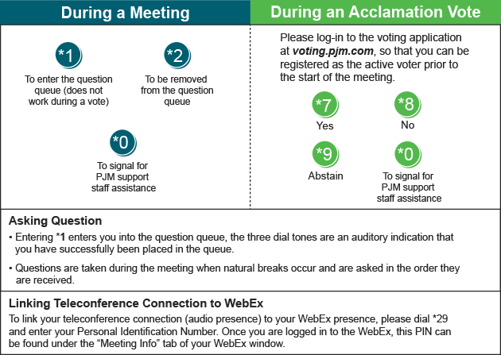

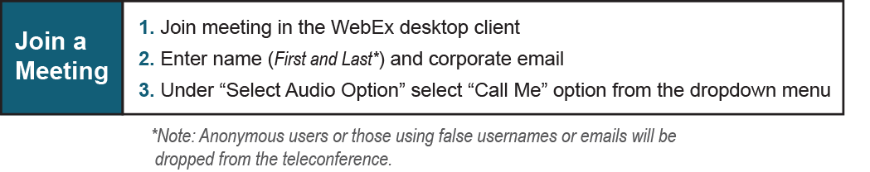
Provide feedback on the progress of this group: Facilitator Feedback Form
Visit learn.pjm.com, an easy-to-understand resource about the power industry and PJM’s role.

