Planning Committee
PJM Conference and Training Center
September 13, 2018
9:00 a.m. – 12:00 p.m. EPT

Administration (9:00-9:05)
- Welcome, announcements and review of the Anti-trust, Code of Conduct, and Media Participation Guidelines
- Approve Planning Committee (PC) Agenda for this meeting
- Approve draft minutes from the August 09th, 2018 PC meeting

Endorsements (9:05-10:15)
DER Ride Through Problem Statement & Issue Charge
Mr. Emanuel Bernabeu, PJM, will present the inverter-based DER Ride Through Problem Statement and Issue Charge, and the revised IEEE 1547-2018 standard. The committee will be requested to endorse this problem statement and issue charge.
Manual 21 Proposed Changes
Mr. Jerry Bell, PJM, will present the proposed changes to Manual 21 Rules & Procedures for Determination of Generating Capability. The committee will be requested to endorse these changes.
- Manual 14F Updates
Mr. Jason Shoemaker, PJM, will present proposed changes to Manual 14F, Competitive Planning Process related to Cost Containment. The committee will be requested to endorse these revisions.

First Reads (10:15-10:30)
2018 Installed Reserve Margin Study Results
Mr. Patricio Rocha Garrido, PJM, will review the 2018 Reserve Requirement Study results (IRM, FPR). The committee will be requested to endorse the study results at its next meeting.

Informational Updates (10:30-12:00)
Cost Commitment Status and Next Steps
Mr. Mark Sims, PJM, will discuss the status and next steps for the Consideration of Cost Commitment for Evaluation of Competitive Transmission Proposals.
Preliminary 2019 Project Budget
Mr. Jim Snow, PJM, will review the Preliminary 2019 Project Budget.
Contact Management Update
Ms. Amanda Egan, PJM, will provide an update on the Contact Management feature.
- Planning Resilience
Mr. Aaron Berner, PJM, will provide educational information regarding possible methods of employing resilience analyses in the RTEP study processes.
- NERC Retirements Study Results
Mr. Aaron Berner, PJM, will provide a brief outline of a special assessment being performed by NERC in relation to accelerated generation retirements.
Model Build Activity Update
Mr. Jonathan Thompson, PJM, will provide an update regarding current model build activities, including the 2018 series MMWG/MOD-032 cases.
Reliability Compliance Update
Mr. Preston Walker, PJM, will provide an update on the activities, issues and items of interest at NERC, SERC, and RFC.

Information Only
Elections for Winter Capacity Interconnection Rights (CIRs) 2022/2023
To further support resource aggregation for which the PJM Tariff already provides, PJM is pursuing formation of a long term process for winter Capacity Interconnection Rights (“CIRs”) that would be incorporated in the New Services Queue which will be discussed at the Planning Committee. Pending formation of a final process PJM established in 2016 through Docket No. ER17-367, a process for a year by year transitional period during which intermittent resources and environmentally limited generation resources may request additional winter CIRs. This transitional study period is being continued for an additional year pending completion of those discussions held at the Planning Committee. This transitional study would be a study to make additional capability available for only the 2022/2023 Delivery Year and is the same as PJM used during the first year for the 2020/2021 Delivery Year.
Generation Owners of Intermittent Resources and Environmentally Limited Resources which seek to obtain additional Capacity Interconnection Rights related to the winter period (defined as November through April of a Delivery Year) for the purposes of aggregation under the Tariff, Attachment DD, must submit the following information to be eligible for this study:
- Resource name
- Location (e.g. substation name)
- Queue Number
- Company
- Generation type (intermittent or Environmentally Limited Generation Resource
- Total amount of CIR (MW) being requested (CIR amount = current CIR + incremental CIR for this transitional study)
The projects will be queued in the order the request has been received for allocating Winter CIRs based on the available transmission capability.

PJM will start to accept requests starting Friday August 31, 2018. All requests must be submitted no later than Wednesday, October 31, 2018 by 5:00PM Eastern Time. Please submit this information to TransitionalCIRrequests@pjm.com. If you have any questions regarding this communication, please contact TransitionalCIRrequests@pjm.com.
FERC Order 845 Compliance Requirements
PJM hosted a Special Planning Committee meeting on August 20 to review potential changes to PJM Manuals and the OATT to meet compliance with FERC Order 845. PJM assessed that seven of the ten reforms will result in minimal changes to the Interconnection Process. The remaining three (Option to Build, Reporting Requirements, and Surplus Interconnection Service) will require extensive changes including new processes. PJM will host a follow up session on September 21.

Future Meeting Dates
September 21, 2018 | 1:00 p.m. Special PC: Order 845 Compliance Requirements | Teleconference / WebEx
October 11, 2018 | 9:00 a.m. Planning Committee | PJM Conference & Training Center/ WebEx
November 8, 2018 | 9:00 a.m. Planning Committee | PJM Conference & Training Center/ WebEx
December 13, 2018 | 9:00 a.m. Planning Committee | PJM Conference & Training Center/ WebEx
Author: Anisha Fernandes

Antitrust:
You may not discuss any topics that violate, or that might appear to violate, the antitrust laws including but not limited to agreements between or among competitors regarding prices, bid and offer practices, availability of service, product design, terms of sale, division of markets, allocation of customers or any other activity that might unreasonably restrain competition. If any of these items are discussed the chair will re-direct the conversation. If the conversation still persists, parties will be asked to leave the meeting or the meeting will be adjourned.

Code of Conduct:
As a mandatory condition of attendance at today's meeting, attendees agree to adhere to the PJM Code of Conduct as detailed in PJM Manual M-34 section 4.5, including, but not limited to, participants' responsibilities and rules regarding the dissemination of meeting discussion and materials.

Public Meetings/Media Participation:
Unless otherwise noted, PJM stakeholder meetings are open to the public and to members of the media. Members of the media are asked to announce their attendance at all PJM stakeholder meetings at the beginning of the meeting or at the point they join a meeting already in progress. Members of the Media are reminded that speakers at PJM meetings cannot be quoted without explicit permission from the speaker. PJM Members are reminded that "detailed transcriptional meeting notes" and white board notes from "brainstorming sessions" shall not be disseminated. Stakeholders are also not allowed to create audio, video or online recordings of PJM meetings. PJM may create audio, video or online recordings of stakeholder meetings for internal and training purposes, and your participation at such meetings indicates your consent to the same.
Participant Identification in WebEx:
When logging into the WebEx desktop client, please enter your real first and last name as well as a valid email address. Be sure to select the “call me” option.
PJM support staff continuously monitors WebEx connections during stakeholder meetings. Anonymous users or those using false usernames or emails will be dropped from the teleconference.

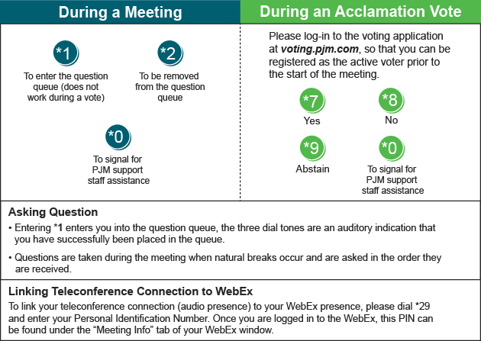

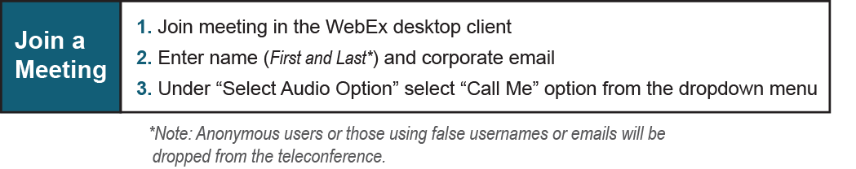

Provide feedback on the progress of this group: Facilitator Feedback Form
Visit learn.pjm.com, an easy-to-understand resource about the power industry and PJM’s role.

