Planning Committee
PJM Conference and Training Center
January 11, 2018
9:00 a.m. – 12:15 p.m. EPT

Administration (9:00-9:15)
Welcome, announcements and review of the Anti-trust, Code of Conduct, and Media Participation Guidelines. - Mr. Paul McGlynn.
Approve draft minutes from the December 14th, 2017 Planning Committee (PC) meeting.
Mr. Paul McGlynn, PJM, announce the change in meeting time for all future Planning Committee meetings to 9:00am.
Mr. Steve Herling, PJM, will announce organizational changes at PJM.

Endorsement (9:15-9:45)
Market Efficiency Problem Statement
Mr. Asanga Perera will review a problem statement related to market efficiency analysis procedures. The committee will be requested to endorse this Problem Statement.
Manual 14F and Operating Agreement Changes for Cost Containment
Ms. Sue Glatz, PJM, will present changes to PJM Manual 14F (Competitive Planning Process) and the PJM Operating Agreement to incorporate changes regarding cost containment developed during the Special PC sessions. The committee will be requested to endorse these changes.

First Reads (9:45-10:30)
- Manual 14A and Manual 14E Changes for New Service Request Study Methods
Mr. Ed Franks, PJM, will present changes to PJM Manual 14A (New Services Request Process) and PJM Manual 14E (Additional Information for Upgrade and Transmission Interconnection Projects). These changes correspond to the PJM OATT changes endorsed at the November 9th Planning Committee Meeting. The committee will be requested to endorse these changes at the next meeting.
- Manual 02 Changes
Mr. Jeff McLaughlin, PJM, will present changes to PJM Manual 2 (Transmission Service Request). These changes correspond to the PJM OATT changes endorsed at the November 9th Planning Committee Meeting. The committee will be requested to endorse these changes at the next meeting.
- Manual 14B Changes
Mr. Michael Herman, PJM, will present changes to PJM Manual 14B (Regional Transmission Planning Process) to clean up issues found during a periodic review. The committee will be requested to endorse these changes at the next meeting.
Designated Entity Design Standards Task Force Close Out
Mr. Michael Herman, PJM, will present the final report from the Task Force and an update charter to convert the Task Force to a Subcommittee that will meet every two years. The committee will be requested to endorse the Charter changes at the next meeting.

Informational Updates (10:30-12:15)
Manual 14 Series Proposed Changes
Ms. Lisa Krizenoskas, PJM, will present potential changes to the PJM Manual 14 series to increase clarity when locating information related to the PJM planning process.
RTEP 2018 Schedule Update
Mr. Alex Worcester, PJM, will provide a status update regarding the 2018 series RTEP cases.
NERC and Regional Coordination Update
Mr. Preston Walker, PJM, will provide an update on the activities, issues and items of interest at NERC, SERC, and RFC.
Transmission Expansion Advisory Committee (TEAC) Meeting
Mr. Mark Sims, PJM, discuss stakeholder feedback to the review process of the Regional and Local Plans, including those conducted at the TEAC and Sub-regional RTEP Committees.
PJM External Capacity filing
Mr. Aaron Berner, PJM, will discuss the addition of reviews required to permit external generation to participate in PJM’s market as a Pseudo-Tied generator. These discussions will center around the addition of language to Manual 12 surrounding the review of planning studies conducted on external systems which must be conducted by entities other than PJM to complete the Pseudo-Tie certification.

Future Meeting Dates
February 8, 2018 | 9:00 a.m. | PJM Conference & Training Center/ WebEx
March 8, 2018 | 9:00 a.m. | PJM Conference & Training Center/ WebEx
April 5, 2018 | 9:00 a.m. | PJM Conference & Training Center/ WebEx
May 3, 2018 | 9:00 a.m. | PJM Conference & Training Center/ WebEx
June 7, 2018 | 9:00 a.m. | PJM Conference & Training Center/ WebEx
July 12, 2018 | 9:00 a.m. | PJM Conference & Training Center/ WebEx
August 9, 2018 | 9:00 a.m. | PJM Conference & Training Center/ WebEx
September 13, 2018 | 9:00 a.m. | PJM Conference & Training Center/ WebEx
October 11, 2018 | 9:00 a.m. | PJM Conference & Training Center/ WebEx
November 8, 2018 | 9:00 a.m. | PJM Conference & Training Center/ WebEx
December 13, 2018 | 9:00 a.m. | PJM Conference & Training Center/ WebEx
Author: Susan McGill

Antitrust:
You may not discuss any topics that violate, or that might appear to violate, the antitrust laws including but not limited to agreements between or among competitors regarding prices, bid and offer practices, availability of service, product design, terms of sale, division of markets, allocation of customers or any other activity that might unreasonably restrain competition. If any of these items are discussed the chair will re-direct the conversation. If the conversation still persists, parties will be asked to leave the meeting or the meeting will be adjourned.

Code of Conduct:
As a mandatory condition of attendance at today's meeting, attendees agree to adhere to the PJM Code of Conduct as detailed in PJM Manual M-34 section 4.5, including, but not limited to, participants' responsibilities and rules regarding the dissemination of meeting discussion and materials.

Public Meetings/Media Participation:
Unless otherwise noted, PJM stakeholder meetings are open to the public and to members of the media. Members of the media are asked to announce their attendance at all PJM stakeholder meetings at the beginning of the meeting or at the point they join a meeting already in progress. Members of the Media are reminded that speakers at PJM meetings cannot be quoted without explicit permission from the speaker. PJM Members are reminded that "detailed transcriptional meeting notes" and white board notes from "brainstorming sessions" shall not be disseminated. Stakeholders are also not allowed to create audio, video or online recordings of PJM meetings. PJM may create audio, video or online recordings of stakeholder meetings for internal and training purposes, and your participation at such meetings indicates your consent to the same.
Participant Identification in WebEx:
When logging into the WebEx desktop client, please enter your real first and last name as well as a valid email address. Be sure to select the “call me” option.
PJM support staff continuously monitors WebEx connections during stakeholder meetings. Anonymous users or those using false usernames or emails will be dropped from the teleconference.



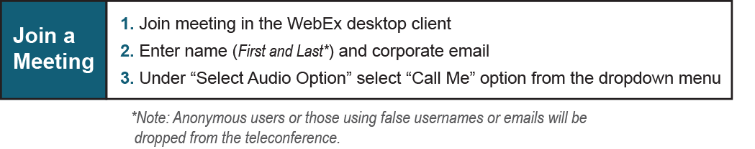

Provide feedback on the progress of this group: Facilitator Feedback Form
Visit learn.pjm.com, an easy-to-understand resource about the power industry and PJM’s role.

