Operating Committee
WebEx Only
November 4, 2021
9:00 a.m. – 2:00 p.m. EDT

Administration (9:00-9:15)
Lauren Strella Wahba, PJM, will provide announcements; review the Antitrust, Code of Conduct, Public Meetings/Media Participation, and the WebEx Participant Identification Requirement.
  - Review and approve draft minutes from the October 7th OC meeting.

  - Review of the OC work plan.

Review of Operations (9:15-9:35)
PJM COVID-19 Update
Paul McGlynn, PJM, will provide an update on PJM’s operations plan in response to COVID-19. https://pjm.com/committees-and-groups/pandemic-coordination.aspx

Review of Operating Metrics
Stephanie Monzon, PJM, will review the October 2021 PJM operating metrics slides. Metrics will include PJM’s load forecast error, BAAL performance, and transmission / generation outage statistics.

Endorsements/Approvals (9:35 – 11:00)
- Manual 03: Transmission Operations
Dean Manno, PJM, will review updates to Manual 3: Transmission Operations as a part of the periodic review. The Operating Committee will be asked to endorse these changes at today’s meeting.

- Manual 10: Pre-Scheduling Operations
Vince Stefanowicz, PJM, will review updates to Manual 10: Pre-Scheduling Operations as a part of the periodic review.
The Operating Committee will be asked to endorse these changes at today’s meeting.

- Manual 14D: Generator Operational Requirements
Vince Stefanowicz, PJM, will review updates to Manual 14D: Generator Operational Requirements as a part of the periodic review.
The Operating Committee will be asked to endorse these changes at today’s meeting.

- Manual 13: Emergency Operations
Brian Oakes, PJM, will review updates to Manual 13: Emergency Operations as part of the periodic review.
The Operating Committee will be asked to endorse these changes at today’s meeting.

- Day Ahead Schedule Reserve (DASR) Update
David Kimmel, PJM, will review preliminary proposed changes to the 2022 Day Ahead Scheduling
Reserve (DASR) requirement.
The Operating Committee will be asked to endorse the changes at today’s meeting.

Winter Weekly Reserve Target Update
Patricio Rocha Garrido, PJM, will review the results of the 2021/22 Winter Weekly Reserve Target
(WWRT) analysis.
The Operating Committee will be asked to endorse the results at today’s meeting.

- Synchronous Reserve Deployment Stakeholder Initiative
a. Ilyana Dropkin, PJM, will provide a summary of the Synchronous Reserve Deployment Stakeholder Initiative.

b. Mike Zhang, PJM, will provide a second read of the PJM package that was developed in the SRDTF.
The Operating Committee will be asked to endorse the solution package at today’s meeting.

c. Siva Josyula, IMM, will proved a first read of the IMM package that was developed in the SRDTF.
The Operating Committee will be asked to endorse the solution package at today’s meeting.

First Reading

Informational Updates (11:00-2:00)
- System Operations Subcommittee (SOS) Report
Becky Carroll, PJM, will provide a summary of the most recent SOS meeting.

- Manual 13 Maximum Emergency Implementation Details
Chris Pilong, PJM, will review the implementation details associated with the temporary Maximum Emergency process in PJM Manual 13 Section 6.4 that was approved at the October 22, 2021 MRC.

- Reliability Products and Services Assessment
Chris Pilong, PJM, and Alex Scheirer, PJM, will present background on the Reliability Products and Services assessment that is to be performed by the OC and provide initial education on related studies and analysis that can contribute to the assessment.
- Operations Assessment Task Force Review (OATF)
Todd Bickel, PJM, will provide a review the OATF winter 2021/22 study.

- Unit Specific Parameters 2022/2023 DY Update
Tom Hauske, PJM, will provide an update on Unit Specific Parameters for the 2022/2023 DY.

- Winter Gas Electric Coordination and Fuels Review
Brian Fitzpatrick, PJM, will provide an overview of winter Gas Electric Coordination activities and a look at current key fuel markets.

- NERC Lessons Learned
Donnie Bielak, PJM, with review the latest posted NERC Lessons Learned reports.

- Reliability Compliance Update
Becky Davis, PJM, will provide an update on NERC, SERC, RF, and NAESB standards, and other pertinent regulatory and compliance information, and solicit feedback from the members on Reliability Compliance efforts.

Working Items

Informational Only Postings

OC Subcommittee/ Task Force Informational Section
System Operations Subcommittee (SOS): SOS Website
Data Management Subcommittee (DMS): DMS Website
DER & Inverter-Based Resources Subcommittee (DIRS): DIRS Website
Fuel Requirements for Black Start Resources: Fuel Reqt. for Black Start Resources Issue Tracker
Synchronous Reserve Deployment Task Force: SRDTF Website
IROL – CIP Cost Recovery: IROL – CIP Cost Recovery Issue Tracker

Future Meeting Dates and Materials |  |  | Materials Due  to Secretary | Materials Published
Date | Time | Location | 5 p.m. | 4 p.m.
December 02, 2021 | 9 a.m. | WebEx | November 22, 2021 | November 24, 2021

Author: L. Strella Wahba

Antitrust:
You may not discuss any topics that violate, or that might appear to violate, the antitrust laws including but not limited to agreements between or among competitors regarding prices, bid and offer practices, availability of service, product design, terms of sale, division of markets, allocation of customers or any other activity that might unreasonably restrain competition. If any of these items are discussed the chair will re-direct the conversation. If the conversation still persists, parties will be asked to leave the meeting or the meeting will be adjourned.

Code of Conduct:
As a mandatory condition of attendance at today's meeting, attendees agree to adhere to the PJM Code of Conduct as detailed in PJM Manual M-34 section 4.5, including, but not limited to, participants' responsibilities and rules regarding the dissemination of meeting discussion and materials.

Public Meetings/Media Participation:
Unless otherwise noted, PJM stakeholder meetings are open to the public and to members of the media. Members of the media are asked to announce their attendance at all PJM stakeholder meetings at the beginning of the meeting or at the point they join a meeting already in progress. Members of the Media are reminded that speakers at PJM meetings cannot be quoted without explicit permission from the speaker. PJM Members are reminded that "detailed transcriptional meeting notes" and white board notes from "brainstorming sessions" shall not be disseminated. Stakeholders are also not allowed to create audio, video or online recordings of PJM meetings. PJM may create audio, video or online recordings of stakeholder meetings for internal and training purposes, and your participation at such meetings indicates your consent to the same.
Participant Identification in WebEx:
When logging into the WebEx desktop client, please enter your real first and last name as well as a valid email address. Be sure to select the “call me” option.
PJM support staff continuously monitors WebEx connections during stakeholder meetings. Anonymous users or those using false usernames or emails will be dropped from the teleconference.

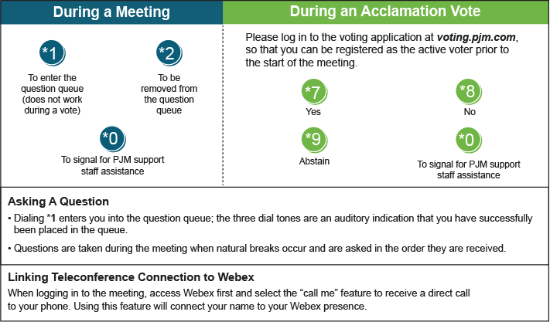

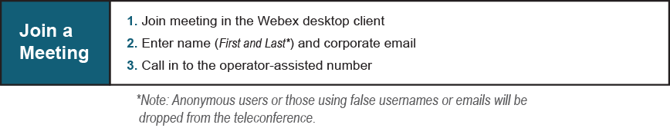
Provide feedback on the progress of this group: Facilitator Feedback Form
Visit learn.pjm.com, an easy-to-understand resource about the power industry and PJM’s role.

