Markets & Reliability Committee
Webex Only
November 17, 2021
9:00 a.m. – 12:00 p.m. EPT
*Operator assisted phone lines will be opened 30 minutes prior to the start of the meeting. Due to the high volume of remote participation, stakeholders are asked to connect early to allow additional time for operator queue processing.

Administration (9:00-9:05)
Welcome, announcements and Anti-trust, Code of Conduct, and Public Meetings/Media Participation – Stu Bresler and Dave Anders

Consent Agenda (9:05-9:10)
- Approve minutes of the October 20, 2021 meeting of the Markets and Reliability Committee (MRC).
- Endorse proposed revisions to Manual 01 Attachment F: Control Center and Data Exchange Requirements (MOC Remote Operations) related to Exceptional Circumstances outside of COVID-19.
- Endorse proposed revisions to Manual 03: Transmission Operations resulting from its periodic review.
- Endorse proposed revisions to Manual 13: Emergency Operations resulting from its periodic review.
- Endorse proposed revisions to Manual 14F: Competitive Planning Process addressing changes to the proposal fee structure to conform to the PJM Operating Agreement.
- Endorse proposed revisions to Manual 19: Load Forecasting and Analysis resulting from its biennial review.
- Endorse final proposed changes to the 2022 Day Ahead Scheduling Reserve (DASR) requirement.

Endorsements (9:10-9:30)
- Sunset of the Carbon Pricing Senior Task Force (9:10-9:20)
- Eric Hsia will review a recommendation to sunset the Carbon Pricing Senior Task Force (CPSTF).
- Adrien Ford, ODEC, will move to sunset the Carbon Pricing Senior Task Force (CPSTF). The committee will be asked to endorse sunsetting the CPSTF.

- Sunset of the High Voltage Direct Current Senior Task Force (9:20-9:30)
Carl Johnson, PJM Public Power Coalition on behalf of American Municipal Power, will move to sunset the High Voltage Direct Current Senior Task Force (HVDCSTF). The committee will be asked to endorse the motion to sunset the HVDCSTF.

First Readings (9:30-12:00)
- Solar-Battery Hybrid Resources (9:30-10:00)
Andrew Levitt and Thomas DeVita will review a proposed solution package to address various aspects of market participation by solar-battery hybrid resources. The committee will be asked to endorse the proposed solution and corresponding Tariff and Operating Agreement (OA) revisions at its next meeting.
Issue Tracking: Solar-Battery Hybrid Resources
- Transparency Forum (10:00-10:20)
Greg Poulos, on behalf of the New Jersey Division of the Rate Counsel, will review a proposed Charter for the creation of a new Transparency Forum. The committee will be asked to approve the proposed Charter at its next meeting.
- Undefined Regulation Mileage Ratio Calculation (10:20-10:45)
- Adam Keech will discuss next steps of the Undefined Regulation Mileage Ratio proposal in light of the failed vote at the October MRC.
- Danielle Croop will review a Problem Statement and Issue Charge addressing broader Regulation Market redesign. The committee will be asked to approve the proposed Charter at its next meeting.
Issue Tracking: Undefined Regulation Mileage Ratio Calculation
- Synchronous Reserve Deployment Stakeholder Initiative (10:45-11:10)
Mike Zhang will review a proposed solution package addressing synchronous reserve deployment. The committee will be asked to endorse the proposed solution and corresponding Tariff and OA revisions at its next meeting.
Issue Tracking: Synchronized Reserve Event Actions and Expectations
- Tariff Attachment DD Revisions (11:10-11:30)
Janell Fabiano and Chenchao Lu will review proposed revisions to Tariff Attachment DD as endorsed by the Governing Document Enhancement and Clarification Subcommittee (GDECS). The committee will be asked to endorse the proposed revisions at its next meeting.

- PJM Manuals (11:30-12:00)
- Emmy Messina will review proposed revisions to Manual 06: Financial Transmission Rights conforming to the AFMTF PJM/Joint Stakeholder package endorsed at the October MRC. The committee will be asked to endorse the revisions at its next meeting.
Issue Tracking: ARR/FTR Market Review
- Vince Stefanowicz will review proposed revisions to Manual 10: Pre-Scheduling Operations resulting from its periodic review. The committee will be asked to endorse the revisions at its next meeting.
- Michael Herman will provide a review of Manual 14B revisions resulting from its biennial review. The committee will be asked to endorse the proposed revisions at its next meeting.
- Vince Stefanowicz will review proposed revisions to Manual 14D: Generator Operational Requirements resulting from its periodic review. The committee will be asked to endorse the revisions at its next meeting.

Future Agenda Items (12:00)

Future Meeting Dates and Materials |  |  |  | Materials Due  to Secretary | Materials Published
Date | Time | Location
December 15, 2021 | 9:00 a.m. |  | WebEx | December 3, 2021 | December 8, 2021
January 26, 2022 | 9:00 a.m. |  | TBD | January 14, 2022 | January 19, 2022
February 24, 2022 | 9:00 a.m. |  | TBD | February 14, 2022 | February 17, 2022
March 23, 2022 | 9:00 a.m. |  | TBD | March 11, 2022 | March 16, 2022
April 27, 2022 | 9:00 a.m. |  | TBD | April 15, 2022 | April 20, 2022
May 25, 2022 | 9:00 a.m. |  | TBD | May 13, 2022 | May 18, 2022
June 29, 2022 | 9:00 a.m. |  | TBD | June 17, 2022 | June 22, 2022

Author: M. Greening

Antitrust:
You may not discuss any topics that violate, or that might appear to violate, the antitrust laws including but not limited to agreements between or among competitors regarding prices, bid and offer practices, availability of service, product design, terms of sale, division of markets, allocation of customers or any other activity that might unreasonably restrain competition. If any of these items are discussed the chair will re-direct the conversation. If the conversation still persists, parties will be asked to leave the meeting or the meeting will be adjourned.

Code of Conduct:
As a mandatory condition of attendance at today's meeting, attendees agree to adhere to the PJM Code of Conduct as detailed in PJM Manual M-34 section 4.5, including, but not limited to, participants' responsibilities and rules regarding the dissemination of meeting discussion and materials.

Public Meetings/Media Participation:
Unless otherwise noted, PJM stakeholder meetings are open to the public and to members of the media. Members of the media are asked to announce their attendance at all PJM stakeholder meetings at the beginning of the meeting or at the point they join a meeting already in progress. Members of the Media are reminded that speakers at PJM meetings cannot be quoted without explicit permission from the speaker. PJM Members are reminded that "detailed transcriptional meeting notes" and white board notes from "brainstorming sessions" shall not be disseminated. Stakeholders are also not allowed to create audio, video or online recordings of PJM meetings. PJM may create audio, video or online recordings of stakeholder meetings for internal and training purposes, and your participation at such meetings indicates your consent to the same.
Participant Identification in Webex:
When logging into the Webex desktop client, please enter your real first and last name as well as a valid email address. Be sure to select the “call me” option.
PJM support staff continuously monitors Webex connections during stakeholder meetings. Anonymous users or those using false usernames or emails will be dropped from the teleconference.

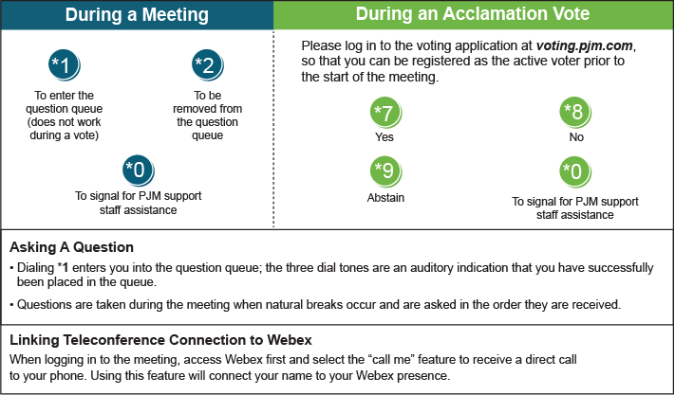

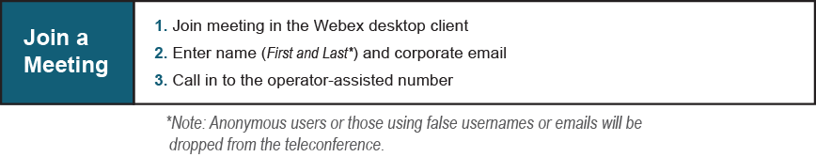
Provide feedback on the progress of this group: Facilitator Feedback Form
Visit learn.pjm.com, an easy-to-understand resource about the power industry and PJM’s role.

