Markets and Reliability Committee
Webex Only
January 27, 2021
9:00 a.m. – 1:15 p.m.
*Operator assisted phone lines will be opened 30 minutes prior to the start of the meeting. Due to the high volume of remote participation, stakeholders are asked to connect early to allow additional time for operator queue processing.

Administration (9:00-9:05)
Welcome, announcements and Anti-trust, Code of Conduct, and Public Meetings/Media Participation – Stu Bresler and Dave Anders

Consent Agenda (9:05-9:10)
- Approve minutes of the December 17, 2020 meeting of the Markets and Reliability Committee (MRC).
- Endorse proposed revisions to Manual 6: Financial Transmission Rights addressing the enforcement of FTR Bid Limits at the corporate entity level.
- Endorse proposed revisions to Manual 12: Balancing Operations resulting from the periodic review.
- Endorse proposed revisions to Manual 13: Emergency Operations resulting from the periodic review.
- Endorse proposed revisions to Manual 18: PJM Capacity Market conforming to the FERC-ordered rule changes in the Minimum Offer Price Rule and Forward Energy & Ancillary Services Offset dockets (Docket Nos. EL16-49-003, EL18-178-003, ER18- 1314-006 and EL19-58).
Issue Tracking: Capacity Market Minimum Offer Price Rule (MOPR) Order
- Endorse proposed revisions to Manual 38: Operations Planning resulting from the periodic review.

Endorsements/Approvals (9:10-11:30)
- Manual 14C Revisions (9:10-9:30)
Mark Sims will review proposed revisions to Manual 14C: Generation and Transmission Interconnection Facility Construction as part of the biennial cover-to-cover review. The committee will be asked to endorse the revisions.
- Real Time Values Market Rules (9:30-9:50)
Laura Walter will review a solution package addressing Real Time Values Market Rules and corresponding revisions to Manual 11: Energy & Ancillary Services Market Operations, Tariff Attachment K and Operating Agreement (OA) Schedule 1. The committee will be asked to endorse the solution package and corresponding revisions.
Issue Tracking: Real Time Market Values
- PRD Credits Disposition (9:50-10:10)
Pete Langbein will review a proposed solution package addressing the disposition of PRD credits and corresponding revisions to Manual 11: Energy & Ancillary Services Market Operations, Manual 18: PJM Capacity Market, OA, Tariff, and Reliability Assurance Agreement (RAA). The committee will be asked to endorse the solution package and corresponding revisions.
Issue Tracking: Price Responsive Demand (PRD) Credits Disposition
- Stability Limits in Markets and Operations (10:10-10:50)
- Lisa Morelli will provide an overview of the MIC’s work activities and related procedural history for the Stability Limits in Markets and Operations issue.
- Joe Ciabattoni will review a proposed Capacity Constraint solution package and corresponding Operating Agreement (OA) and Tariff revisions.
- Paul Sotkiewicz, on behalf of JPower, will review a proposed Opportunity Cost solution package.
The committee will be asked to endorse a solution package and corresponding revisions.
Issue Tracking: Stability Limits in Markets and Operations
- Black Start Unit Testing, CRF, Involuntary Termination, MTSL and Substitution Rules (10:50-11:30)
Becky Davis will review proposed solution packages addressing Black Start Unit Involuntary Termination, Substitution Rules, Capital Recovery Factor (CRF) and Minimum Tank Suction Level (MTSL) and corresponding revisions to the Tariff, Manual 12: Balancing Operations, Manual 14D: Generator Operational Requirements, and Manual 15: Cost Development Guidelines. The committee will be asked to endorse a proposed solution.
Black Start Unit Involuntary Termination & Substitution Rules

First Readings (11:30-1:00)
- Black Start Unit Testing, CRF, Involuntary Termination, MTSL and Substitution Rules including Existing Resources (11:30-11:50)
Greg Poulos, on behalf of Delaware Division of the Public Advocate, will review a proposed solution package addressing Black Start Unit Involuntary Termination, Substitution Rules, Capital Recovery Factor (CRF) and Minimum Tank Suction Level (MTSL) that includes existing resources.
- Storage as a Transmission Asset (SATA) (11:50-12:30)
  - Michele Greening will provide an overview of the SATA work activities and timeline.
  - Jeffrey Goldberg will review the proposed solution package addressing storage as a transmission asset.
  - Pauline Foley will review Tariff and OA revisions supporting the solution package.
  - Sharon Segner, LS Power, intends to propose a friendly amendment to this agenda item. Related materials have been posted with this agenda item in addition to under agenda item 8.
The committee will be asked to endorse the proposed solution and revisions at its next meeting.
Issue Tracking: Storage As a Transmission Asset
- Competitive Exemption OA Revisions for SATA Resources (12:30-12:50)
Sharon Segner, LS Power, will review proposed OA revisions regarding the competitive procurement exemption – immediate need process related to SATA resources. The committee will be asked to endorse the revisions at a future meeting.
- PJM Manuals (12:50-1:00)
  - Maureen Curley will review proposed revisions to Manual 40: Training and Certification Requirements resulting from the periodic review. The committee will be asked to endorse the revisions at its next meeting.

Informational Reports (1:00-1:15)
- Recent FERC Order Regarding the Capacity Market (1:00-1:15)
Chen Lu will provide an update on the recent FERC Order regarding the Capacity Market.

Informational Posting Only

Future Agenda Items (1:15)

Future Meeting Dates
February 24, 2021 | 9:00 a.m. | WebEx
March 24, 2021 | 9:00 a.m. | WebEx
April 21, 2021 | 9:00 a.m. | WebEx
May 26, 2021 | 9:00 a.m. | WebEx
June 23, 2021 | 9:00 a.m. | WebEx
July 28, 2021 | 9:00 a.m. | TBD
August 25, 2021 | 9:00 a.m. | TBD
September 29, 2021 | 9:00 a.m. | TBD
October 20, 2021 | 9:00 a.m. | TBD
November 17, 2021 | 9:00 a.m. | TBD
December 15, 2021 | 9:00 a.m. | TBD

Author: M. Greening

Antitrust:
You may not discuss any topics that violate, or that might appear to violate, the antitrust laws including but not limited to agreements between or among competitors regarding prices, bid and offer practices, availability of service, product design, terms of sale, division of markets, allocation of customers or any other activity that might unreasonably restrain competition. If any of these items are discussed the chair will re-direct the conversation. If the conversation still persists, parties will be asked to leave the meeting or the meeting will be adjourned.

Code of Conduct:
As a mandatory condition of attendance at today's meeting, attendees agree to adhere to the PJM Code of Conduct as detailed in PJM Manual M-34 section 4.5, including, but not limited to, participants' responsibilities and rules regarding the dissemination of meeting discussion and materials.

Public Meetings/Media Participation:
Unless otherwise noted, PJM stakeholder meetings are open to the public and to members of the media. Members of the media are asked to announce their attendance at all PJM stakeholder meetings at the beginning of the meeting or at the point they join a meeting already in progress. Members of the Media are reminded that speakers at PJM meetings cannot be quoted without explicit permission from the speaker. PJM Members are reminded that "detailed transcriptional meeting notes" and white board notes from "brainstorming sessions" shall not be disseminated. Stakeholders are also not allowed to create audio, video or online recordings of PJM meetings. PJM may create audio, video or online recordings of stakeholder meetings for internal and training purposes, and your participation at such meetings indicates your consent to the same.
Participant Identification in WebEx:
When logging into the WebEx desktop client, please enter your real first and last name as well as a valid email address. Be sure to select the “call me” option.
PJM support staff continuously monitors WebEx connections during stakeholder meetings. Anonymous users or those using false usernames or emails will be dropped from the teleconference.

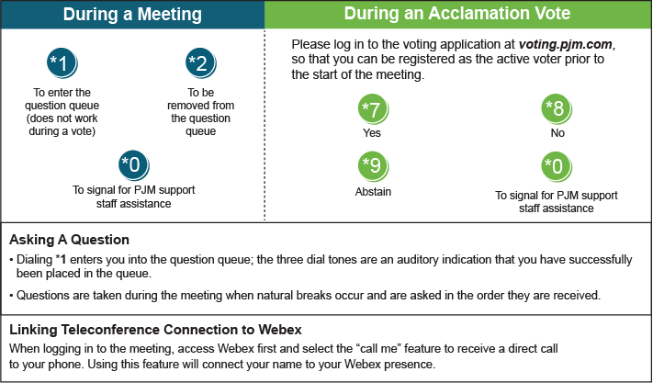

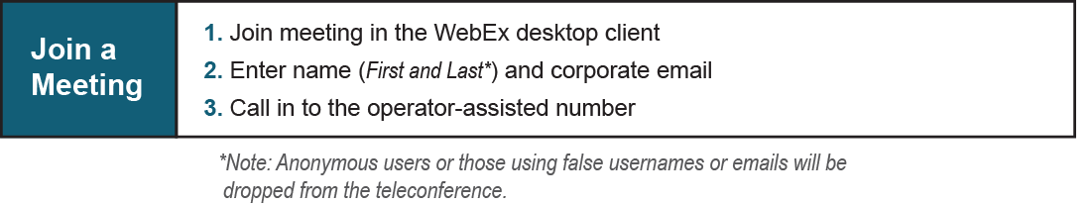
Provide feedback on the progress of this group: Facilitator Feedback Form
Visit learn.pjm.com, an easy-to-understand resource about the power industry and PJM’s role.

