Markets and Reliability Committee
Webex Only
June 18, 2020
9:00 a.m. – 10:25 a.m.
*Operator assisted phone lines will be opened 30 minutes prior to the start of the meeting. Due to the high volume of remote participation, stakeholders are asked to connect early to allow additional time for operator queue processing.

Administration (9:00-9:05)
Welcome, announcements and Anti-trust, Code of Conduct, and Public Meetings/Media Participation – Stu Bresler and Dave Anders

Consent Agenda (9:05-9:10)
- Approve minutes of the May 28, 2020 meeting of the Markets and Reliability Committee (MRC).
- Endorse clarifying and administrative changes to Manuals 14A: New Services Request Process, 14E: Upgrade and Transmission Interconnection Requests, and 14G: Generation Interconnection Requests identified as part of the periodic review.

Endorsements/Approvals (9:10-9:35)
- Emerging Technologies Forum (9:10-9:20)
Eric Hsia will review a new proposed forum addressing Emerging Technologies. The committee will be asked to endorse the charter.
- Stakeholder Group Sunsets (9:20-9:35)
Dave Anders will present a proposed list of stakeholder groups for sunset. The committee will be asked to endorse the stakeholder group sunsets.

First Readings (9:35-10:25)
- Five Minute Dispatch and Pricing (9:35-10:00)
Adam Keech will provide an update regarding Five Minute Dispatch and Pricing and will review a proposed solution addressing the short-term. The committee will be asked to endorse the proposed solution at its next meeting.
Issue Tracking: Five Minute Dispatch and Pricing
- Tariff Clean-up Revisions (10:00-10:10)
Jacqui Hugee will provide a review of Tariff clean-up revisions related to PJM’s recent market participation risk evaluation enhancements filing. The committee will be asked to endorse the proposed revisions at its next meeting.

- PJM Manuals (10:10-10:25)
  - Emmy Messina will review administrative updates to Manual 6: Financial Transmission Rights as part of the periodic review. The committee will be asked to endorse the proposed revisions at its next meeting.

  - Ray Fernandez will review updates to Manual 14D: Generator Operational Requirements and Manual 27: Open Access Transmission Tariff Accounting related to changes to deadlines for adjustments associated with finalizing the zonal network service peak load values. The committee will be asked to endorse the proposed revisions at its next meeting

Informational Reports
None

Informational Postings Only
None

Future Agenda Items (10:25)

Future Meeting Dates
July 23, 2020 | 9:00 a.m. | PJM Conference & Training Center/ WebEx
August 20, 2020 | 9:00 a.m. | PJM Conference & Training Center/ WebEx
September 17, 2020 | 9:00 a.m. | PJM Conference & Training Center/ WebEx
October 29, 2020 | 9:00 a.m. | PJM Conference & Training Center/ WebEx
November 19, 2020 | 9:00 a.m. | PJM Conference & Training Center/ WebEx
December 17, 2020 | 9:00 a.m. | PJM Conference & Training Center/ WebEx
Author: M. Greening

Antitrust:
You may not discuss any topics that violate, or that might appear to violate, the antitrust laws including but not limited to agreements between or among competitors regarding prices, bid and offer practices, availability of service, product design, terms of sale, division of markets, allocation of customers or any other activity that might unreasonably restrain competition. If any of these items are discussed the chair will re-direct the conversation. If the conversation still persists, parties will be asked to leave the meeting or the meeting will be adjourned.

Code of Conduct:
As a mandatory condition of attendance at today's meeting, attendees agree to adhere to the PJM Code of Conduct as detailed in PJM Manual M-34 section 4.5, including, but not limited to, participants' responsibilities and rules regarding the dissemination of meeting discussion and materials.

Public Meetings/Media Participation:
Unless otherwise noted, PJM stakeholder meetings are open to the public and to members of the media. Members of the media are asked to announce their attendance at all PJM stakeholder meetings at the beginning of the meeting or at the point they join a meeting already in progress. Members of the Media are reminded that speakers at PJM meetings cannot be quoted without explicit permission from the speaker. PJM Members are reminded that "detailed transcriptional meeting notes" and white board notes from "brainstorming sessions" shall not be disseminated. Stakeholders are also not allowed to create audio, video or online recordings of PJM meetings. PJM may create audio, video or online recordings of stakeholder meetings for internal and training purposes, and your participation at such meetings indicates your consent to the same.
Participant Identification in WebEx:
When logging into the WebEx desktop client, please enter your real first and last name as well as a valid email address. Be sure to select the “call me” option.
PJM support staff continuously monitors WebEx connections during stakeholder meetings. Anonymous users or those using false usernames or emails will be dropped from the teleconference.

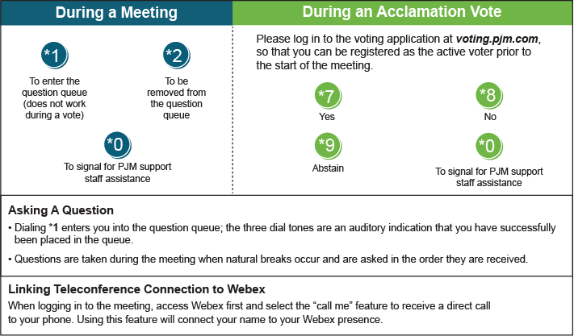

Provide feedback on the progress of this group: Facilitator Feedback Form
Visit learn.pjm.com, an easy-to-understand resource about the power industry and PJM’s role.

