Market Implementation Committee
WebEx Only
January 12, 2021
9:00 a.m. – 4:00 p.m. EPT

Administration (9:00-9:10)
Nicholas DiSciullo will review the Antitrust, Code of Conduct, Public Meetings/Media Participation and the WebEx Participant Identification Requirements.

The Committee will be asked to approve the draft minutes from the December 2, 2020 Market Implementation Committee meeting.

2021 MIC Work Plan

Endorsements/Approvals (9:10 – 9:40)
- Manual 18: Minimum Offer Price Rule Changes (9:10 – 9:25)
Jeff Bastian will review updates to Manual 18: PJM Capacity Market. These changes conform with the FERC-ordered rule changes in the Minimum Offer Price Rule and Forward Energy & Ancillary Services Offset dockets (Docket Nos. EL16-49-003, EL18-178-003, ER18- 1314-006 and EL19-58).
The committee will be asked to endorse the Manual 18 revisions at this meeting.
Issue Tracking: Capacity Market Minimum Offer Price Rule (MOPR) Order

- PRD Credits Disposition (9:25 – 9:40)
Pete Langbein will review the BGE proposal addressing the PRD Credits Disposition issue.
The committee will be asked to endorse the proposal at this meeting. If the package receives greater than 50%, a second non-binding poll will be taken asking whether participants prefer the package over the status quo.
Issue Tracking: Price Responsive Demand (PRD) Credits Disposition

First Readings (9:40 – 10:50)
- Capital Recovery Factor for Avoidable Project Investment Cost Determinations (9:40 – 10:10)
Jeff Bastian will provide a first read of the Problem Statement and Issue Charge addressing Capital Recovery Factor for Avoidable Project Investment Cost Determinations.
The committee will be asked to approve the issue charge and solution as part of the Quick Fix process outlined in Section 8.6.1 of Manual 34 at the February MIC meeting.

- Long-Term 5-Minute Dispatch & Pricing Work Plan (10:10 – 10:30)
Aaron Baizman will provide an update on the Long Term Timeline and will provide a first read of the solution package from the Long-Term Five Minute Dispatch & Pricing Matrix that was worked in MIC Special Session meetings.
The committee will be asked to endorse the proposal at the February MIC meeting.
Issue Tracking: Five Minute Dispatch and Pricing
- RPM Capacity Transfer Rights (10:30 – 10:50)
Kevin Zemanek, Buckeye Power will provide a first read of the Problem Statement and Issue Charge addressing RPM Capacity Transfer Rights. The committee will be asked to approve the Issue Charge at the February MIC meeting.

Working Items (10:50 - 12:05)
- Market Suspension (10:50 – 11:35)
Stefan Starkov will provide education on the Market Suspension issue, highlighting common causes of manual economic dispatch, conditions that can prevent a zonal dispatch rate calculation, and a possible approach for determining clearing prices during a Market Suspension event.
Issue Tracking: Rules Related to Market Suspension

- Transparency in Performance Assessment Interval Settlements (11:35 – 12:05)
Susan Kenney, PJM, will review two of the areas identified as needing additional transparency in PAI Settlements, both related to unit modeling.
Issue Tracking: Transparency in Performance Assessment Interval (PAI) Settlements

Lunch (12:05 - 1:00)

Additional Items (1:00 – 2:10)
- PPL Dynamic Line Ratings (1:00 – 1:15)
David Quier, PPL, will present PPL’s Dynamic Line Ratings Implementation Plan.

- Minimum Offer Price Rule Floor Prices (1:15 – 1:40)
Natalie Tacka will provide an overview of the default MOPR floor prices for new entry resources, which were posted on December 18, 2020.
Issue Tracking: Capacity Market Minimum Offer Price Rule (MOPR) Order

- Fast Start Pricing Order Overview (1:40 – 2:00)
Thomas DeVita will provide an overview of the FERC Order on PJM’s Fast Start Pricing compliance filing in docket ER19-2722.

- ELCC Deficiency Letter Response (2:00 – 2:10)
Andrew Levitt, PJM, and Thomas DeVita, PJM, will discuss considerations related to the questions raised by the ELCC deficiency letter issued by FERC in docket ER21-278 and solicit stakeholder feedback.

Informational Section
CP Unit Specific Parameter Update
Materials are posted as informational only.

Interregional Coordination Update
Materials are posted as informational only.

Credit Subcommittee (CS)
Meeting materials are posted to the CS website.

Demand Response Subcommittee (DRS)
Meeting materials are posted to the DRS website.

DER & Inverter-based Resources Subcommittee (DIRS)
Meeting materials are posted to the DIRS website.

Market Settlements Subcommittee (MSS)
Meeting materials are posted to the MSS website.

Report on Market Operations
The Report on Market Operations will be reviewed during the MC Webinar.

Future Meeting Dates
February 10, 2021 | 9:00 a.m. | WebEx
March 10, 2021 | 9:00 a.m. | WebEx
April 7, 2021 | 9:00 a.m. | WebEx
May 13, 2021 | 9:00 a.m. | WebEx
June 9, 2021 | 9:00 a.m. | WebEx
July 14, 2021 | 9:00 a.m. | WebEx
August 11, 2021 | 9:00 a.m. | WebEx
September 9, 2021 | 9:00 a.m. | WebEx
October 6, 2021 | 9:00 a.m. | WebEx
November 3, 2021 | 9:00 a.m. | WebEx
December 1, 2021 | 9:00 a.m. | WebEx

Author: Nick DiSciullo

Antitrust:
You may not discuss any topics that violate, or that might appear to violate, the antitrust laws including but not limited to agreements between or among competitors regarding prices, bid and offer practices, availability of service, product design, terms of sale, division of markets, allocation of customers or any other activity that might unreasonably restrain competition. If any of these items are discussed the chair will re-direct the conversation. If the conversation still persists, parties will be asked to leave the meeting or the meeting will be adjourned.

Code of Conduct:
As a mandatory condition of attendance at today's meeting, attendees agree to adhere to the PJM Code of Conduct as detailed in PJM Manual M-34 section 4.5, including, but not limited to, participants' responsibilities and rules regarding the dissemination of meeting discussion and materials.

Public Meetings/Media Participation:
Unless otherwise noted, PJM stakeholder meetings are open to the public and to members of the media. Members of the media are asked to announce their attendance at all PJM stakeholder meetings at the beginning of the meeting or at the point they join a meeting already in progress. Members of the Media are reminded that speakers at PJM meetings cannot be quoted without explicit permission from the speaker. PJM Members are reminded that "detailed transcriptional meeting notes" and white board notes from "brainstorming sessions" shall not be disseminated. Stakeholders are also not allowed to create audio, video or online recordings of PJM meetings. PJM may create audio, video or online recordings of stakeholder meetings for internal and training purposes, and your participation at such meetings indicates your consent to the same.
Participant Identification in WebEx:
When logging into the WebEx desktop client, please enter your real first and last name as well as a valid email address. Be sure to select the “call me” option.
PJM support staff continuously monitors WebEx connections during stakeholder meetings. Anonymous users or those using false usernames or emails will be dropped from the teleconference.
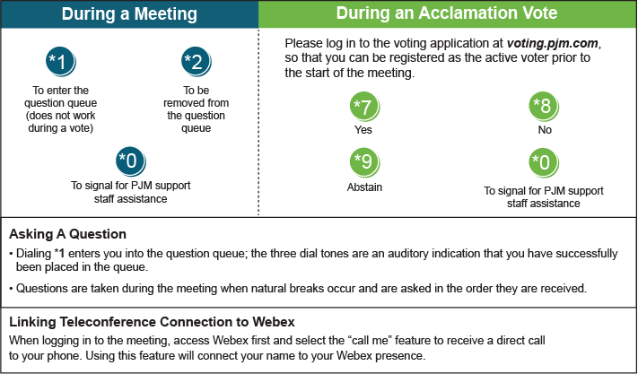

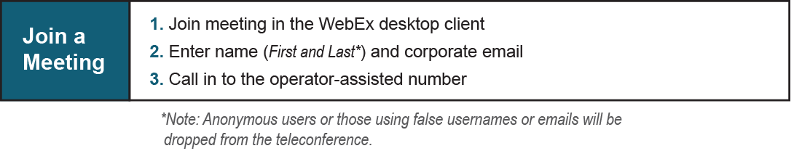
Provide feedback on the progress of this group: Facilitator Feedback Form
Visit learn.pjm.com, an easy-to-understand resource about the power industry and PJM’s role.

