Market Implementation Committee
WebEx Only
October 7 2020
9:00 a.m. – 4:00 p.m. EPT

Administration (9:00-9:05)
Nicholas DiSciullo will review the Antitrust, Code of Conduct, Public Meetings/Media Participation and the WebEx Participant Identification Requirements.

The Committee will be asked to approve the draft minutes from the September 2, 2020 Market Implementation Committee meeting.

Endorsements/Approvals (9:05 – 9:55)
- Behind the Meter Generation (9:05 – 9:20)
Terri Esterly will review the Problem Statement and Issue Charge addressing clarifications to the Behind the Meter Generation business rules related to a BTMG unit changing status from BTMG (netting against the load) to a resource participating in PJM Markets (and vice versa).
The committee will be asked to approve the problem statement and issue charge at this meeting.

- Biennial Review of Manual 15 (9:20 – 9:40)
Gabrielle Genuario and Roger Cao will review updates to Manual 15 as part of the Biennial Review.
The committee will be asked to endorse the Manual 15 revisions at this meeting.

- Manual 18 Updates (9:40 – 9:55)
Jeff Bastian will review the Problem Statement and Issue Charge addressing a minor correction to Manual 18 with regards to an effective date for notifying pseudo-tied resource owners of their assigned LDA prior to each delivery year.
The committee will be asked to approve the issue charge and endorse the proposed revisions to Manual 18 as part of the Quick Fix process outlined in Section 8.6.1 of Manual 34 at this meeting.

First Readings (9:55 - 11:10)
- Fuel Cost Policy Enhancements (9:55 – 10:25)
- Bhavana Keshavamurthy will provide a first read of the PSEG proposal addressing Key Work Activity 4 of the Fuel Cost Policy Enhancements Issue Charge.
- Catherine Tyler, Monitoring Analytics, will present the IMM’s comments.

Issue Tracking: Fuel Cost Policy

- Real Time Values Market Rules (10:25 – 10:55)
- Lauren Strella Wahba will provide an update on the work completed during the MIC Special Session meetings and will review the solution packages from the Real Time Values Market Rules matrix.
- The IMM will present the details of their package on the Real Time Values issue.

Issue Tracking: Real Time Market Values

- Manual 11 Revisions (10:55 – 11:10)
Vijay Shah will review proposed updates to Manual 11: Energy & Ancillary Services Market Operations. The changes are around increasing transparency and conforming to current PJM process as part of the 5 minute Dispatch and Pricing Problem Statement.

Issue Tracking: Five Minute Dispatch and Pricing

Working Items (11:10 - 12:10)
- Market Suspension (11:10 – 11:40)
Stefan Starkov will lead a discussion on the Market Suspension issue, addressing the first 4 items of Phase 1 from the Issue Charge.

Issue Tracking: Rules Related to Market Suspension

- PRD Credits Disposition (11:40 – 12:10)
Lisa Morelli will facilitate a discussion to identify interests and design components for the PRD Credits Disposition issue charge.

Issue Tracking: Price Responsive Demand (PRD) Credits Disposition

Lunch (12:10 – 12:40)

Additional Items (12:40 – 1:35)
- Fast Start Pricing Implementation (12:40 – 12:55)
Phil D’Antonio will provide an update on the tentative plan for the Fast Start Pricing implementation.

- Extended Transmission Outage Winter 2020-21 (12:55 – 1:00)
Marilyn Jayachandran will provide a review of an extended outage that will occur over the upcoming winter.

- CP Unit Specific Parameter Update (1:00 – 1:05)
Lauren Strella Wahba will provide an update on the CP Unit Specific Parameters process.

- Long-Term 5-Minute Dispatch & Pricing Work Plan (1:05 – 1:20)
Aaron Baizman will provide an update on the work plan to address the Long-Term 5-Minute Dispatch & Pricing effort.

- Capacity Capability Senior Task Force Update (1:20 – 1:35)
Andrew Levitt will provide an overview on the ELCC data submission requirements and applicable deadlines by delivery year for intermittent and limited duration resources.

Informational Section
FTR Auction Bid Limit Reminder
Materials are posted as informational only.

Manual 03 Changes
Materials provide an overview of changes made to Manual 3 as part of the periodic review. Materials are posted as informational only.

Manual 03 Attachment E Automatic Sectionalizing Schemes
This document is posted in accordance with requirements stated in Manual 3, Section 5. Materials are posted as informational only.

Interregional Coordination Update
Materials are posted as informational only.

Credit Subcommittee (CS)
Meeting materials will be posted to the CS website.

Demand Response Subcommittee (DRS)
Meeting materials will be posted to the DRS website.

DER & Inverter-based Resources Subcommittee (DIRS)
Meeting materials will be posted to the DIRS website.

Market Settlements Subcommittee (MSS)
Meeting materials are posted to the MSS website.

Report on Market Operations
The Report on Market Operations will be reviewed during the MC Webinar.

Future Meeting Dates
November 5, 2020 | 9:00 a.m. | WebEx
December 2, 2020 | 9:00 a.m. | WebEx

Author: Nick DiSciullo

Antitrust:
You may not discuss any topics that violate, or that might appear to violate, the antitrust laws including but not limited to agreements between or among competitors regarding prices, bid and offer practices, availability of service, product design, terms of sale, division of markets, allocation of customers or any other activity that might unreasonably restrain competition. If any of these items are discussed the chair will re-direct the conversation. If the conversation still persists, parties will be asked to leave the meeting or the meeting will be adjourned.

Code of Conduct:
As a mandatory condition of attendance at today's meeting, attendees agree to adhere to the PJM Code of Conduct as detailed in PJM Manual M-34 section 4.5, including, but not limited to, participants' responsibilities and rules regarding the dissemination of meeting discussion and materials.

Public Meetings/Media Participation:
Unless otherwise noted, PJM stakeholder meetings are open to the public and to members of the media. Members of the media are asked to announce their attendance at all PJM stakeholder meetings at the beginning of the meeting or at the point they join a meeting already in progress. Members of the Media are reminded that speakers at PJM meetings cannot be quoted without explicit permission from the speaker. PJM Members are reminded that "detailed transcriptional meeting notes" and white board notes from "brainstorming sessions" shall not be disseminated. Stakeholders are also not allowed to create audio, video or online recordings of PJM meetings. PJM may create audio, video or online recordings of stakeholder meetings for internal and training purposes, and your participation at such meetings indicates your consent to the same.
Participant Identification in WebEx:
When logging into the WebEx desktop client, please enter your real first and last name as well as a valid email address. Be sure to select the “call me” option.
PJM support staff continuously monitors WebEx connections during stakeholder meetings. Anonymous users or those using false usernames or emails will be dropped from the teleconference.
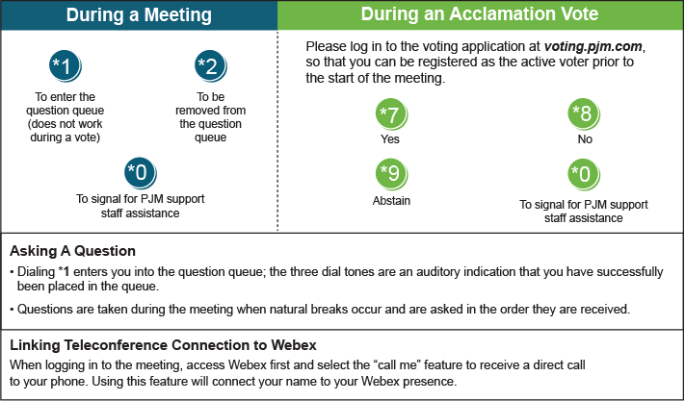

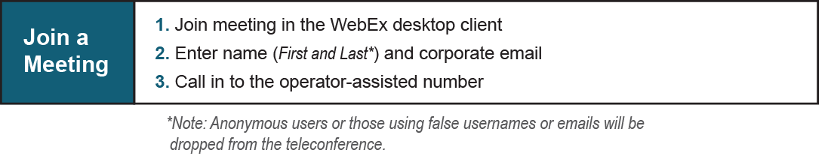
Provide feedback on the progress of this group: Facilitator Feedback Form
Visit learn.pjm.com, an easy-to-understand resource about the power industry and PJM’s role.

