Market Implementation Committee
PJM Conference & Training Center, Audubon, PA
October 10, 2018
9:00 a.m. – 4:00 p.m. EPT

Administration (9:00-9:30)
Ms. Bhavana Keshavamurthy and Ms. Chantal Hendrzak will provide announcements; review the Antitrust, Code of Conduct, Public Meetings/Media Participation, the WebEx Participant Identification Requirement, and Issue Tracking.

The Committee will be asked to approve the draft minutes from the September 12, 2018 MIC meeting.

        - Ms. Lisa Drauschak, PJM, will provide an overview of lessons learned from the GreenHat default and an update from the special workshop on FTRs.

Endorsements/Approvals (9:30-10:45)
- Must Offer Exception Process (9:30-10:00)
        - Mr. Pat Bruno, PJM, will present the updated PJM package.
        - Mr. Joe Bowring, Monitoring Analytics, will present the IMM package.
Issue Tracking: Must Offer Exemption Process
The committee will be asked to vote on the package. If the package receives greater than 50%, a second non-binding vote will be taken asking whether participants prefer that package over the status quo.

- Pseudo Tie Overlapping Congestion (10:00-10:15)
        - Ms.Nikki Militello, PJM, will present changes to Manual 11 related to Pseudo Tie Overlapping Congestion.
        - Mr. Ray Fernandez, PJM, will present changes to Manual 28 related to Pseudo Tie Overlapping Congestion.
The committee will be asked to endorse changes to Manual 11 and Manual 28.

- Annual Review of Manual 6 (10:15-10:30)
Mr. Brian Chmielewski, PJM, will present changes to Manual 6 as part of the Annual Review.
The committee will be asked to endorse changes to Manual 6.

- Surety Bonds (10:30-10:45)
        - Mr. Hal Loomis, PJM, will present the results of a Credit Subcommittee poll on accepting Surety Bonds as an additional form of collateral and review the two packages.
        - Ms. Sharon Midgley, Exelon, will review the Exelon proposal.
Issue Tracking: Surety Bonds Opportunity
The committee will be asked to vote on the packages. If any package receives greater than 50%, a second non-binding vote will be taken asking whether participants prefer that package over the status quo.

First Readings (10:45-12:15)
- FTR Forfeiture Rule (10:45-11:15)
        - Mr.Chris Carpenter, VECO will provide a presentation on the FTR Impact Test.
        - Mr. Brian Chmielewski, PJM, will present a first read of the PJM proposal. Members are encouraged to review the posted matrix and provide additional proposals to: FTRGroup@pjm.com.
Issue Tracking: FTR Forfeiture Rule Changes
- Gas Pipeline Contingencies (11:15-11:45)
Mr. Rich Brown, PJM, will present a first read of the Gas Contingency Costs proposals.
Issue Tracking: Gas Pipeline Contingencies

- Day Ahead Market Timeline Update(11:45-12:00)
Mr. Keyur Patel, PJM, will present a first read of the tariff changes related to the changes to the Day Ahead Timeline.

- Biennial Review of Manual 27 (12:00-12:15)
Mr. Ray Fernandez, PJM, will present a first read of Manual 27 changes as part of the Biennial Review.

Lunch (12:15 – 1:00)

Additional Items (1:00-1:45)
- Electric Storage Participation FERC Order 841 (1:00-1:15)
Ms. Laura Walter, PJM will present the PJM straw proposal for compliance with FERC Order 841 to be filed by December 3, 2018.
Issue Tracking: Electric Storage Participation FERC Order 841

- Retirement of Mount Washington RAS(1:15-1:30)
Mr. Caleb Kim, BGE will provide an update on the retirement of the Mount Washington Remedial Action Scheme (RAS).

- Bright Ideas Update (1:30-1:45)
Ms. Rebecca Stadelmeyer, PJM will review the Bright Ideas initiative, which recommendations have been implemented to date and which recommendations are scheduled for future releases.

Informational Section
Credit Subcommittee (CS)
Meeting materials will be posted to the CS website.

Demand Response Subcommittee (DRS)
Meeting materials will be posted to the DRS web site.

Intermittent Resources Subcommittee (IRS)
Meeting materials will be posted to the IRS web site.

Interregional Coordination Update
Materials are posted as informational only.

Net Energy Injections Quarterly Report
Materials are posted as informational only.

Market Settlements Subcommittee (MSS)
Meeting materials are posted to the MSS web site.

Report on Market Operations
The Report on Market Operations will be reviewed during the MC Webinar.

Future Meeting Dates
November 7, 2018 | 9:00 a.m. | PJM Conference & Training Center/ WebEx
December 12, 2018 | 9:00 a.m. | PJM Conference & Training Center/ WebEx
January 9, 2019 | 9:00 a.m. | PJM Conference & Training Center/ WebEx
February 6, 2019 | 9:00 a.m. | PJM Conference & Training Center/ WebEx
March 6, 2019 | 9:00 a.m. | PJM Conference & Training Center/ WebEx
April 10, 2019 | 9:00 a.m. | PJM Conference & Training Center/ WebEx
May 15, 2019 | 9:00 a.m. | PJM Conference & Training Center/ WebEx
June 12, 2019 | 9:00 a.m. | PJM Conference & Training Center/ WebEx

Author: Bhavana Keshavamurthy

Antitrust:
You may not discuss any topics that violate, or that might appear to violate, the antitrust laws including but not limited to agreements between or among competitors regarding prices, bid and offer practices, availability of service, product design, terms of sale, division of markets, allocation of customers or any other activity that might unreasonably restrain competition. If any of these items are discussed the chair will re-direct the conversation. If the conversation still persists, parties will be asked to leave the meeting or the meeting will be adjourned.

Code of Conduct:
As a mandatory condition of attendance at today's meeting, attendees agree to adhere to the PJM Code of Conduct as detailed in PJM Manual M-34 section 4.5, including, but not limited to, participants' responsibilities and rules regarding the dissemination of meeting discussion and materials.

Public Meetings/Media Participation:
Unless otherwise noted, PJM stakeholder meetings are open to the public and to members of the media. Members of the media are asked to announce their attendance at all PJM stakeholder meetings at the beginning of the meeting or at the point they join a meeting already in progress. Members of the Media are reminded that speakers at PJM meetings cannot be quoted without explicit permission from the speaker. PJM Members are reminded that "detailed transcriptional meeting notes" and white board notes from "brainstorming sessions" shall not be disseminated. Stakeholders are also not allowed to create audio, video or online recordings of PJM meetings. PJM may create audio, video or online recordings of stakeholder meetings for internal and training purposes, and your participation at such meetings indicates your consent to the same.

Participant Identification in WebEx:
When logging into the WebEx desktop client, please enter your real first and last name as well as a valid email address. Be sure to select the “call me” option.
PJM support staff continuously monitors WebEx connections during stakeholder meetings. Anonymous users or those using false usernames or emails will be dropped from the teleconference.

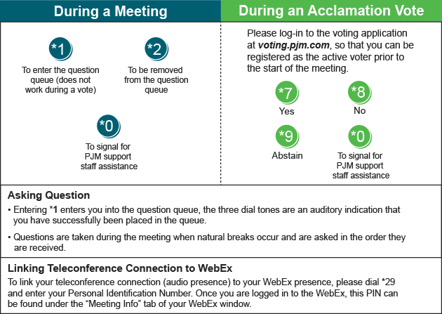

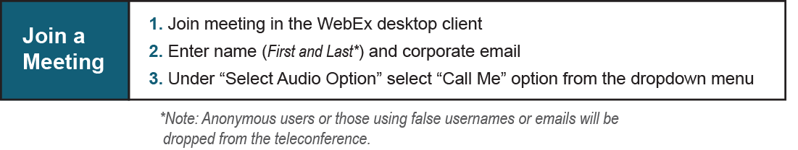

Provide feedback on the progress of this group: Facilitator Feedback Form
Visit learn.pjm.com, an easy-to-understand resource about the power industry and PJM’s role.

