Market Implementation Committee
PJM Conference & Training Center, Audubon, PA
May 11, 2016
9:30 a.m. – 2:30 p.m. EPT

Administration (9:30-9:40)
Welcome, announcements and review of the Antitrust, Code of Conduct, and Public Meetings/Media Participation Guidelines – Ms. Christina Stotesbury

Mr. Todd Keech, PJM, will provide a brief update regarding the extension of the Day-Ahead Market.
Mr. Tong Zhao, PJM, will review required schedule updates in Markets Gateway.

Approve draft minutes from the April 6, 2016 Market Implementation Committee meeting.

Review MIC Issue Tracking

Endorsements/Approvals (9:40-9:55)
Manual 11 – Day-Ahead Scheduling Reserve (9:40-9:55)
Mr. Keyur Patel, PJM, will review a problem statement and issue charge for changes to Manual 11 – Energy & Ancillary Services Market Operations for the Day-Ahead Scheduling Reserve (DASR). The committee will be asked to endorse the problem statement and issue charge.

First Readings (9:55-11:35)
Biennial Review for Manual 15 – Cost Development Guidelines (9:55-10:10)
Mr. Keyur Patel, PJM, will present changes to Manual 15 – Cost Development Guidelines as part of the periodic review process. The Committee will be asked to endorse these changes at the June Market Implementation Committee meeting.

Periodic Review for Manual 28 – Operating Agreement Accounting (10:10-10:25)
Mr. Ray Fernandez, PJM, will present changes to Manual 28 – Operating Agreement Accounting as part of the periodic review process. The Committee will be asked to endorse these changes at the June Market Implementation Committee meeting.

PLS Exception Process (10:25-10:40)
Mr. Tong Zhao, PJM, and Ms. Jacqui Hugee, PJM, will present a PLS Exception process proposal for consideration. The Committee will be asked to endorse this proposal at the June Market Implementation Committee meeting.

Auction Specific Bilateral Transactions (10:40-10:55)
Ms. Jen Tribulski, PJM, will present PJM’s proposed solution on Auction Specific Bilateral Transactions. The Committee will be asked to endorse this proposal at the June Market Implementation Committee meeting.

Break (10:55-11:05)

Open Registration for Demand Response Problem Statement and Issue Charge (11:05-11:20)
Mr. Bruce Campbell, EnergyConnect, will present a problem statement and issue charge concerning the registration submission deadline for Demand Response resources. The Committee will be asked to endorse the problem statement and issue charge at the June Market Implementation Committee meeting.

Residual ARR Enhancements Problem Statement and Issue Charge (11:20-11:35)
Ms. Sharon Midgley, Exelon, and Mr. Jeff Whitehead, Direct Energy, will present a problem statement and issue charge to discuss potential enhancements to the Residual Auction Revenue Rights (ARR) process. The Committee will be asked to endorse the problem statement and issue charge at the June Market Implementation Committee meeting.

Informational Updates (11:35-1:30)
Tariff-Required Report on MOPR Net Short/New Long Analysis for 2020/2021 Auctions (11:35-11:50)
Mr. Jeff Bastian, PJM, will report on analysis of the Maximum Net Short and Net Long positions as much as are used in the Minimum Offer Price Rule as required under the Tariff.

Net Energy Injections Quarterly Report (11:50-12:10)
Mr. Ken Schuyler, PJM, will provide an update on the first quarter Net Energy Injections report.

Lunch (12:10-1:00)

Inter-Regional Coordination Activity (1:00-1:30)
- Mr. Stan Williams, PJM, will provide an update on inter-regional coordination efforts.
- Mr. Asanga Perera, PJM, will provide an update on the PJM-MISO and PJM-TVA JOA and JRCA revisions.

Working Issues (1:30-2:30)
Operating Parameter Discussion (1:30-2:00)
Mr. Tom Hauske, PJM, will provide education and continue the discussion around un-nesting Operating Parameter definitions in Manuals 11, 15 and 28.
Issue Tracking: Operating Parameter Definitions

Release of Capacity in 17/18 Delivery Year 3rd Incremental Auction (2:00-2:30)
Mr. Jeff Bastian, PJM, will initiate a discussion in response to the reporting directive in FERC Docket ER16-532 concerning the release of annual capacity in the 2017/2018 Delivery Year 3rd Incremental Auction related to excess capacity procured in the Capacity Performance Transition Incremental Auction.

Informational Section
Report on Market Operations
The Report on Market Operations will be reviewed during the Members Committee meeting on May 19, 2016.

MIC Working Session Updates
Energy Scheduling
Energy Scheduling was put on hold to allow for further discussion at Joint and Common Market (JCM) meetings. Interface pricing became more narrowly focused and a document was issued to provide clarification around this issue. The other outstanding issue is related to the IMO Pricing Point, which PJM is working with Monitoring Analytics to define. Additional clarification will be provided when available.
Issue Tracking: Energy Scheduling

FTR Forfeiture
The last MIC working session was held on February 18, 2014. PJM submitted comments to the FERC related to Docket No. EL14-37-000 in June 2015, and is awaiting a FERC Order. Meeting materials are posted to the MIC web site.
Issue Tracking: FTR Forfeiture

Up-To Congestion Transactions
A MIC working session was held on June 10, 2014. This issue has been put on hold to allow greater concentration on the remaining issues in the stakeholder process that have more pressing completion date requirements. When available, materials will be posted to the MIC web site.
Issue Tracking: Up To Congestion Transactions – Financial and Node Limitation

Subcommittee and Task Force Updates
Credit Subcommittee (CS)
Meeting materials will be posted to the CS website.

Demand Response Subcommittee (DRS)
Meeting materials will be posted to the DRS web site.

Intermittent Resources Subcommittee (IRS)
Meeting materials will be posted to the IRS web site.

Market Settlements Subcommittee (MSS)
Meeting materials are posted to the MSS web site.

Future Meeting Dates
June 8, 2016 | 9:30 a.m. | PJM Interconnection – Conference & Training Center
July 13, 2016 | 9:30 a.m. | PJM Interconnection – Conference & Training Center
August 10, 2016 | 9:30 a.m. | PJM Interconnection – Conference & Training Center
September, 14, 2016 | 9:30 a.m. | PJM Interconnection – Conference & Training Center
October 5, 2016 | 9:30 a.m. | PJM Interconnection – Conference & Training Center
November 2, 2016 | 9:30 a.m. | PJM Interconnection – Conference & Training Center
December 14, 2016 | 9:30 a.m. | PJM Interconnection – Conference & Training Center

Author: Christina Stotesbury

Antitrust:
You may not discuss any topics that violate, or that might appear to violate, the antitrust laws including but not limited to agreements between or among competitors regarding prices, bid and offer practices, availability of service, product design, terms of sale, division of markets, allocation of customers or any other activity that might unreasonably restrain competition. If any of these items are discussed the chair will re-direct the conversation. If the conversation still persists, parties will be asked to leave the meeting or the meeting will be adjourned.

Code of Conduct:
As a mandatory condition of attendance at today's meeting, attendees agree to adhere to the PJM Code of Conduct as detailed in PJM Manual M-34 section 4.5, including, but not limited to, participants' responsibilities and rules regarding the dissemination of meeting discussion and materials.

Public Meetings/Media Participation:
Unless otherwise noted, PJM stakeholder meetings are open to the public and to members of the media. Members of the media are asked to announce their attendance at all PJM stakeholder meetings at the beginning of the meeting or at the point they join a meeting already in progress. Members of the Media are reminded that speakers at PJM meetings cannot be quoted without explicit permission from the speaker. PJM Members are reminded that "detailed transcriptional meeting notes" and white board notes from "brainstorming sessions" shall not be disseminated. Stakeholders are also not allowed to create audio, video or online recordings of PJM meetings.

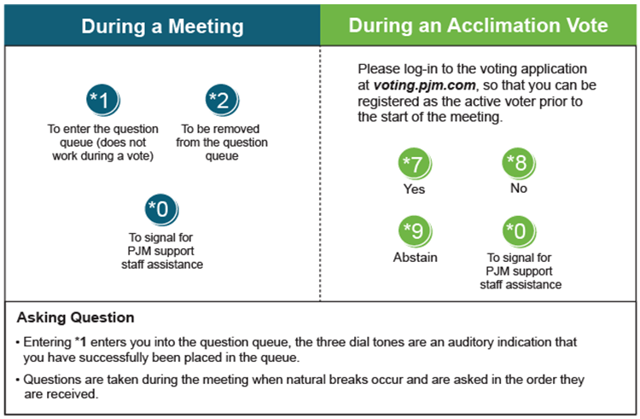

Facilitator Feedback Form: http://www.pjm.com/committees-and-groups/committees/form-facilitator-feedback.aspx

