Members Committee

Two Hundred Twenty-eighth Meeting

PJM Conference and Training Center / Webex

July 27, 2022

10:45 a.m. – 5:00 p.m. EPT

***\*Operator assisted phone lines will be opened 30 minutes prior to the start of the meeting. Due to the high volume of remote participation, stakeholders are asked to connect early to allow additional time for operator queue processing.***

Administration (10:45-10:55)

1. Announce sector selections of new members since the last meeting – Dave Anders
2. Confirm the presence of a quorum of representatives or designated alternates for this meeting – Dave Anders
3. Anti-trust, Code of Conduct, Meeting Participation, and Safety announcements – Dave Anders

Consent Agenda (10:55-11:00)

1. **Approve** draft minutes of the June 29, 2022 Members Committee meeting.
2. **Endorse/Approve** proposed revisions addressing Start-Up Cost Offer Development in Manual 15: Cost Development Guidelines, Tariff definitions and Attachment K, and Operating Agreement definitions and Schedules 1 and 2.

[Issue Tracking: Start-up Cost Offer Development](https://www.pjm.com/committees-and-groups/issue-tracking/issue-tracking-details.aspx?Issue=46ced1bf-a450-4c80-9199-08ec2be2f4cb)

Endorsements (11:00-11:35)

1. Manual 34 – CBIR Matrix Solutions Options (11:00-11:10)

John Horstmann, Dayton Power & Light, will move and Adrien Ford, ODEC, will second proposed revisions to Manual 34: PJM Stakeholder Process seeking to improve Consensus Based Issue Resolution (CBIR) matrix development efficiency by initially adding options to the blank matrix prior to posting. **The committee will be asked to approve the proposed Manual 34 revisions.**

1. Market Seller Offer Cap (11:10-11:35)

Dave Anders and Pat Bruno will review proposed revisions to the Market Seller Offer Cap (MSOC). **The committee will be asked to endorse the proposed Tariff revisions. Same day endorsement may be sought at the MRC and MC for the Tariff revisions.**

[Issue Tracking: Capacity Market Reform](https://www.pjm.com/committees-and-groups/issue-tracking/issue-tracking-details.aspx?Issue=d0505dad-6dca-43b3-9334-bd8aba2a16e9)

Reports (11:35-12:35)

1. 2022 PJM Annual Meeting (11:35-11:45)

Michele Greening will provide an update regarding the upcoming 2022 PJM Annual Meeting (Part II).

1. Notice of Anticipated Section 206 Filing Regarding Operating Agreement Language on Designated Entity Agreements and Notice of Consultation to the Members Committee Related to a Possible Section 205 Filing (11:45-12:10)

Pauline Foley will provide notice regarding an anticipated Section 206 filing regarding OA language on Designated Entity Agreements and notice of consultation related to a possible Section 205 filing:

PJM anticipates making a filing pursuant to Section 206 of the Federal Power Act asserting that the Operating Agreement is unjust and unreasonable as it relates to the implementation of Designated Entity Agreements. ~~The specific course of action depends in part on the resolution of the related Problem Statement/Issue Charges at the July 27, 2022 MRC.~~ PJM does not anticipate proposing a replacement rate at the time of filing.

In accordance with Tariff, section 9.2(b) and the Consolidated Transmission Owners Agreement, section 7.5.1(ii), PJM hereby provides notice of consultation to the Members Committee preceding a potential filing pursuant to Section 205 of the Federal Power Act to revise the *pro forma* Designated Entity Agreement set forth in Tariff, Attachment KK.

1. MC Vice Chair Report (12:10-12:20)
2. Provide an update on the Members Committee Annual Plan – Becky Robinson
3. Provide a report on the July 11, 2022 Liaison Committee meeting with the PJM Board of Managers – Becky Robinson
4. Webinar Feedback (12:20-12:35)

Stakeholders may raise any items identified for further discussion from the July 25, 2022 Members Committee Webinar.

* 1. Feedback and/or continued discussion of the Illinois Citizen Utility Board proposed revisions to amend OA, Section 7.2 to include an additional Board qualification as discussed at the MC Webinar.

|  |
| --- |
| Future Agenda Items (12:35) |
|  |

|  |  |  |  |  |  |  |
| --- | --- | --- | --- | --- | --- | --- |
| **Future Meeting Dates and Materials** | | | | | **Materials Due  to Secretary** | **Materials Published** |
| Date | Time | | Location | |  |  |
| September 21, 2022 | | 1:15 p.m. | | PJM Conference & Training Center and WebEx | September 9, 2022 | September 14, 2022 |
| October 26, 2022 | | 9:00 a.m. | | Hyatt Regency Chesapeake Bay Golf Resort, Spa and Marina in Cambridge, MD | October 14, 2022 | October 19, 2022 |
| November 16, 2022 | | 1:15 p.m. | | PJM Conference & Training Center and WebEx | November 4, 2022 | November 9, 2022 |
| December 21, 2022 | | 1:15 p.m. | | PJM Conference & Training Center and WebEx | December 9, 2022 | December 14, 2022 |

Author: M. Greening

Antitrust:

You may not discuss any topics that violate, or that might appear to violate, the antitrust laws including but not limited to agreements between or among competitors regarding prices, bid and offer practices, availability of service, product design, terms of sale, division of markets, allocation of customers or any other activity that might unreasonably restrain competition. If any of these items are discussed the chair will re-direct the conversation. If the conversation still persists, parties will be asked to leave the meeting or the meeting will be adjourned.

Code of Conduct:

As a mandatory condition of attendance at today's meeting, attendees agree to adhere to the PJM Code of Conduct as detailed in PJM Manual M-34 section 4.5, including, but not limited to, participants' responsibilities and rules regarding the dissemination of meeting discussion and materials.

Public Meetings/Media Participation:

Unless otherwise noted, PJM stakeholder meetings are open to the public and to members of the media. Members of the media are asked to announce their attendance at all PJM stakeholder meetings at the beginning of the meeting or at the point they join a meeting already in progress. Members of the Media are reminded that speakers at PJM meetings cannot be quoted without explicit permission from the speaker. PJM Members are reminded that "detailed transcriptional meeting notes" and white board notes from "brainstorming sessions" shall not be disseminated. Stakeholders are also not allowed to create audio, video or online recordings of PJM meetings. PJM may create audio, video or online recordings of stakeholder meetings for internal and training purposes, and your participation at such meetings indicates your consent to the same.

Participant Identification in Webex:

When logging into the Webex desktop client, please enter your real first and last name as well as a valid email address. Be sure to select the “call me” option.

PJM support staff continuously monitors Webex connections during stakeholder meetings. Anonymous users or those using false usernames or emails will be dropped from the teleconference.

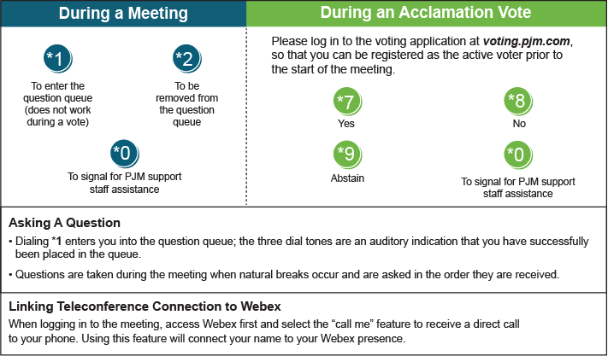

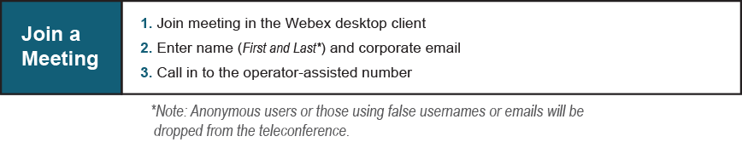

Provide feedback on the progress of this group: [*Facilitator Feedback Form*](https://www.pjm.com/committees-and-groups/committees/form-facilitator-feedback.aspx)   
Visit [*learn.pjm.com*](https://learn.pjm.com/), an easy-to-understand resource about the power industry and PJM’s role.