Members Committee

Two Hundred Twenty-third Meeting

Webex Only

March 23, 2022

1:15 p.m. – 5:00 p.m. EPT

***\*Operator assisted phone lines will be opened 30 minutes prior to the start of the meeting. Due to the high volume of remote participation, stakeholders are asked to connect early to allow additional time for operator queue processing.***

Administration (1:15-1:25)

1. Announce sector selections of new members since the last meeting. – Dave Anders
2. Confirm the presence of a quorum of representatives or designated alternates for this meeting – Dave Anders
3. Anti-trust, Code of Conduct, Meeting Participation, and Safety announcements – Dave Anders

Motion to Amend the Agenda: Steve Lieberman, American Municipal Power, will move, and Bruce Bleiweis, DC Energy, will second a motion to amend the agenda to permit preferential rank voting to occur following voting on the alternatives under 1B, presuming the Members vote to suspend the truncated voting rules under Item 1B-1.

Consent Agenda (1:25-1:30)

1. **Approve** draft minutes of the February 18, 2022 Special Members Committee meeting.
2. **Approve** draft minutes of the February 24, 2022 Members Committee meeting.

Endorsements (1:30-2:30)

1. FTR Credit Requirement including Historical Simulation Initial Margin – Consultation with the Members Committee pursuant to PJM Tariff, Section 9.2(b) in advance of a potential PJM filing under Federal Power Act Section 205
2. Nigeria Bloczynski, PJM, will provide an update on the recent FERC order regarding FTR Credit Requirements for Historical Simulation Initial Margin and will discuss next steps.
3. Steve Lieberman, American Municipal Power, will move, and Bruce Bleiweis, DC Energy, will second the following motions:
   * 1. Approve waiving the rules in Manual 34 section 9.7, Motion Voting Order, to allow voting more than one motion (i.e. NOT to use truncated voting).
     2. Endorse the FTR Credit Requirement revisions, including the HSIM Initial Margining proposal, filed by PJM on December 21, 2021, as amended, **with the 97% confidence interval (CI) accompanied by some new supporting rationale**.
     3. Endorse the FTR Credit Requirement revisions, including the HSIM Initial Margining proposal, filed by PJM on December 21, 2021, as amended, **replacing the 97% confidence interval (CI) with the 99% CI**.
     4. Endorse the FTR Credit Requirement revisions, including the HSIM Initial Margining proposal, filed by PJM on December 21, 2021, as amended, **with the 97% confidence interval (CI), and then moving to the 99% CI in one year**.

**The committee will be asked to vote on the above motions upon first read.**

First Reads (2:30-2:45)

1. Manual 34 Revision - Paper Ballot Voting

Michele Greening will review proposed revisions to Manual 34: Stakeholder Process to update the paper ballot process. The committee will be asked to approve the proposed Manual 34 revisions at its next meeting.

Reports (2:45-3:00)

1. MC Vice Chair Report (2:45-2:55)
2. Provide an update on the Members Committee Annual Plan – Becky Robinson
3. Provide a report on the April 19, 2022 Liaison Committee meeting with the PJM Board of Managers – Becky Robinson
4. Webinar Feedback (2:55-3:00)

Stakeholders may raise any items identified for further discussion from the March 21, 2022 Members Committee Webinar.

|  |
| --- |
| **Future Agenda Items (3:00)** |
|  |

|  |  |  |  |  |  |  |  |  |
| --- | --- | --- | --- | --- | --- | --- | --- | --- |
| **Future Meeting Dates and Materials** | | | | | | **Materials Due  to Secretary** | | **Materials Published** |
| **Date** | **Time** | | **Location** | |  | |  | |
| ***March 23, 2022*** | | 1:15 p.m. | | WebEx | March 11, 2022 | | March 16, 2022 | |
| ***April 27, 2022*** | | 1:15 p.m. | | WebEx | April 15, 2022 | | April 20, 2022 | |
| ***May 17, 2022*** | | 10:00 a.m. | | PJM Conference & Training Center and WebEx | May 5, 2022 | | May 10, 2022 | |
| ***June 29, 2022*** | | 1:15 p.m. | | PJM Conference & Training Center and WebEx | June 17, 2022 | | June 22, 2022 | |
| ***July 27, 2022*** | | 9:00 a.m. | | PJM Conference & Training Center and WebEx | July 15, 2022 | | July 20, 2022 | |
| ***September 21, 2022*** | | 9:00 a.m. | | PJM Conference & Training Center and WebEx | September 9, 2022 | | September 14, 2022 | |
| ***\* October 26, 2022 *tentative dates & time*** | | *\* 9:00 a.m.* | | *Off-site TBD* | *\* October 14, 2022* | | *\* October 19, 2022* | |
| ***November 16, 2022*** | | 9:00 a.m. | | PJM Conference & Training Center and WebEx | November 4, 2022 | | November 9, 2022 | |
| ***December 21, 2022*** | | 9:00 a.m. | | PJM Conference & Training Center and WebEx | December 9, 2022 | | December 14, 2022 | |

Author: M. Greening

Antitrust:

You may not discuss any topics that violate, or that might appear to violate, the antitrust laws including but not limited to agreements between or among competitors regarding prices, bid and offer practices, availability of service, product design, terms of sale, division of markets, allocation of customers or any other activity that might unreasonably restrain competition. If any of these items are discussed the chair will re-direct the conversation. If the conversation still persists, parties will be asked to leave the meeting or the meeting will be adjourned.

Code of Conduct:

As a mandatory condition of attendance at today's meeting, attendees agree to adhere to the PJM Code of Conduct as detailed in PJM Manual M-34 section 4.5, including, but not limited to, participants' responsibilities and rules regarding the dissemination of meeting discussion and materials.

Public Meetings/Media Participation:

Unless otherwise noted, PJM stakeholder meetings are open to the public and to members of the media. Members of the media are asked to announce their attendance at all PJM stakeholder meetings at the beginning of the meeting or at the point they join a meeting already in progress. Members of the Media are reminded that speakers at PJM meetings cannot be quoted without explicit permission from the speaker. PJM Members are reminded that "detailed transcriptional meeting notes" and white board notes from "brainstorming sessions" shall not be disseminated. Stakeholders are also not allowed to create audio, video or online recordings of PJM meetings. PJM may create audio, video or online recordings of stakeholder meetings for internal and training purposes, and your participation at such meetings indicates your consent to the same.

Participant Identification in Webex:

When logging into the Webex desktop client, please enter your real first and last name as well as a valid email address. Be sure to select the “call me” option.

PJM support staff continuously monitors Webex connections during stakeholder meetings. Anonymous users or those using false usernames or emails will be dropped from the teleconference.

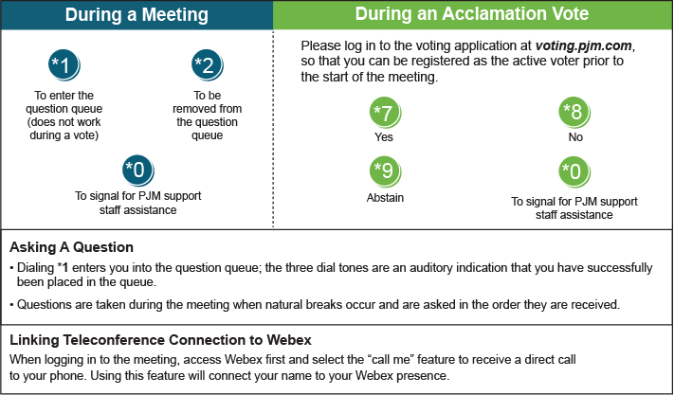

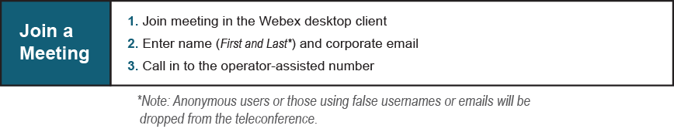

Provide feedback on the progress of this group: [*Facilitator Feedback Form*](https://www.pjm.com/committees-and-groups/committees/form-facilitator-feedback.aspx)   
Visit [*learn.pjm.com*](https://learn.pjm.com/), an easy-to-understand resource about the power industry and PJM’s role.