Members Committee
Two Hundredth Meeting
Webex Only
June 18, 2020
10:30 a.m. – 5:00 p.m. EPT
*Operator assisted phone lines will be opened 30 minutes prior to the start of the meeting. Due to the high volume of remote participation, stakeholders are asked to connect early to allow additional time for operator queue processing.

Administration (10:30-10:35)
- Announce sector selections of new members since the last meeting – David Anders
- Confirm the presence of a quorum of representatives or designated alternates for this meeting – David Anders
- Anti-trust, Code of Conduct, Meeting Participation, and Safety announcements – David Anders

Consent Agenda (10:35- 10:40)
- Approve draft minutes of the May 28, 2020 meeting.
- Endorse proposed Tariff revisions related to Surety Bonds as a form of collateral.
Issue Tracking: Surety Bonds Opportunity

Endorsements/Approvals (10:40-11:35)
- PMA Credit Requirements (10:40-10:50)
Bridgid Cummings will review proposed Tariff revisions related to Peak Market Activity (PMA) credit requirements pertaining to federal, state, and/or local law transfer of charges or credits. The committee will be asked to endorse the proposed Tariff revisions.
Issue Tracking: PMA Credit Requirements for NITS Charges
- Transparency and End Of Life Planning (10:50-11:35)
Joint Stakeholders (AMP, ODEC, LS Power and members of the PJM Industrial Customer Coalition) have requested this agenda item to be added. Joint Stakeholders intend to move their Transparency and End of Life Planning proposal for vote at this meeting.
Issue Tracking: Transparency and End of Life Planning

Reports (11:35-12:05)
- Stakeholder Responsiveness (11:35-11:50)
Jim Gluck and Anita Patel will provide a status of actions PJM is taking based on member feedback and the 2019 stakeholder survey.

- MC Vice Chair Report (11:50-12:00)
- Provide an update on the Members Committee Annual Plan – Katie Guerry
- Provide a report on plans for the July 27, 2020 Liaison Committee meeting with the PJM Board of Managers – Katie Guerry
- Webinar Feedback (12:00-12:05)
Stakeholders may raise any items identified for further discussion from the June 15, 2020 Members Committee Webinar.

Informational Only

Future Agenda Items (12:05)

Future Meeting Dates
July 23, 2020 | 1:15 p.m. | PJM Conference & Training Center/ WebEx
September 17, 2020 | 1:15 p.m. | PJM Conference & Training Center/ WebEx
October 29, 2020 | 1:15 p.m. | PJM Conference & Training Center/ WebEx
November 19, 2020 | 1:15 p.m. | PJM Conference & Training Center/ WebEx
December 17, 2020 | 1:15 p.m. | PJM Conference & Training Center/ WebEx
Author: M. Greening

Antitrust:
You may not discuss any topics that violate, or that might appear to violate, the antitrust laws including but not limited to agreements between or among competitors regarding prices, bid and offer practices, availability of service, product design, terms of sale, division of markets, allocation of customers or any other activity that might unreasonably restrain competition. If any of these items are discussed the chair will re-direct the conversation. If the conversation still persists, parties will be asked to leave the meeting or the meeting will be adjourned.

Code of Conduct:
As a mandatory condition of attendance at today's meeting, attendees agree to adhere to the PJM Code of Conduct as detailed in PJM Manual M-34 section 4.5, including, but not limited to, participants' responsibilities and rules regarding the dissemination of meeting discussion and materials.

Public Meetings/Media Participation:
Unless otherwise noted, PJM stakeholder meetings are open to the public and to members of the media. Members of the media are asked to announce their attendance at all PJM stakeholder meetings at the beginning of the meeting or at the point they join a meeting already in progress. Members of the Media are reminded that speakers at PJM meetings cannot be quoted without explicit permission from the speaker. PJM Members are reminded that "detailed transcriptional meeting notes" and white board notes from "brainstorming sessions" shall not be disseminated. Stakeholders are also not allowed to create audio, video or online recordings of PJM meetings. PJM may create audio, video or online recordings of stakeholder meetings for internal and training purposes, and your participation at such meetings indicates your consent to the same.
Participant Identification in WebEx:
When logging into the WebEx desktop client, please enter your real first and last name as well as a valid email address. Be sure to select the “call me” option.
PJM support staff continuously monitors WebEx connections during stakeholder meetings. Anonymous users or those using false usernames or emails will be dropped from the teleconference.

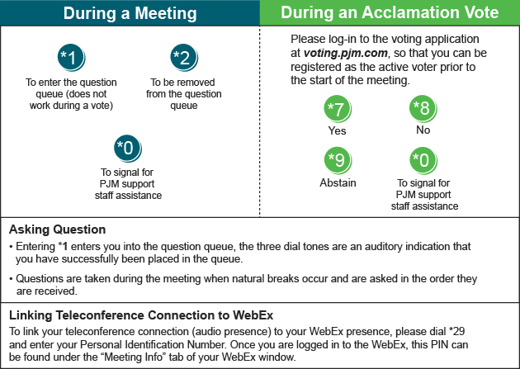

Provide feedback on the progress of this group: Facilitator Feedback Form
Visit learn.pjm.com, an easy-to-understand resource about the power industry and PJM’s role.

