Transmission Expansion Advisory Committee
PJM Conference and Training Center
November 8, 2018
1:00 p.m. – 3:00 p.m. EPT (Actual start time will be dependent upon the completion of the Planning Committee meeting)

Administration (1:00-1:10)
- Welcome, announcements and review of the Anti-trust, Code of Conduct, and Media Participation Guidelines
- Review Transmission Expansion Advisory Committee (TEAC) Agenda for this meeting

RTEP Updates (1:10-3:00)
- Improvements to PJM.com
Tawnya Luna will present an update on the web-based agreements and share a new feature for manual links.
- Interregional Planning Update
Alex Worcester will provide an interregional update on the latest IPSAC and TMEP activity.

- Generator Deactivation Notification Update
Jason Connell will discuss analysis results from the most recently received Generation Deactivation notices.
- Market Efficiency Update
Nick Dumitriu will discuss the 2018 Market Efficiency Re-evaluation analysis and Acceleration analysis. The 2018-2019 Long Term Market Efficiency Window opened on November 2, 2018.

- Dominion Supplemental Projects
Dominion will present the proposed solutions for their supplemental projects.
- Reliability Analysis Update
Aaron Berner will discuss 2018 RTEP baseline recommended solutions and modifications to scope and cost for a Dominion Supplemental project. Next steps of the planning process will also be discussed.

Informational Only
Transmission Owners’ Annual Assumption Meetings:
In accordance with the OATT, Attachment M-3, Transmission Owners will be conducting annual assumptions meetings on December 5th, and December 7th at the three Subregional Committee Meetings. Individuals interested in participating in the assumptions process associated with all Supplemental Projects should plan to attend the appropriate Subregional Committee Meeting(s). Please note that the assumptions presentations provided during the individual meetings, SRRTEP Mid-Atlantic, SRRTEP South, and SRRTEP West, will include those assumptions specific to the Transmission Owners included in those areas.

Future Meeting Dates
December 13, 2018 | 1:00 p.m. Transmission Expansion Advisory Committee | PJM Conference & Training Center/ WebEx

Lisa Krizenoskas

Antitrust:
You may not discuss any topics that violate, or that might appear to violate, the antitrust laws including but not limited to agreements between or among competitors regarding prices, bid and offer practices, availability of service, product design, terms of sale, division of markets, allocation of customers or any other activity that might unreasonably restrain competition. If any of these items are discussed the chair will re-direct the conversation. If the conversation still persists, parties will be asked to leave the meeting or the meeting will be adjourned.

Code of Conduct:
As a mandatory condition of attendance at today's meeting, attendees agree to adhere to the PJM Code of Conduct as detailed in PJM Manual M-34 section 4.5, including, but not limited to, participants' responsibilities and rules regarding the dissemination of meeting discussion and materials.

Public Meetings/Media Participation:
Unless otherwise noted, PJM stakeholder meetings are open to the public and to members of the media. Members of the media are asked to announce their attendance at all PJM stakeholder meetings at the beginning of the meeting or at the point they join a meeting already in progress. Members of the Media are reminded that speakers at PJM meetings cannot be quoted without explicit permission from the speaker. PJM Members are reminded that "detailed transcriptional meeting notes" and white board notes from "brainstorming sessions" shall not be disseminated. Stakeholders are also not allowed to create audio, video or online recordings of PJM meetings. PJM may create audio, video or online recordings of stakeholder meetings for internal and training purposes, and your participation at such meetings indicates your consent to the same.
Participant Identification in WebEx:
When logging into the WebEx desktop client, please enter your real first and last name as well as a valid email address. Be sure to select the “call me” option.
PJM support staff continuously monitors WebEx connections during stakeholder meetings. Anonymous users or those using false usernames or emails will be dropped from the teleconference.



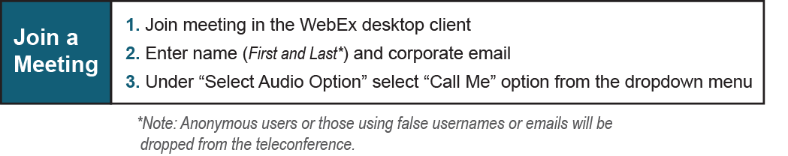

Provide feedback on the progress of this group: Facilitator Feedback Form
Visit learn.pjm.com, an easy-to-understand resource about the power industry and PJM’s role.

