October Planning Committee

**Teleconference / WebEx**

October 4, 2022

9:00 a.m. – 12:00 p.m. EPT

*\*Operator assisted phone lines will be opened 30 minutes prior to the start of the meeting. Due to the high volume of remote participation, stakeholders are asked to connect early to allow additional time for operator queue processing.*

Administration (9:00 – 9:15)

1. Welcome, announcements and review of the Anti-trust, Code of Conduct, and Media Participation Guidelines.
2. Approve Planning Committee (PC) Agenda for this meeting.
3. Approve draft minutes from the September 6, 2022 PC meeting.
4. Review the 2022 PC Work Plan

Endorsements (9:15 – 9:30)

1. 2022 Reserve Requirement Study Results

Patricio Rocha Garrido, PJM, will review the 2022 Reserve Requirement Study results (IRM, FPR, WWRT). The Committee will be requested to endorse the study results at its next meeting.

First Reads

No first reads in October

Informational Updates (9:30 – 10:30)

1. Capacity Interconnection Rights for ELCC Resources & Generator Deliverability Proposal Update

Brian Chmielewski, PJM, will provide an update from the work done in the PC special session on Capacity Interconnection Rights (CIR) for ELCC Resources and Generator Deliverability Proposal.

[Issue Tracking: CIRs for ELCC Resources](https://www.pjm.com/committees-and-groups/issue-tracking/issue-tracking-details.aspx?Issue=83aadda8-b6c1-4630-9483-025b6b93fc28)

Materials for the special sessions can be found [here](https://www.pjm.com/committees-and-groups/committees/pc).

1. Reliability Compliance Update  
   Becky Davis, PJM, will provide an update on the activities, issues and items of interest at NERC, SERC, and RF.
2. Independent Consultant Recommendations for Load Forecast

Andrew Gledhill, PJM, will review the recommendations received from the load forecast model review work with Itron.

CIR for ELCC Resources Special Session (10:30 – 12:00)

1. Capacity Interconnection Rights for ELCC Resources

Brian Chmielewski, PJM, will review the CIR for ELCC resources solution packages and draft polling questions.

Informational Posting

Model Build Activity Update

* MMWG
  + Dynamics
    - PJM has submitted dynamics data, the data has been tested for case initialization
    - PJM is fixing the dynamic data issues identified by the Operation and Planning dynamic data comparison process
  + Loadflow
    - PJM submitted updates to PowerTech for the Trial 4 cases on September 25, 2022
    - PowerTech will provide the pre-final cases for Planning Coordinators to review
    - PJM will request 2023 summer study case updates by October 20, 2022
    - Transmission Owners will submit updates to the 2023 summer study case by October 27, 2022
* RTEP
  + Short Circuit
    - Transmission Owners provided their Trial 0 feedback on September 30, 2022
    - PJM is building the Trial 1 two year case and will send it to the Transmission Owners for review in early January 2023
  + Loadflow
    - PJM will send a request to the Transmission Owners to update tie line data via SharePoint by October 5, 2022
    - PJM will provide the Trial 1 cases for review by October 14, 2022
    - Transmission Owners will provide Behind the Meter generation updates by October 14, 2022

Manual 03 Updates

Updates to PJM Manual 03, Revision 63 – Transmission Operations are posted as informational only with meeting materials.

|  |  |  |  |  |
| --- | --- | --- | --- | --- |
| **Future Meeting Dates and Materials** | | | **Materials Due  to Secretary** | **Materials Published** |
| Date | Time | Meeting (Location) |
| Tuesday,  November 1, 2022 | 9:00 a.m. – 12:00 p.m. | Planning Committee (TBD) | Thursday,  October 20, 2022 | Tuesday,  October 25, 2022 |
| Tuesday,  December 6,2022 | 9:00 a.m. – 12:00 p.m. | Planning Committee (TBD) | Wednesday  November 23, 2022 | Tuesday,  November 29, 2022 |

Author: Marilyn Jayachandran

Antitrust:

You may not discuss any topics that violate, or that might appear to violate, the antitrust laws including but not limited to agreements between or among competitors regarding prices, bid and offer practices, availability of service, product design, terms of sale, division of markets, allocation of customers or any other activity that might unreasonably restrain competition. If any of these items are discussed the chair will re-direct the conversation. If the conversation still persists, parties will be asked to leave the meeting or the meeting will be adjourned.

Code of Conduct:

As a mandatory condition of attendance at today's meeting, attendees agree to adhere to the PJM Code of Conduct as detailed in PJM Manual M-34 section 4.5, including, but not limited to, participants' responsibilities and rules regarding the dissemination of meeting discussion and materials.

Public Meetings/Media Participation:

Unless otherwise noted, PJM stakeholder meetings are open to the public and to members of the media. Members of the media are asked to announce their attendance at all PJM stakeholder meetings at the beginning of the meeting or at the point they join a meeting already in progress. Members of the Media are reminded that speakers at PJM meetings cannot be quoted without explicit permission from the speaker. PJM Members are reminded that "detailed transcriptional meeting notes" and white board notes from "brainstorming sessions" shall not be disseminated. Stakeholders are also not allowed to create audio, video or online recordings of PJM meetings. PJM may create audio, video or online recordings of stakeholder meetings for internal and training purposes, and your participation at such meetings indicates your consent to the same.

Participant Identification in WebEx:

When logging into the WebEx desktop client, please enter your real first and last name as well as a valid email address. Be sure to select the “call me” option.

PJM support staff continuously monitors WebEx connections during stakeholder meetings. Anonymous users or those using false usernames or emails will be dropped from the teleconference.

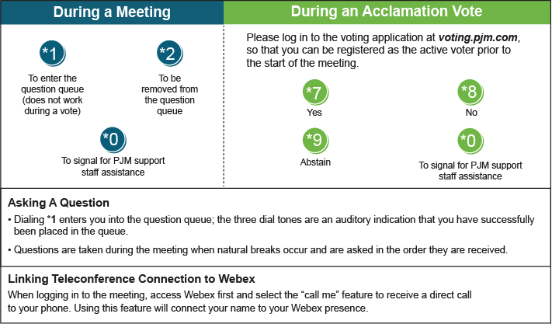

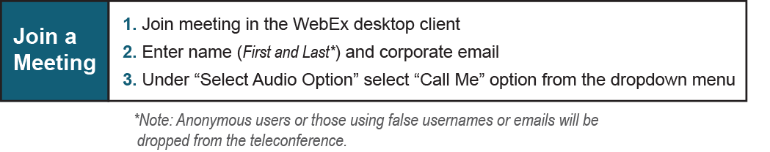

Provide feedback on the progress of this group: *Facilitator Feedback Form*   
Visit [*learn.pjm.com*](http://learn.pjm.com/), an easy-to-understand resource about the power industry and PJM’s role.