July Planning Committee

**Teleconference / WebEx**

July 12, 2022

9:00 a.m. – 12:00 p.m. EPT

*\*Operator assisted phone lines will be opened 30 minutes prior to the start of the meeting. Due to the high volume of remote participation, stakeholders are asked to connect early to allow additional time for operator queue processing.*

Administration (9:00 – 9:15)

1. Welcome, announcements and review of the Anti-trust, Code of Conduct, and Media Participation Guidelines.
2. Approve Planning Committee (PC) Agenda for this meeting.
3. Approve draft minutes from the June 07 2022 PC meeting.
4. Review the 2022 PC Work Plan

Endorsements

No endorsement items in July 2022

First Reads (9:15 – 9:30)

1. Load Model Selection   
   Patricio Rocha-Garrido will present the results of the Load Model selection process for the 2022 Reserve Requirement Study. The committee will be requested to endorse this Load Model selection at the August meeting.

Informational Updates (9:30 – 12:00)

1. Capacity Interconnection Rights for ELCC Resources Update

Brian Chmielewski, PJM, will provide an update from the work done in the PC special session on Capacity Interconnection Rights (CIR) for ELCC Resources.

[Issue Tracking: CIRs for ELCC Resources](https://www.pjm.com/committees-and-groups/issue-tracking/issue-tracking-details.aspx?Issue=83aadda8-b6c1-4630-9483-025b6b93fc28)

Materials for the special sessions can be found [here](https://www.pjm.com/committees-and-groups/committees/pc).

1. Reliability Compliance Update  
   Becky Davis, PJM, will provide an update on the activities, issues and items of interest at NERC, SERC, and RF.
2. Informational Update on NOPRs
3. Jason Connell, PJM, will provide an update on RM22-14-000, Notice of Proposed Rulemaking (“NOPR”), Improvements to Generator Interconnection Procedures and Agreements ( “Interconnection NOPR”)
4. Sami Abdulsalam, PJM, will provide an update on RM22-10-000 Notice of Proposed Rulemaking on Transmission System Planning Performance Requirements for Extreme Weather (“NOPR on Planning Performance for Extreme Weather”).
5. Simon Tam, PJM, will provide an update on RM22-16-000, Notice of Proposed Rulemaking to propose to direct Transmission Providers to submit one-time informational reports on extreme weather vulnerability assessments, climate change, extreme weather and electric system reliability (“One-Time Information Report NOPR”).
6. GMD Steady State Voltage Performance Update

Stanley Sliwa, PJM, will provide an overview of the criteria to establish acceptable system steady state voltage performance during a GMD event per TPL-007-4 Requirement R3.

1. Generator Deliverability Education

Jonathan Kern, PJM, will provide an update on the gen deliverability timeline and education on the generator deliverability proposal and M14B revisions.

Informational Posting

Model Build Activity Update

* MMWG
  + Dynamics
    - MMWG dynamic cases have been approved and finalized
    - Power Tech is working on benchmarking the frequency response with historical events for an EIPC Frequency Response Working Group study
  + Loadflow
    - PJM submitted all 12 Trial 1 cases to PowerTech on June 24, 2022
    - PowerTech will assemble all 12 cases and provide them by July 15, 2022
    - Transmissions Owners will review the 12 cases and provide any updates by July 22, 2022
* RTEP
  + Dynamics
    - PJM is currently building RTEP 2022 series dynamic cases based on the final MMWG cases
* The Gen Model Window for MOD-032 data submittals for applicable Generator Owners closed on Wednesday, June 15th, 2022

PJM Manual 03 Attachment E Automatic Sectionalizing Schemes

The PJM Manual 03 Attachment E Automatic Sectionalizing Schemes Pending Approval and Recent Changes document has been posted as an Information Only item to the June MRC meeting materials.

|  |  |  |  |  |
| --- | --- | --- | --- | --- |
| **Future Meeting Dates and Materials** | | | **Materials Due  to Secretary** | **Materials Published** |
| Date | Time | Meeting (Location) |
| Tuesday, August 9, 2022 | 9:00 a.m. – 12:00 p.m. | Planning Committee (TBD) | Thursday, July 28, 2022 | Tuesday, August 2, 2022 |
| Tuesday, September 6, 2022 | 9:00 a.m. – 12:00 p.m. | Planning Committee (TBD) | Thursday, August 25, 2022 | Tuesday, August 30, 2022 |
| Tuesday,  October 4,2022 | 9:00 a.m. – 12:00 p.m. | Planning Committee (TBD) | Thursday,  September 22, 2022 | Tuesday,  September 27, 2022 |
| Tuesday,  November 1, 2022 | 9:00 a.m. – 12:00 p.m. | Planning Committee (TBD) | Thursday,  October 20, 2022 | Tuesday,  October 25, 2022 |
| Tuesday,  December 6,2022 | 9:00 a.m. – 12:00 p.m. | Planning Committee (TBD) | Wednesday  November 23, 2022 | Tuesday,  November 29, 2022 |

Author: Marilyn Jayachandran

Antitrust:

You may not discuss any topics that violate, or that might appear to violate, the antitrust laws including but not limited to agreements between or among competitors regarding prices, bid and offer practices, availability of service, product design, terms of sale, division of markets, allocation of customers or any other activity that might unreasonably restrain competition. If any of these items are discussed the chair will re-direct the conversation. If the conversation still persists, parties will be asked to leave the meeting or the meeting will be adjourned.

Code of Conduct:

As a mandatory condition of attendance at today's meeting, attendees agree to adhere to the PJM Code of Conduct as detailed in PJM Manual M-34 section 4.5, including, but not limited to, participants' responsibilities and rules regarding the dissemination of meeting discussion and materials.

Public Meetings/Media Participation:

Unless otherwise noted, PJM stakeholder meetings are open to the public and to members of the media. Members of the media are asked to announce their attendance at all PJM stakeholder meetings at the beginning of the meeting or at the point they join a meeting already in progress. Members of the Media are reminded that speakers at PJM meetings cannot be quoted without explicit permission from the speaker. PJM Members are reminded that "detailed transcriptional meeting notes" and white board notes from "brainstorming sessions" shall not be disseminated. Stakeholders are also not allowed to create audio, video or online recordings of PJM meetings. PJM may create audio, video or online recordings of stakeholder meetings for internal and training purposes, and your participation at such meetings indicates your consent to the same.

Participant Identification in WebEx:

When logging into the WebEx desktop client, please enter your real first and last name as well as a valid email address. Be sure to select the “call me” option.

PJM support staff continuously monitors WebEx connections during stakeholder meetings. Anonymous users or those using false usernames or emails will be dropped from the teleconference.

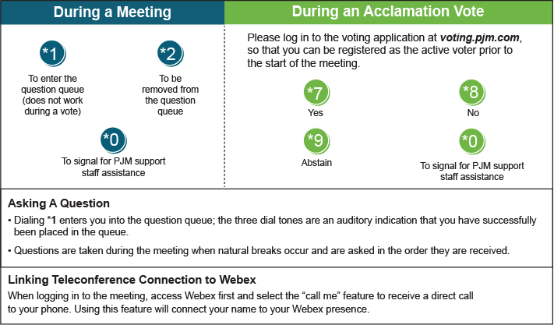

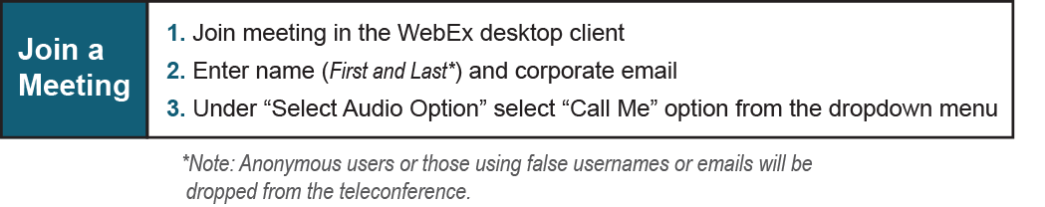

Provide feedback on the progress of this group: *Facilitator Feedback Form*   
Visit [*learn.pjm.com*](http://learn.pjm.com/), an easy-to-understand resource about the power industry and PJM’s role.