June Planning Committee

**Teleconference / WebEx**

June 07, 2022

9:00 a.m. – 11:00 a.m. EPT

*\*Operator assisted phone lines will be opened 30 minutes prior to the start of the meeting. Due to the high volume of remote participation, stakeholders are asked to connect early to allow additional time for operator queue processing.*

Administration (9:00 – 9:20)

1. Welcome, announcements and review of the Anti-trust, Code of Conduct, and Media Participation Guidelines.
2. Approve Planning Committee (PC) Agenda for this meeting.
3. Approve draft minutes from the May 10, 2022 PC meeting.
4. Pauline Foley, PJM, will provide an update on PJM’s response to the Department of Energy (DOE) Grid Deployment Office’s Notice of Inquiry (NOI) and Request for Information (RFI) regarding the Transmission Facilitation Program (TFP).
5. Amanda Egan will provide a demonstration of upcoming changes to the process of registering as an Active Voter within the Voting Application.

Endorsements (9:20 – 10:00)

1. 2022 RRS Assumptions

Jason Quevada, PJM, will present the 2022 RRS assumptions as developed in the Resource Adequacy Analysis Subcommittee. The committee will be requested to endorse the study assumptions at today’s meeting

1. Interconnection Process Subcommittee

Jason Connell, PJM, will provide a second read of the draft charter of the Interconnection Process Subcommittee, which is being formed to continue the discussion of interconnection process improvements after the work of the IPRTF concludes. The committee will be asked to vote on the draft charter at today’s meeting.

[Issue Tracking: Interconnection Process Subcommittee](https://www.pjm.com/committees-and-groups/issue-tracking/issue-tracking-details.aspx?Issue=0caa55a8-041c-4365-8a44-46ad2420b148)

Materials can be found [here](https://www.pjm.com/committees-and-groups/task-forces/iprtf)

First Reads

Informational Updates (10:00 – 11:00)

1. Capacity Interconnection Rights for ELCC Resources Update

Brian Chmielewski, PJM, will provide an update from the work done in the PC special session on Capacity Interconnection Rights (CIR) for ELCC Resources.

[Issue Tracking: CIRs for ELCC Resources](https://www.pjm.com/committees-and-groups/issue-tracking/issue-tracking-details.aspx?Issue=83aadda8-b6c1-4630-9483-025b6b93fc28)

Materials for the special sessions can be found [here](https://www.pjm.com/committees-and-groups/committees/pc).

1. Generator Deliverability Timeline Update

Jonathan Kern, PJM, will provide an update on the generator deliverability proposal development timeline.

1. Interconnection Queue Update

Jason Shoemaker, PJM, will review status of the PJM Interconnection Queues.

1. Transmission & Substation Subcommittee Update

Jay Liu, PJM, will provide an update on the TSS work activities through first half of 2022 and a work plan for the remainder of the year.

1. Reliability Compliance Update  
   Becky Davis, PJM, will provide an update on the activities, issues and items of interest at NERC, SERC, and RF.

Informational Posting

Model Build Activity Update

* MMWG
  + Dynamics
    - MMWG dynamic cases passed the disturbance test; there are issues incorporating CMLD models into MMWG dynamic cases, PowerTech and the members are discussing possible solutions
    - EIPC FRWG minimum inertia case passed the no fault test; PowerTech is working on disturbance test
  + Loadflow
    - Transmission Owners provided idevs to update the 2022 series on May 27, 2022
    - PJM will apply the idevs and submit Trial 1 to PowerTech on June 24, 2022
* RTEP
  + Dynamics
    - PJM is currently building RTEP 2022 series dynamic cases
  + Short Circuit
    - PJM is currently reviewing the 2024 Short circuit model & breaker analysis for all Transmission Owners
    - PJM’s System Planning Modeling & Support department delivered the 5 year short circuit case and associated files to the PJM’s Transmission Planning department for further review and analysis
* The upcoming Gen Model Window for MOD-032 data submittals for applicable Generator Owners will open on Sunday, May 1st, 2022 and end on Wednesday, June 15th, 2022

|  |  |  |  |  |
| --- | --- | --- | --- | --- |
| **Future Meeting Dates and Materials** | | | **Materials Due  to Secretary** | **Materials Published** |
| Date | Time | Meeting (Location) |
| Tuesday,  July 12, 2022 | 9:00 a.m. – 12:00 p.m. | Planning Committee (TBD) | Thursday, June 30, 2022 | Tuesday, July 5, 2022 |
| Tuesday, August 9, 2022 | 9:00 a.m. – 12:00 p.m. | Planning Committee (TBD) | Thursday, July 28, 2022 | Tuesday, August 2, 2022 |
| Tuesday, September 6, 2022 | 9:00 a.m. – 12:00 p.m. | Planning Committee (TBD) | Thursday, August 25, 2022 | Tuesday, August 30, 2022 |

Author: Marilyn Jayachandran

Antitrust:

You may not discuss any topics that violate, or that might appear to violate, the antitrust laws including but not limited to agreements between or among competitors regarding prices, bid and offer practices, availability of service, product design, terms of sale, division of markets, allocation of customers or any other activity that might unreasonably restrain competition. If any of these items are discussed the chair will re-direct the conversation. If the conversation still persists, parties will be asked to leave the meeting or the meeting will be adjourned.

Code of Conduct:

As a mandatory condition of attendance at today's meeting, attendees agree to adhere to the PJM Code of Conduct as detailed in PJM Manual M-34 section 4.5, including, but not limited to, participants' responsibilities and rules regarding the dissemination of meeting discussion and materials.

Public Meetings/Media Participation:

Unless otherwise noted, PJM stakeholder meetings are open to the public and to members of the media. Members of the media are asked to announce their attendance at all PJM stakeholder meetings at the beginning of the meeting or at the point they join a meeting already in progress. Members of the Media are reminded that speakers at PJM meetings cannot be quoted without explicit permission from the speaker. PJM Members are reminded that "detailed transcriptional meeting notes" and white board notes from "brainstorming sessions" shall not be disseminated. Stakeholders are also not allowed to create audio, video or online recordings of PJM meetings. PJM may create audio, video or online recordings of stakeholder meetings for internal and training purposes, and your participation at such meetings indicates your consent to the same.

Participant Identification in WebEx:

When logging into the WebEx desktop client, please enter your real first and last name as well as a valid email address. Be sure to select the “call me” option.

PJM support staff continuously monitors WebEx connections during stakeholder meetings. Anonymous users or those using false usernames or emails will be dropped from the teleconference.

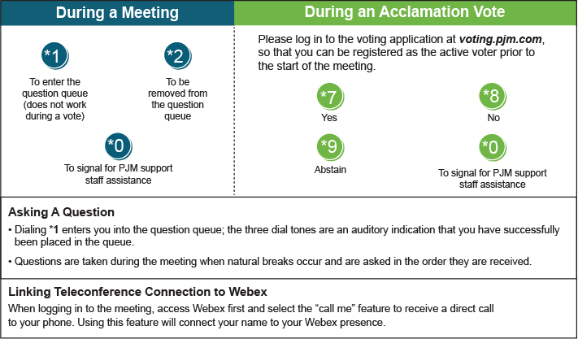

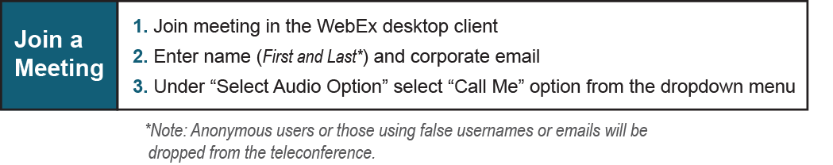

Provide feedback on the progress of this group: *Facilitator Feedback Form*   
Visit [*learn.pjm.com*](http://learn.pjm.com/), an easy-to-understand resource about the power industry and PJM’s role.