November Planning Committee

**Teleconference / WebEx**

November 2, 2021

9:00 a.m. – 12:00 p.m. EPT

Administration (9:00 – 9:15)

1. Welcome, announcements and review of the Anti-trust, Code of Conduct, and Media Participation Guidelines.
2. Approve Planning Committee (PC) Agenda for this meeting.
3. Approve draft minutes from the October 5, 2021 PC meeting.
4. Review of PC Charter. The committee will be requested to endorse the Charter at next month’s meeting.

Endorsements (9:15 – 10:00)

1. 2021/2022– Winter Weekly Reserve Target Patricio Rocha Garrido, PJM, will review the 2021/2022 Winter Weekly Reserve Target (WWRT) study results. **The committee will be requested to endorse the WWRT study results at today’s meeting.**
2. Manual 14B: PJM Region Transmission Planning Process Update

Michael Herman, PJM, will provide a review of Manual 14B regarding the biennial cover to cover review. The committee will be asked to vote on the manual changes at today’s meeting.

1. Manual 19: Load Forecasting and Analysis Update

John Reynolds, PJM, will provide a review of Manual 19 regarding the biennial cover to cover review. The committee will be asked to vote on the manual changes at today’s meeting.

1. Manual 14F: Competitive Planning Process Update

Joseph Hay, PJM, will provide a review of Manual 14F changes to the proposal fee structure to conform to the PJM Operating Agreement. The committee will be asked to vote on the manual changes at today’s meeting.

First Reads ( )

1. ~~Manual 14A: New Services Request Process & Manual 14B: PJM Region Transmission Planning Updates~~

~~Jonathan Kern, PJM, will provide a first read of Manual 14A and 14B to reflect changes to generator deliverability test and related procedures. The committee will be asked to approve the issue charge and endorse the proposed solution (manual changes) as part of the Quick Fix process outlined in Section 8.6.1 of Manual 34 at next month’s meeting.~~

Informational Updates (10:00 – 12:00)

1. Generator Deliverability Proposal: Status and Next Steps

Jonathan Kern, PJM, will provide an educational session for Manual 14A and 14B changes to generator deliverability test and related procedures.

1. PJM Interconnection Queue Status Update   
   Jason Shoemaker, PJM, will review and update of the PJM Interconnection Queues.
2. Capacity Interconnection Rights for ELCC Resoures Update

Brian Chmielewski, PJM, will provide an update on work being done during the PC special session on Capacity Interconnection Rights (CIR) for ELCC Resources.

Materials and upcoming meeting dates for special sessions can be found [here](https://www.pjm.com/committees-and-groups/committees/pc).

1. Interconnection Process Reform

Jack Thomas, PJM, will provide an update on the Interconnection Process Reform Task Force.

Materials and upcoming meeting dates for task force can be found [here](https://www.pjm.com/committees-and-groups/task-forces/iprtf)

1. Reliability Compliance Update  
   Becky Davis, PJM, will provide an update on the activities, issues and items of interest at NERC, SERC, and RF.

Informational Posting

Model Build Activity Update

* MMWG
  + Loadflow
    - PJM sends 2022 summer study case updates to PowerTech by November 5, 2021
    - Transmission Owners to provide 2022 summer study case trial 1 updates to PJM by November 18, 2021
    - PJM sends 2022 summer study case trial 1 updates to PowerTech by November 19, 2021
* RTEP
  + Loadflow
    - Transmission Owners submit trial 1 updates via Model on Demand, tie line updates via new SharePoint tool by November 19, 2021
  + Short Circuit
    - PJM is currently reviewing the files and data provided by Transmission Owners
    - The trial 1 2024 short circuit case will be posted in January 2022

|  |  |  |  |  |
| --- | --- | --- | --- | --- |
| **Future Meeting Dates and Materials** | | | **Materials Due  to Secretary** | **Materials Published** |
| Date | Time | Meeting (Location) |
| Tuesday, November 2, 2021 | 9:00 a.m. – 12:00 p.m. | Planning Committee (WebEx) | Thursday, October 21, 2021 | Tuesday, October 26, 2021 |
| Tuesday, November 2, 2021 | *3:00 p.m. – 5:00 p.m.* | Interconnection Policy Workshop #7 (WebEx) | *Monday, October 25, 2021* | *Thursday, October 28, 2021* |
| Thursday, November 4, 2021 | 3:00 p.m. – 5:00 p.m. | Interconnection Process Reform Task Force (Webex) | Wednesday, October 27, 2021 | Monday, November 1, 2021 |
| Monay,  November 8, 2021 | *3:00 p.m. – 5:00 p.m.* | Special PC: CIR for ELCC Resources (WebEx) | *Friday,*  *October 29, 2021* | *Wednesday,*  *November 3, 2021* |
| Thursday, November 18, 2021 | 11:00 a.m. – 1:00 p.m. | Interconnection Process Reform Task Force (Webex) | Wednesday, November 10, 2021 | Monday, November 15, 2021 |
| Tuesday,  November 23, 2021 | *1:00 p.m. – 4:00 p.m.* | Special PC: CIR for ELCC Resources (WebEx) | *Monday,*  *November 15, 2021* | *Thursday,*  *November 18, 2021* |
| Tuesday, November 30, 2021 | *9:00 a.m. – 12:00 p.m.* | Interconnection Process Reform Task Force (Webex) | *Monday,*  *November 22, 2021* | *Thursday,*  *November 25, 2021* |
| ~~Tuesday, November 30, 2021~~ | ~~9:00 a.m. – 12:00 p.m.~~ | ~~Planning Committee (WebEx)~~ | ~~Thursday, November 18, 2021~~ | ~~Tuesday, November 23, 2021~~ |
| Tuesday, December 14, 2021 | 9:00 a.m. – 12:00 p.m. | Planning Committee (WebEx) | Thursday, December 2, 2021 | Tuesday, December 7, 2021 |

Author: Molly Mooney

Antitrust:

You may not discuss any topics that violate, or that might appear to violate, the antitrust laws including but not limited to agreements between or among competitors regarding prices, bid and offer practices, availability of service, product design, terms of sale, division of markets, allocation of customers or any other activity that might unreasonably restrain competition. If any of these items are discussed the chair will re-direct the conversation. If the conversation still persists, parties will be asked to leave the meeting or the meeting will be adjourned.

Code of Conduct:

As a mandatory condition of attendance at today's meeting, attendees agree to adhere to the PJM Code of Conduct as detailed in PJM Manual M-34 section 4.5, including, but not limited to, participants' responsibilities and rules regarding the dissemination of meeting discussion and materials.

Public Meetings/Media Participation:

Unless otherwise noted, PJM stakeholder meetings are open to the public and to members of the media. Members of the media are asked to announce their attendance at all PJM stakeholder meetings at the beginning of the meeting or at the point they join a meeting already in progress. Members of the Media are reminded that speakers at PJM meetings cannot be quoted without explicit permission from the speaker. PJM Members are reminded that "detailed transcriptional meeting notes" and white board notes from "brainstorming sessions" shall not be disseminated. Stakeholders are also not allowed to create audio, video or online recordings of PJM meetings. PJM may create audio, video or online recordings of stakeholder meetings for internal and training purposes, and your participation at such meetings indicates your consent to the same.

Participant Identification in WebEx:

When logging into the WebEx desktop client, please enter your real first and last name as well as a valid email address. Be sure to select the “call me” option.

PJM support staff continuously monitors WebEx connections during stakeholder meetings. Anonymous users or those using false usernames or emails will be dropped from the teleconference.

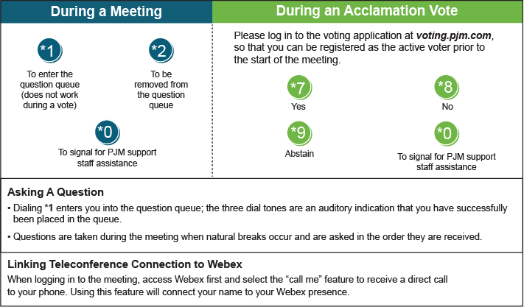

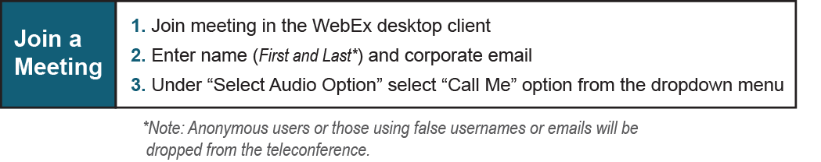

Provide feedback on the progress of this group: *Facilitator Feedback Form*   
Visit [*learn.pjm.com*](http://learn.pjm.com/), an easy-to-understand resource about the power industry and PJM’s role.