August Planning Committee

**Teleconference / WebEx**

August 31, 2021

9:00 a.m. – 12:00 p.m. EPT

Administration (9:00 – 9:15)

1. Welcome, announcements and review of the Anti-trust, Code of Conduct, and Media Participation Guidelines.
2. Approve Planning Committee (PC) Agenda for this meeting.
3. Approve draft minutes from the August 10, 2021 PC meeting.

Endorsements (9:15 – 9:45)

1. Manual 14G: Generation Interconnection Requests Update  
   Theresa Esterly, PJM, will provide a first read for updates to Manual 14G regarding the Behind the Meter Generation (BTMG) business rules on status changes. The committee will be asked to vote on the manual changes at today’s meeting.

First Reads (9:45 – 10:15)

1. 2021 Installed Reserve Margin Study Results Patricio Rocha Garrido, PJM, will review the 2021 Reserve Requirement Study results (IRM, FPR). The Committee will be requested to endorse the study results at its next meeting.

Informational Updates (10:15 – 12:00)

1. Preliminary 2022 Project Budget  
   Jim Snow, PJM, will review the Preliminary 2022 Project Budget.
2. Interconnection Queue Status Update

Jason Shoemaker, PJM, will provide an update on recent changes to the Interconnection Queue process and queue timings.

1. Capacity Interconnection Rights for ELCC Resoures Update

Brian Chmielewski, PJM, will provide an update on work being done during the PC special session on Capacity Interconnection Rights (CIR) for ELCC Resources.

Materials and upcoming meeting dates for special sessions can be found [here](https://www.pjm.com/committees-and-groups/committees/pc).

1. Interconnection Process Reform

Jack Thomas, PJM, will provide an update on the Interconnection Process Reform Task Force.

Materials and upcoming meeting dates for task force can be found [here](https://www.pjm.com/committees-and-groups/task-forces/iprtf)

1. Reliability Compliance Update  
   Becky Davis, PJM, will provide an update on the activities, issues and items of interest at NERC, SERC, and RF.
2. Designated Entity Agreements Update

Pauline Foley, PJM Legal, will provide an update regarding PJM’s use of the Designated Entity Agreements.

Informational Posting

Model Build Activity Update

* 2021 series MMWG
  + Powerflow
    - PowerTech will post Trial 3 cases by Friday August 27, 2021
    - Transmission Owners will provide Trial 3 updates and Data Dictionary by Friday September 3, 2021
    - PJM will provide Trial 3 updates and Data Dictionary to PowerTech by Friday September 10, 2021
  + Dynamics
    - Transmission Owners to submit dynamic device models to PJM by Friday October 1, 2021
    - Transmission Owners to submit dynamic load models to PJM by Friday November 12, 2021
* 2022 series RTEP
  + Powerflow
    - PJM will provide the Model on Demand seedcase to the Transmission Owners for Trial 0 by Friday August 27, 2021
    - Transmission Owners will provide Trial 0 updates via Model on Demand by Friday September 24, 2021
  + Short Circuit
    - PJM will provide the initial files by Friday September 3, 2021
    - Transmission Owners will provide updated 2024 case and files by Friday October 1, 2021

** Corrected meeting dates/times reflected below

|  |  |  |  |  |
| --- | --- | --- | --- | --- |
| **Future Meeting Dates and Materials** | | | **Materials Due  to Secretary** | **Materials Published** |
| Date | Time | Meeting (Location) |
| Tuesday, August 31, 2021 | 9:00 a.m. – 12:00 p.m. | Planning Committee (WebEx) | Thursday, August 19, 2021 | Tuesday, August 24, 2021 |
| Monday, September 13, 2021 | 9:00 a.m. – 12:00 p.m. | Interconnection Policy Workshop #5 (WebEx) | Friday, September 3, 2021 | Wednesday, September 8, 2021 |
| Monday, September 20, 2021 | 9:00 a.m. – 3:00 p.m. | Interconnection Process Reform Task Force (Webex) | Friday, September 10, 2021 | Wednesday, September 15, 2021 |
| Tuesday, September 21, 2021 | 9:00 a.m. – 12:00 p.m. | Special PC: CIR for ELCC Resources (WebEx) | Monday, September 13, 2021 | Thursday, September 16, 2021 |
| Thursday, September 30, 2021 | 9:00 a.m. – 3:00 p.m. | Interconnection Policy Workshop #6 (WebEx) | Wednesday, September 22, 2021 | Monday, September 27, 2021 |
| Tuesday, October 5, 2021 | 9:00 a.m. – 12:00 p.m. | Planning Committee (WebEx) | Thursday, September 23, 2021 | Tuesday, September 28, 2021 |
| Thursday, October 7, 2021 | 2:00 p.m. – 5:00 p.m. | Interconnection Process Reform Task Force (Webex) | Wednesday, September 29, 2021 | Monday, October 4, 2021 |
| Tuesday, October 19, 2021 | 9:00 a.m. – 12:00 p.m. | Interconnection Process Reform Task Force (Webex) | Monday, October 11, 2021 | Thursday, October 14, 2021 |
| Monday, October 25, 2021 | 1:00 p.m. – 4:00 p.m. | Interconnection Policy Workshop #7 (WebEx) | Friday, October 15, 2021 | Wednesday, October 20, 2021 |
| Tuesday, November 2, 2021 | 9:00 a.m. – 12:00 p.m. | Planning Committee (WebEx) | Thursday, October 21, 2021 | Tuesday, October 26, 2021 |
| Tuesday, November 30, 2021 | 9:00 a.m. – 12:00 p.m. | Planning Committee (WebEx) | Thursday, November 18, 2021 | Tuesday, November 23, 2021 |

Author: Molly Mooney

Antitrust:

You may not discuss any topics that violate, or that might appear to violate, the antitrust laws including but not limited to agreements between or among competitors regarding prices, bid and offer practices, availability of service, product design, terms of sale, division of markets, allocation of customers or any other activity that might unreasonably restrain competition. If any of these items are discussed the chair will re-direct the conversation. If the conversation still persists, parties will be asked to leave the meeting or the meeting will be adjourned.

Code of Conduct:

As a mandatory condition of attendance at today's meeting, attendees agree to adhere to the PJM Code of Conduct as detailed in PJM Manual M-34 section 4.5, including, but not limited to, participants' responsibilities and rules regarding the dissemination of meeting discussion and materials.

Public Meetings/Media Participation:

Unless otherwise noted, PJM stakeholder meetings are open to the public and to members of the media. Members of the media are asked to announce their attendance at all PJM stakeholder meetings at the beginning of the meeting or at the point they join a meeting already in progress. Members of the Media are reminded that speakers at PJM meetings cannot be quoted without explicit permission from the speaker. PJM Members are reminded that "detailed transcriptional meeting notes" and white board notes from "brainstorming sessions" shall not be disseminated. Stakeholders are also not allowed to create audio, video or online recordings of PJM meetings. PJM may create audio, video or online recordings of stakeholder meetings for internal and training purposes, and your participation at such meetings indicates your consent to the same.

Participant Identification in WebEx:

When logging into the WebEx desktop client, please enter your real first and last name as well as a valid email address. Be sure to select the “call me” option.

PJM support staff continuously monitors WebEx connections during stakeholder meetings. Anonymous users or those using false usernames or emails will be dropped from the teleconference.

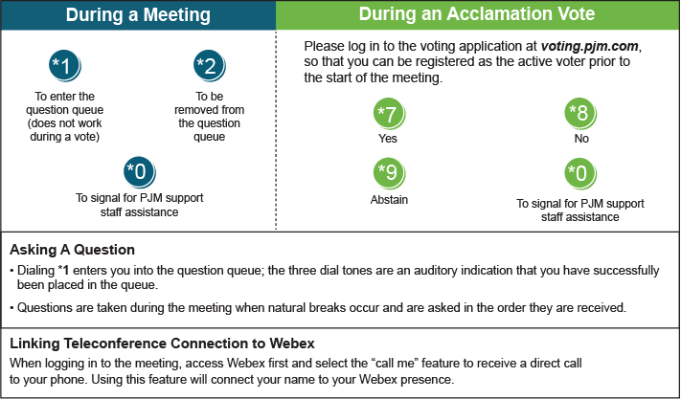

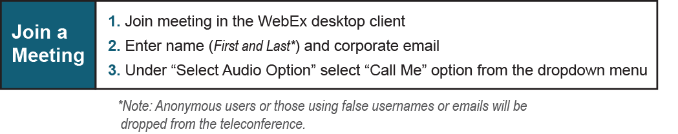

Provide feedback on the progress of this group: *Facilitator Feedback Form*   
Visit [*learn.pjm.com*](http://learn.pjm.com/), an easy-to-understand resource about the power industry and PJM’s role.