Operating Committee
PJM Conference & Training Center, Audubon, PA
August 11, 2022
9:00 a.m. – 2:00 p.m. EDT

*Operator assisted phone lines will be opened 30 minutes prior to the start of the meeting. Due to the high volume of remote participation, stakeholders are asked to connect early to allow additional time for operator queue processing.

Administration (9:00-9:15)
Jeff McLaughlin, PJM, will provide announcements; review the Antitrust, Code of Conduct, Public Meetings/Media Participation, and the WebEx Participant Identification Requirement.
  - Review and approve draft minutes from the July 14 OC meeting.

  - Review of the OC work plan.

Review of Operations (9:15 - 9:35)
Review of Operating Metrics
Hong Chen, PJM, will review the June 2022 PJM operating metrics slides. Metrics will include PJM’s load forecast error, BAAL performance, and transmission / generation outage statistics.

- Security Update
Steve McElwee, PJM, will provide a security briefing.

Endorsements/Approvals (9:35 – 9:55)
- Manual 14D: Generator Operational Requirements and Manual 10: Pre-Scheduling Operations
Andrew Levitt, PJM, will review conforming changes to Manual 14D and Manual 10 as part of the phase one hybrid resources issue.
The Operating Committee will be asked to endorse these changes at today’s meeting.
Solar-Battery Hybrid Resources Issue Tracking

Max Emergency Changes for Resource Limitation Reporting
A review of solution packages will be performed for the Max Emergency Changes for Resource Limitation Reporting issue as part of the Consensus Based Issue Resolution (CBIR) Lite process.
Chris Pilong, PJM, will review Package A.
Joel Luna, Monitoring Analytics, will review Package B.
The Operating Committee will be asked to endorse the proposed solutions at its next meeting.
Issue Tracking: Max Emergency Changes for Resource Limitation Reporting

First Reading (9:55 – 1:30)
- Max Emergency Changes for Resource Limitation Reporting
A review of solution packages will be performed for the Max Emergency Changes for Resource Limitation Reporting issue as part of the Consensus Based Issue Resolution (CBIR) Lite process.
- Chris Pilong, PJM, will review Package A.
- Joel Luna, Monitoring Analytics, will review Package B.
The Operating Committee will be asked to endorse the proposed solutions at its next meeting.
Issue Tracking: Max Emergency Changes for Resource Limitation Reporting

- Internal NITS Process
A first read of solution package(s) will be performed for the Internal Network Integration Transmission Service (NITS) Process issue as part of the CBIR Lite process.
The Operating Committee will be asked to endorse the proposed solution at its next meeting.

- Renewable Dispatch
A first read of solution package(s) will be performed for the Renewable Dispatch issue as part of the CBIR process.
Issue Tracking: Renewable Dispatch
The Operating Committee will be asked to endorse the proposed solution(s) at its next meeting.

- IROL-CIP Cost Recovery
A first read of the solution package for the IROL-CIP Cost Recovery issue will be performed as part of the CBIR process.
Issue Tracking: IROL-CIP Cost Recovery
The Operating Committee will be asked to endorse the proposed solution at its next meeting.

Lunch (12:00 – 12:20)

- Fuel Requirements for Black Start Resources
A first read of solution packages will be performed for the Fuel Requirements and Black Start Resources issue as part of the CBIR process.
- Janell Fabiano, PJM, will provide a brief background on the issue and a review of the unique voting procedure.
- Dan Bennett, PJM, will review Package H (PJM / Brookfield / DCOPC).
- Joe Bowring, Monitoring Analytics, will review Package B (IMM).
Issue Tracking: Fuel Requirements for Black Start Resources
The Operating Committee will be asked to endorse the proposed solutions after its next meeting.

- Manual 14D and Manual 13 Revisions
Vince Stefanowicz, PJM, will perform a first read of changes to Manual 14D: Generator Operational Requirements and Manual 13: Emergency Operation. The changes are associated with NERC standards EOP-011 – Emergency Preparedness and Operations, IRO-010 – Reliability Coordinator Data Specification and Collection, and TOP-003 – Operational Reliability Data will be performed.
The Operating Committee will be asked to endorse these changes at its next meeting.

- Manual 10, Manual 12 and Manual 13 Revisions
David Kimmel, PJM, will perform a first read of changes associated with Reserve Price Formation impacting Manual 10: Pre-Scheduling Operations, Manual 12: Balancing Operations and Manual 13: Emergency Operations.
The Operating Committee will be asked to endorse these changes at its next meeting.

- Manual 39: Nuclear Plant Interface Coordination
Darrell Frogg, PJM, will review Manual 39 changes as a part of the periodic review.
The Operating Committee will be asked to endorse these changes at its next meeting.

Additional Items (1:30 – 2:00)
- PPL Dynamic Line Rating Implementation Update
Dave Hislop, PJM, will provide an update on the implementation of the PPL Dynamic Line Rating.

- System Resilience
Chris Pilong, PJM, will provide an update on system resilience.

- Regulation Market Design Senior Task Force Update
Michael Herman, PJM, will provide an informational update on the efforts of the Regulation Market Design Senior Task Force (RMDSTF). Meeting materials are posted to the RMDSTF webpage (https://www.pjm.com/committees-and-groups/task-forces/rmdstf).

Working Items
No working items this month.

Informational Only Postings
- System Operations Subcommittee (SOS)
Donnie Bielak, PJM, will provide a summary of the most recent SOS meeting.

- Reliability Compliance Update
Becky Davis, PJM, will provide an update on NERC, SERC, RF, and NAESB standards, and other pertinent regulatory and compliance information, and solicit feedback from the members on Reliability Compliance efforts.

OC Subcommittee/ Task Force Informational Section
System Operations Subcommittee (SOS): SOS Website
Data Management Subcommittee (DMS): DMS Website
DER & Inverter-Based Resources Subcommittee (DIRS): DIRS Website
Fuel Requirements for Black Start Resources: Fuel Reqt. for Black Start Resources Issue Tracker
Synchronous Reserve Deployment Task Force: SRDTF Website
IROL – CIP Cost Recovery: IROL – CIP Cost Recovery Issue Tracker

Future Meeting Dates and Materials |  |  | Materials Due  to Secretary | Materials Published
Date | Time | Location | 5 p.m. | 4 p.m.
September 8, 2022 | 9 a.m. | PJM Conference & Training Center and WebEx | August 29, 2022 | September 1, 2022
October 7, 2022 | 9 a.m. | PJM Conference & Training Center and WebEx | September 27, 2022 | September 30, 2022
November 3, 2022 | 9 a.m. | PJM Conference & Training Center and WebEx | October 24, 2022 | October 27, 2022
December 8, 2022 | 9 a.m. | PJM Conference & Training Center and WebEx | November 28, 2022 | December 1, 2022

Author: Jeffrey McLaughlin

Antitrust:
You may not discuss any topics that violate, or that might appear to violate, the antitrust laws including but not limited to agreements between or among competitors regarding prices, bid and offer practices, availability of service, product design, terms of sale, division of markets, allocation of customers or any other activity that might unreasonably restrain competition. If any of these items are discussed the chair will re-direct the conversation. If the conversation still persists, parties will be asked to leave the meeting or the meeting will be adjourned.

Code of Conduct:
As a mandatory condition of attendance at today's meeting, attendees agree to adhere to the PJM Code of Conduct as detailed in PJM Manual M-34 section 4.5, including, but not limited to, participants' responsibilities and rules regarding the dissemination of meeting discussion and materials.
Public Meetings/Media Participation:
Unless otherwise noted, PJM stakeholder meetings are open to the public and to members of the media. Members of the media are asked to announce their attendance at all PJM stakeholder meetings at the beginning of the meeting or at the point they join a meeting already in progress. Members of the Media are reminded that speakers at PJM meetings cannot be quoted without explicit permission from the speaker. PJM Members are reminded that "detailed transcriptional meeting notes" and white board notes from "brainstorming sessions" shall not be disseminated. Stakeholders are also not allowed to create audio, video or online recordings of PJM meetings. PJM may create audio, video or online recordings of stakeholder meetings for internal and training purposes, and your participation at such meetings indicates your consent to the same.
Participant Identification in WebEx:
When logging into the WebEx desktop client, please enter your real first and last name as well as a valid email address. Be sure to select the “call me” option.
PJM support staff continuously monitors WebEx connections during stakeholder meetings. Anonymous users or those using false usernames or emails will be dropped from the teleconference.

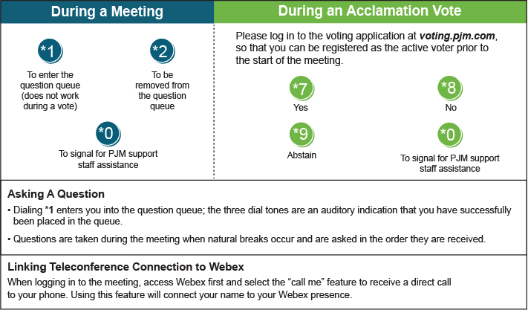

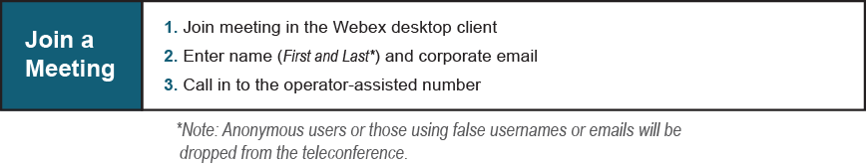

Provide feedback on the progress of this group: Facilitator Feedback Form
Visit learn.pjm.com, an easy-to-understand resource about the power industry and PJM’s role.

