Operating Committee
WebEx Only
April 14, 2022
9:00 a.m. – 3:00 p.m. EDT

*Operator assisted phone lines will be opened 30 minutes prior to the start of the meeting. Due to the high volume of remote participation, stakeholders are asked to connect early to allow additional time for operator queue processing.

Administration (9:00-9:15)
Lauren Strella Wahba, PJM, will provide announcements; review the Antitrust, Code of Conduct, Public Meetings/Media Participation, and the WebEx Participant Identification Requirement.
  - Review and approve draft minutes from the March 10th OC meeting.

  - Review of the OC work plan.

  - Review of the OC Charter.
The Operating committee will be asked to endorse the Charter at its next meeting.

  - Dave Anders, PJM, will provide an update on the voting protocols for Board elections at the May
Members Committee meeting

Review of Operations (9:15-9:35)
Review of Operating Metrics
Stephanie Schwarz, PJM, will review the March 2022 PJM operating metrics slides. Metrics will include PJM’s load forecast error, BAAL performance, and transmission / generation outage statistics.

- PJM COVID-19 Update
Paul McGlynn, PJM, will provide an update on PJM’s operations plan in response to COVID-19. https://pjm.com/committees-and-groups/pandemic-coordination.aspx

- Security Update
Steve McElwee, PJM, will provide a security briefing.

Endorsements/Approvals (9:35-10:35)
- Manual 01: Control Center and Data Exchange Requirements
Bilge Derin, PJM, will review Manual 01 changes as a part of the periodic review.
The Operating Committee will be asked to endorse these changes at today’s meeting.

- Documenting the Appropriate UFLS Requirements Applicable to EKPC
Denise Foster Cronin, EKPC, will provide a review of a Problem Statement and Issue Charge
to appropriately document the underfrequency relay requirements applicable to EKPC. The
Operating Committee will be asked to approve the Issue Charge and endorse the proposed
solution at today’s meeting as part of the Quick Fix process outlined in Section 8.6.1 of
Manual 34. The MRC and MC will ultimately be asked to endorse/approve the solution and
corresponding OA revisions.

- Reliability Products and Services Assessment
Chris Pilong and Alex Scheirer, PJM, will provide a review of a proposed "initial direction"
regarding reliability products and services as required by the Resource Adequacy Sr. Task Force
Charter.
RASTF Website
The Operating Committee will be asked to approve the initial recommendation at today’s
meeting.

- Dynamic Rating Issue
  - Chris Callaghan, PJM, will provide a review of the Interim Measures to Facilitate the
Integration of Dynamic Ratings into PJM Operations (Phase 1) Issue Charge and Problem
Statement. Bilge Derin, PJM, will provide a review of changes to M03: Transmission Operations,
M03A: Energy Management System (EMS) Model Update and Quality Assurance (QA), and M01:
Control Center and Data Exchange Requirements.
The Operating Committee will be asked to approve the issue charge and endorse the
proposed solution as part of the Quick Fix process outlined in Section 8.6.1 of Manual 34 at
today’s meeting.

  - Chris Callaghan, PJM, will provide a review of the Potential Additional Issues Relating to the
Implementation of Dynamic Line Ratings (Phase 2) Issue Charge and Problem Statement.
The Operating Committee will be asked to approve the Issue Charge at today’s meeting.

First Reading (10:35 -11:20)
- Manual 03: Transmission Operations
Dean Manno, PJM, will review Manual 03 changes as a part of the periodic review.
The Operating Committee will be asked to endorse these changes at its next meeting.

- Manual 36: System Restoration
Rich Brown, PJM, will review Manual 36 changes as a part of the periodic review.
The Operating Committee will be asked to endorse these changes at its next meeting.

- Manual 12: Balancing Operations
Mike Handlin, PJM, will review conforming changes to Manual 12: Balancing Operations as a part of the Stability Limits in Markets and Operation Issue Charge and Problem Statement being worked through the Markets Implementation Committee.
The Operating Committee will be asked to endorse these changes at its next meeting.
Stability Limits in Markets and Operation

- Outage Coordination Issue Charge and Problem Statement
Paul McGlynn, PJM, will present a first read of an Issue Charge and Problem Statement that will enhance outage coordination processes and procedures.
The Operating Committee will be asked to approve the Issue Charge at its next meeting.

- RSCS Charter
Monica Burkett, PJM, will provide a first read of changes made to the Reliability Standards & Compliance Subcommittee Charter.
The Operating Committee will be asked to approve the changes to the Charter at its next meeting.

Additional Items (11:20-12:20)
- Managing Transmission Line Ratings Order No. 881 Compliance Filing (RM20-16-000) Update
David Hislop, PJM, and Bilge Derin, PJM, will provide an informational update regarding PJM’s FERC
Order No. 881 compliance efforts relating to ambient adjusted ratings. PJM continues to provide
updates and solicit stakeholder input at Operating Committee meetings as it prepares its compliance
filing, which is due July 12, 2022.
Order 881

- PPL Dynamic Line Rating Implementation Update
Dave Hislop, PJM, will provide an update on the implementation of the PPL Dynamic Line Rating.

- Transmission Service Reservation Priority Rollover Rights
Rich Souder, PJM, and Mark Stanisz, PJM, will provide an overview of the process for obtaining and exercising rollover rights relating to firm transmission service reservation priority as set forth in the PJM Tariff, Part I, sections 2.2 and 2.3. PJM will discuss the deadlines existing firm service customers should be aware of in light of the terms of their transmission service agreements, and preview PJM’s intent to return to the Operating Committee with a Problem Statement/Issue Charge to explore potential enhancements to the process.

- Coal Combustion Residuals EPA Rule Update
Gary Helm, PJM, will provide an informational update about PJM’s filed comments regarding the Environmental Protection Agency’s rule on disposal of coal combustion residuals (CCRs) in the EPA dockets EPA-HQ-OLEM-2021-0587; (EPA-HQ-OLEM-2021-0590; and EPA-HQ-OLEM- 2021-0595.
https://www.pjm.com/-/media/documents/ferc/filings/2022/20220325-pjm-comments-to-epa.ashx

- Fuel and Energy Security Update
Natalie Tacka, PJM, will provide an update on the Fuel and Energy Security initiative.

- Generating Facility Cold Weather Operating Limits Periodic Data Request
Vince Stefanowicz, PJM, will review a new data request to capture cold weather operating limit data
required for the Generation Owners and PJM to remain in compliance with NERC Standards EOP-
011-2, Emergency Preparedness and Operations, IRO-010-4 Reliability Coordinator Data
Specification and Collection, and TOP-003-5 Operational Reliability Data when they become effective
on 4/1/23.

- Review of Interconnection Process Reform OATT Revisions
Ed Franks, PJM, will present language updates to Parts II and III of the Open Access Transmission
Tariff resulting from the proposed Interconnection Process Reform.

- 2022 PJM Grid Security Drill Announcement
Ed Figuli, PJM, will provide an announcement regarding the coordination of this year’s PJM Grid
Security Drill.

LUNCH (12:20 – 12:40)

Working Items (12:40-3:00)
- IROL-CIP Cost Recovery
Darlene Phillips, PJM, will facilitate a discussion to review and identify additional solution options on
the IROL-CIP Cost Recovery matrix as part of the Consensus Based Issue Resolution process.
Issue Tracking: IROL-CIP Cost Recovery

- Renewable Dispatch
Darlene Phillips, PJM, will facilitate a discussion to review and identify additional design
components on the Renewable Dispatch matrix as part of the Consensus Based Issue Resolution
process.
Issue Tracking: Renewable Dispatch

- Max Emergency Changes for Resource Limitation Reporting
- Joe Bowring, IMM, will provide education on the Opportunity Cost Calculation.
- Donnie Bielak, PJM, will provide education on the purpose of Maximum Emergency and how it is
used by Dispatch.
- Melissa Pilong, PJM, will provide education Maximum Emergency categories for qualification.
- Angelo Marcino, PJM, and Tong Zhao, PJM, will provide education on Real-Time Market and Day-
Ahead Market clearing and reserve perspective.
- Darlene Phillips, PJM, will facilitate a discussion to identify interests on the Max Emergency
Changes for Resource Limitation Reporting matrix as a part of the Consensus Based Issue
Resolution Lite process.
Issue Tracking: Max Emergency Changes for Resource Limitation Reporting

Informational Only Postings
- System Operations Subcommittee (SOS)
Donnie Bielak, PJM, will provide a summary of the most recent SOS meeting.

- Reliability Compliance Update
Becky Davis, PJM, will provide an update on NERC, SERC, RF, and NAESB standards, and other
pertinent regulatory and compliance information, and solicit feedback from the members on Reliability
Compliance efforts.

- Winter Operations Review
Review of the 2021-2022 Winter Operations Summary.

- Synchrophasor Update
Yang Chen, PJM, will review recent activities around PMUs at PJM.

- NERC Lessons Learned
Kevin Hatch, PJM, will review the latest posted NERC Lessons Learned reports.

- Fuel Inventory Update
The Fuel Inventory Update will be posted bi-weekly on the Operating Committee main page under
the Fuel Inventory Update section. Along with the presentation, an excel file with the remaining GWh
data from all fuel inventory data requests since October 2021 is also posted.

OC Subcommittee/ Task Force Informational Section
System Operations Subcommittee (SOS): SOS Website
Data Management Subcommittee (DMS): DMS Website
DER & Inverter-Based Resources Subcommittee (DIRS): DIRS Website
Fuel Requirements for Black Start Resources: Fuel Reqt. for Black Start Resources Issue Tracker
Synchronous Reserve Deployment Task Force: SRDTF Website
IROL – CIP Cost Recovery: IROL – CIP Cost Recovery Issue Tracker

Future Meeting Dates and Materials |  |  | Materials Due  to Secretary | Materials Published
Date | Time | Location | 5 p.m. | 4 p.m.
May 12, 2022 | 9 a.m. | WebEx Only | May 2, 2022 | May 5, 2022
June 9, 2022 | 9 a.m. | PJM Conference & Training Center and WebEx | May 30, 2022 | June 2, 2022
July 14, 2022 | 9 a.m. | PJM Conference & Training Center and WebEx | July 1, 2022 | July 7, 2022
August 11, 2022 | 9 a.m. | PJM Conference & Training Center and WebEx | August 1, 2022 | August 4, 2022
September 8, 2022 | 9 a.m. | PJM Conference & Training Center and WebEx | August 29, 2022 | September 1, 2022
October 7, 2022 | 9 a.m. | PJM Conference & Training Center and WebEx | September 27, 2022 | September 30, 2022
November 3, 2022 | 9 a.m. | PJM Conference & Training Center and WebEx | October 24, 2022 | October 27, 2022
December 8, 2022 | 9 a.m. | PJM Conference & Training Center and WebEx | November 28, 2022 | December 1, 2022

Author: L. Strella Wahba

Antitrust:
You may not discuss any topics that violate, or that might appear to violate, the antitrust laws including but not limited to agreements between or among competitors regarding prices, bid and offer practices, availability of service, product design, terms of sale, division of markets, allocation of customers or any other activity that might unreasonably restrain competition. If any of these items are discussed the chair will re-direct the conversation. If the conversation still persists, parties will be asked to leave the meeting or the meeting will be adjourned.

Code of Conduct:
As a mandatory condition of attendance at today's meeting, attendees agree to adhere to the PJM Code of Conduct as detailed in PJM Manual M-34 section 4.5, including, but not limited to, participants' responsibilities and rules regarding the dissemination of meeting discussion and materials.
Public Meetings/Media Participation:
Unless otherwise noted, PJM stakeholder meetings are open to the public and to members of the media. Members of the media are asked to announce their attendance at all PJM stakeholder meetings at the beginning of the meeting or at the point they join a meeting already in progress. Members of the Media are reminded that speakers at PJM meetings cannot be quoted without explicit permission from the speaker. PJM Members are reminded that "detailed transcriptional meeting notes" and white board notes from "brainstorming sessions" shall not be disseminated. Stakeholders are also not allowed to create audio, video or online recordings of PJM meetings. PJM may create audio, video or online recordings of stakeholder meetings for internal and training purposes, and your participation at such meetings indicates your consent to the same.
Participant Identification in WebEx:
When logging into the WebEx desktop client, please enter your real first and last name as well as a valid email address. Be sure to select the “call me” option.
PJM support staff continuously monitors WebEx connections during stakeholder meetings. Anonymous users or those using false usernames or emails will be dropped from the teleconference.

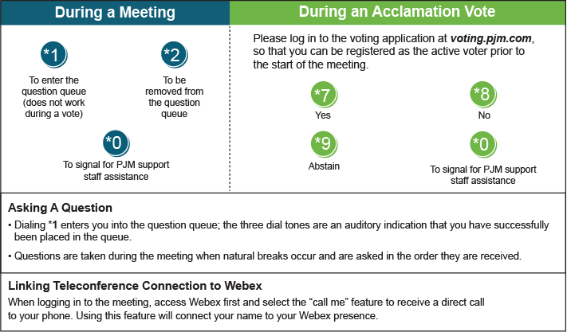

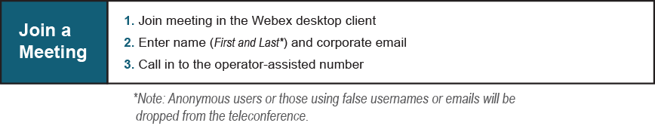

Provide feedback on the progress of this group: Facilitator Feedback Form
Visit learn.pjm.com, an easy-to-understand resource about the power industry and PJM’s role.

