Operating Committee
Webex Only
March 11, 2021
9:00 a.m. – 12:00 p.m. EST

Administration (9:00-9:15)
Lauren Strella Wahba, PJM, will provide announcements; review the Antitrust, Code of Conduct, Public Meetings/Media Participation, and the WebEx Participant Identification Requirement.
  - Review and approve draft minutes from the February 11th OC meeting.
  - Review of the OC work plan.

Review of Operations (9:15-9:30)
PJM COVID-19 Update
Paul McGlynn, PJM, will provide an update on PJM’s operations plan in response to COVID-19. https://pjm.com/committees-and-groups/pandemic-coordination.aspx

Review of Operating Metrics
Stephanie Monzon, PJM, will review the February 2021 PJM operating metrics slides. Metrics will include PJM’s load forecast error, BAAL performance, and transmission / generation outage statistics.

Endorsements (9:30-10:30)
- Manual 37: Reliability Coordination
Matthew Wharton, PJM, will review Manual 37 changes. The Operating Committee will be asked to endorse these changes at today’s meeting.
- Manual 02: Transmission Service Request
Jeff McLaughlin, PJM, will review Manual 02 changes. The Operating Committee will be asked to endorse these changes at today’s meeting.
- Synchronized Reserve Event Actions and Expectations Problem Statement & Issue Charge
Mike Zhang, PJM, will provide a first read on the Problem Statement & Issue Charge for Synchronized Reserve Event Actions and Expectations. The Operating Committee will be asked to approve the issue charge at today’s meeting.
- Resource Tracker Ownership Confirmation Requirement Problem Statement & Issue Charge
Chris Franks, PJM, will review a Quick Fix Problem Statement & Issue Charge to update language in
Manual 14D Section 5.3.7 regarding the Resource Tracker Ownership Confirmation Requirement. The
Operating Committee will be asked to approve the issue charge and endorse the proposed
revisions as part of the Quick Fix process outlined in Section 8.6.1 of Manual 34 at today’s
meeting.

- Transmission Services Transmission Loading Relief (TLR) buy-through Problem Statement & Issue Charge
Chris Advena, PJM, will review a Quick Fix Problem Statement & Issue Charge to remove the TLR
buy-through congestion process from the Schedule 1, section 1.10.6A of the Operating Agreement.
The Operating Committee will be asked to approve the issue charge and endorse the proposed
solution as part of the Quick Fix process outlined in Section 8.6.1 of Manual 34 at today’s
meeting.

First Reading (10:30-10:50)
- IROL-CIP Cost Recovery
Darrell Frogg, PJM, will provide a first read of the Problem Statement and Issue Charge addressing IROL-CIP Cost Recovery. The Operating Committee will be asked to approve the Issue Charge at its next meeting.

Informational Update (10:50-12:00)
- System Operations Subcommittee (SOS) Report
Rebecca Carroll, PJM, will provide a summary of the most recent SOS meeting.

- Regulation Performance Updates
Gabrielle Genuario, PJM, will provide an update on PJM regulation market performance.

- Frequency Response Review
Ilyana Dropkin, PJM, will provide an update on PJM primary frequency response performance.

- Synchronous Reserve Updates
David Kimmel, PJM, will provide a review of recent synchronized reserve performance.

- Transmission Line Ratings RM20-16 NOPR
Chris Pilong, PJM, will provide an update on PJM’s filing related to the RM20-16 NOPR.

- NERC Lessons Learned
Donnie Bielak with review the latest posted NERC Lessons Learned reports.

16. Reliability Compliance
Becky Davis, PJM, will provide an update on NERC, SERC and RFC standards, and other pertinent regulatory and compliance information, and solicit feedback from the members on Reliability Compliance efforts.

OC Subcommittee/ Task Force Informational Section
System Operations Subcommittee (SOS): SOS Website

Data Management Subcommittee (DMS): DMS Website

DER & Inverter-Based Resources Subcommittee (DIRS): DIRS Website

System Restoration Coordinators Subcommittee (SRCS): SRCS Website

Fuel Requirements for Black Start Resources: Fuel Reqt. for Black Start Resources Issue Tracker

Future Meeting Dates
April 08, 2021 | 9:00 a.m. | WebEx
May 14, 2021 | 9:00 a.m. | WebEx
June 10, 2021 | 9:00 a.m. | WebEx
July 15, 2021 | 9:00 a.m. | TBD/ WebEx
August 12, 2021 | 9:00 a.m. | TBD/ WebEx
September 10, 2021 | 9:00 a.m. | TBD / WebEx
October 07, 2021 | 9:00 a.m. | TBD / WebEx
November 04, 2021 | 9:00 a.m. | TBD / WebEx
December 02, 2021 | 9:00 a.m. | TBD / WebEx

Author: L. Strella Wahba

Antitrust:
You may not discuss any topics that violate, or that might appear to violate, the antitrust laws including but not limited to agreements between or among competitors regarding prices, bid and offer practices, availability of service, product design, terms of sale, division of markets, allocation of customers or any other activity that might unreasonably restrain competition. If any of these items are discussed the chair will re-direct the conversation. If the conversation still persists, parties will be asked to leave the meeting or the meeting will be adjourned.

Code of Conduct:
As a mandatory condition of attendance at today's meeting, attendees agree to adhere to the PJM Code of Conduct as detailed in PJM Manual M-34 section 4.5, including, but not limited to, participants' responsibilities and rules regarding the dissemination of meeting discussion and materials.

Public Meetings/Media Participation:
Unless otherwise noted, PJM stakeholder meetings are open to the public and to members of the media. Members of the media are asked to announce their attendance at all PJM stakeholder meetings at the beginning of the meeting or at the point they join a meeting already in progress. Members of the Media are reminded that speakers at PJM meetings cannot be quoted without explicit permission from the speaker. PJM Members are reminded that "detailed transcriptional meeting notes" and white board notes from "brainstorming sessions" shall not be disseminated. Stakeholders are also not allowed to create audio, video or online recordings of PJM meetings. PJM may create audio, video or online recordings of stakeholder meetings for internal and training purposes, and your participation at such meetings indicates your consent to the same.
Participant Identification in WebEx:
When logging into the WebEx desktop client, please enter your real first and last name as well as a valid email address. Be sure to select the “call me” option.
PJM support staff continuously monitors WebEx connections during stakeholder meetings. Anonymous users or those using false usernames or emails will be dropped from the teleconference.

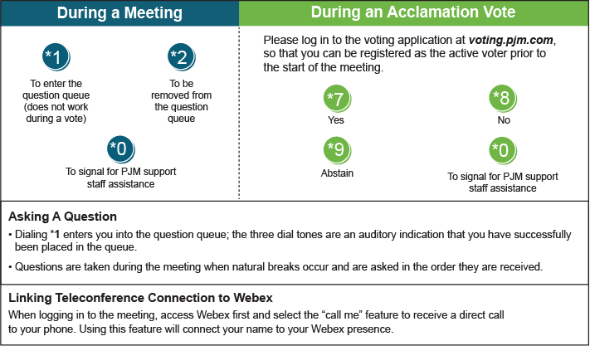

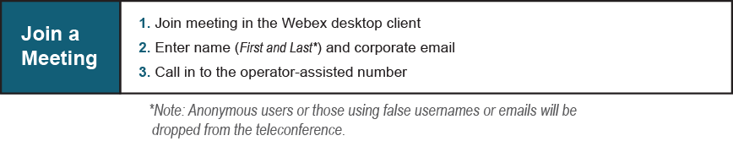
Provide feedback on the progress of this group: Facilitator Feedback Form
Visit learn.pjm.com, an easy-to-understand resource about the power industry and PJM’s role.

