Market Implementation Committee

WebEx / Conference & Training Center

July 13, 2022

9:00 a.m. – 4:00 p.m. EPT

Administration (9:00 – 9:15)

Nicholas DiSciullo will review the Antitrust, Code of Conduct, Public Meetings/Media Participation and the WebEx Participant Identification Requirements.

The Committee will be asked to approve the draft minutes from the June 8, 2022 Market Implementation Committee.

1. Zeenath Fernandes will provide an update on the retirement of Weak Encryption and its impact to Markets applications.

Endorsements/Approvals (9:15 – 10:55)

1. **Variable Environmental Costs and Credits (9:15 – 9:45)** 
   1. Melissa Pilong will review a proposal providing detailed guidance and updates to rules related to variable environmental charges and/or credits and their inclusion in cost-based energy offers.
   2. Joel Luna, IMM, will provide education on the inclusion of Renewable Energy Certificates (RECs) and Production Tax Credits (PTCs) in cost-based offers.

The committee will be asked to endorse the proposal at this meeting.

[Issue Tracking: Variable Environmental Costs and Credits](https://www.pjm.com/committees-and-groups/issue-tracking/issue-tracking-details.aspx?Issue=c95724bc-c61d-4226-9772-ac411886523e)

1. **Market Suspension (9:45 – 10:00)** 
   1. Stefan Starkov will review the PJM/IMM Package addressing the treatment of long-term market suspensions.
   2. Sean Chang, Shell, will provide details on a proposed friendly amendment to the PJM/IMM Package.

**The committee will be asked to endorse the package at this meeting.**

[Issue Tracking: Rules Related to Market Suspension](https://www.pjm.com/committees-and-groups/issue-tracking/issue-tracking-details.aspx?Issue=214df9c5-db87-4a02-84be-b917c118d6ed)

1. **Manual 6 Revisions (10:00 – 10:15)**

Emmy Messina will review revisions to Manual 6: Financial Transmission Rights as part of the periodic review and ARR FTR Market Task Force-based conforming changes (Docket No. ER22-797-000).

**The committee will be asked to endorse the revisions at this meeting.**

1. **Manual 18 Revisions: Hybrid Resources (10:15 – 10:25)**

Andrew Levitt will provide an update on the recent hybrids filing (Docket No. ER22-1420) and review conforming revisions to Manual 18: PJM Capacity Market.

**The committee will be asked to endorse the revisions at this meeting.**

[Issue Tracking: Solar-Battery Hybrid Resources](https://www.pjm.com/committees-and-groups/issue-tracking/issue-tracking-details.aspx?Issue=3423b18c-59c2-49dd-84c5-af42b1ba0256)

1. **Manual 28 Revisions: Start-Up Cost Offer Development (10:25 – 10:35)**

Rebecca Stadelmeyer will review revisions to Manual 28: Operating Agreement Accounting to support the Startup Cost Offer Development proposal the committee approved at the April 2022 meeting.

**The committee will be asked to endorse the revisions at this meeting.**

[Issue Tracking: Start-Up Cost Offer Development](https://www.pjm.com/committees-and-groups/issue-tracking/issue-tracking-details.aspx?Issue=46ced1bf-a450-4c80-9199-08ec2be2f4cb)

1. **DR/PRD Compliance Construct for Weather Sensitive Load (10:35 – 10:55)**

Sharon Midgley, Exelon, will review a Problem Statement and Issue Charge addressing the exploration of an alternative DR/PRD compliance construct for weather sensitive load.

**The committee will be asked to approve the Issue Charge at this meeting.**

First Readings (10:55 – 11:55)

1. **Day-ahead Zonal Load Bus Distribution Factors (10:55 – 11:25)**

Amanda Martin will provide education and a first read of a Problem Statement and Issue Charge addressing Day-ahead Zonal Load Bus Distribution Factors. The committee will be asked to approve the issue charge as part of the “CBIR Lite” process outlined in Section 8.6.2 of Manual 34 at its next meeting.

1. **Reserve Price Formation Manual Revisions (11:25 – 11:55)**
   1. Damon Fereshetian will review the Reserve Price Formation Manual revision schedule and the plan to update Manual 11: Energy & Ancillary Services Market Operations
   2. Ilyana Dropkin will provide a first read of conforming revisions to Manual 15: Cost Development Guidelines to address the Reserve Price Formation implementation.

The committee will be asked to endorse the Manual 15 revisions at its next meeting.

[Issue Tracking: Energy Price Formation](https://www.pjm.com/committees-and-groups/issue-tracking/issue-tracking-details.aspx?Issue=9adc71ec-e467-4c91-8239-79ed6a865ea0)

Lunch (11:55 – 12:50)

Working Items (12:50 – 3:45)

1. **Capacity Offer Opportunities for Generation with Co-Located Load (12:50 – 1:50)**
   1. Yuri Smolanitsky will provide education on the impact of sudden loss of co-located load.
   2. Lisa Morelli will facilitate a discussion to review solution options and initial packages for the Capacity Offer Opportunities for Generation with Co-Located Load matrix. Additional solution options and initial packages can be provided in advance of the meeting or during the meeting.

[Issue Tracking: Capacity Offer Opportunities for Generation with Co-Located Load](https://www.pjm.com/committees-and-groups/issue-tracking/issue-tracking-details.aspx?Issue=6897c7e7-d8b7-438e-9e3f-b6099f9dd7ec)

1. **Operating Reserve Clarification for Resources Operating as Requested by PJM (1:50 – 2:50)**

Nick DiSciullo will facilitate a discussion to review design components for the Operating Reserve Clarification for Resources Operating as Requested by PJM matrix. Lisa Morelli and Joel Luna, IMM, will review some potential solution options for the Desired MW section of the matrix. Additional design components and solution options can be provided in advance of the meeting or during the meeting.

[Issue Tracking: Operating Reserve Clarification for Resources Operating as Requested by PJM](https://www.pjm.com/committees-and-groups/issue-tracking/issue-tracking-details.aspx?Issue=6897c7e7-d8b7-438e-9e3f-b6099f9dd7ec)

1. **Quadrennial Review (2:50 – 3:45)**
   1. Rebecca Carroll will review the Work Plan and the results of the Quadrennial Review Poll.
   2. Joe Bowring, IMM, will review its main recommendations.
   3. Joe Bowring, IMM, will present an additional VRR curve sensitivity based on a participant request.
   4. Rebecca Carroll will facilitate a discussion to review proposals for the Quadrennial Review matrix. Additional proposals can be provided in advance of the meeting or during the meeting.

**The committee will be asked to vote on the packages after the July 18 MIC Special Session for the Quadrennial Review.**

[Issue Tracking: 2022 Quadrennial Review](https://www.pjm.com/committees-and-groups/issue-tracking/issue-tracking-details-non-stakeholder.aspx?Issue=8d764b81-1e26-4ed6-98ad-0b1db80ebb08)

Additional Items (3:45 – 4:00)

1. **ARR/FTR Market Task Force (3:45 – 3:55)**

Dave Anders will discuss the results of a recent poll on potential future activities of the task force as well as a potential path forward.

1. Cost Development Subcommittee Update (3:55 – 4:00)

Nicole Scott will provide an informational update on the work to be performed at the Cost Development Subcommittee.

Informational Section

**Fast Start Pricing Monthly Metrics Update**

Materials are posted as informational only.

**Interregional Coordination Update**

Materials are posted as informational only.

**PJM Manual 03 Attachment E Automatic Sectionalizing Schemes**

Materials are posted as informational only.

**Stability Limits in Markets and Operations**

Materials are posted as informational only.

**ARR FTR Market Task Force (AFMTF)**   
Meeting materials are posted to the [AFMTF website](https://www.pjm.com/committees-and-groups/task-forces/afmtf).

**Reactive Power Compensation Task Force (RPCTF)**   
Meeting materials are posted to the [RPCTF website.](https://www.pjm.com/committees-and-groups/task-forces/rpctf)

**Cost Development Subcommittee (CDS)**   
Meeting materials are posted to the [CDS website](https://www.pjm.com/committees-and-groups/subcommittees/cds).

**Demand Response Subcommittee (DRS)**   
Meeting materials are posted to the [DRS website](http://www.pjm.com/committees-and-groups/subcommittees/drs.aspx).

**DER & Inverter-based Resources Subcommittee (DIRS)**

Meeting materials are posted to the [DIRS website.](https://www.pjm.com/committees-and-groups/subcommittees/dirs.aspx)

**Market Settlements Subcommittee (MSS)**

Meeting materials are posted to the [MSS website](http://www.pjm.com/committees-and-groups/subcommittees/mss.aspx).

OC/MIC Fuel Requirements for Black Start Resources

Meeting materials are posted to the [Operating Committee website](https://www.pjm.com/committees-and-groups/committees/oc).

Report on Market Operations

The Report on Market Operations will be reviewed during the [MC Webinar](http://www.pjm.com/committees-and-groups/committees/mc.aspx).

|  |  |  |  |  |
| --- | --- | --- | --- | --- |
| **Future Meeting Dates and Materials** | | | **Materials Due  to Secretary** | **Materials Published** |
| Date | Time | Location | 5 p.m. | 4 p.m. |
| August 10 | 9 a.m. | WebEx / Conference & Training Center | July 29 | August 3 |
| September 7 | 9 a.m. | WebEx / Conference & Training Center | August 26 | August 31 |
| October 6 | 9 a.m. | WebEx / Conference & Training Center | September 26 | September 29 |
| November 2 | 9 a.m. | WebEx / Conference & Training Center | October 21 | October 26 |
| December 7 | 9 a.m. | WebEx / Conference & Training Center | November 23 | November 30 |

Author: Nick DiSciullo

Antitrust:

You may not discuss any topics that violate, or that might appear to violate, the antitrust laws including but not limited to agreements between or among competitors regarding prices, bid and offer practices, availability of service, product design, terms of sale, division of markets, allocation of customers or any other activity that might unreasonably restrain competition. If any of these items are discussed the chair will re-direct the conversation. If the conversation still persists, parties will be asked to leave the meeting or the meeting will be adjourned.

Code of Conduct:

As a mandatory condition of attendance at today's meeting, attendees agree to adhere to the PJM Code of Conduct as detailed in PJM Manual M-34 section 4.5, including, but not limited to, participants' responsibilities and rules regarding the dissemination of meeting discussion and materials.

Public Meetings/Media Participation:

Unless otherwise noted, PJM stakeholder meetings are open to the public and to members of the media. Members of the media are asked to announce their attendance at all PJM stakeholder meetings at the beginning of the meeting or at the point they join a meeting already in progress. Members of the Media are reminded that speakers at PJM meetings cannot be quoted without explicit permission from the speaker. PJM Members are reminded that "detailed transcriptional meeting notes" and white board notes from "brainstorming sessions" shall not be disseminated. Stakeholders are also not allowed to create audio, video or online recordings of PJM meetings. PJM may create audio, video or online recordings of stakeholder meetings for internal and training purposes, and your participation at such meetings indicates your consent to the same.

Participant Identification in WebEx:

When logging into the WebEx desktop client, please enter your real first and last name as well as a valid email address. Be sure to select the “call me” option.

PJM support staff continuously monitors WebEx connections during stakeholder meetings. Anonymous users or those using false usernames or emails will be dropped from the teleconference.

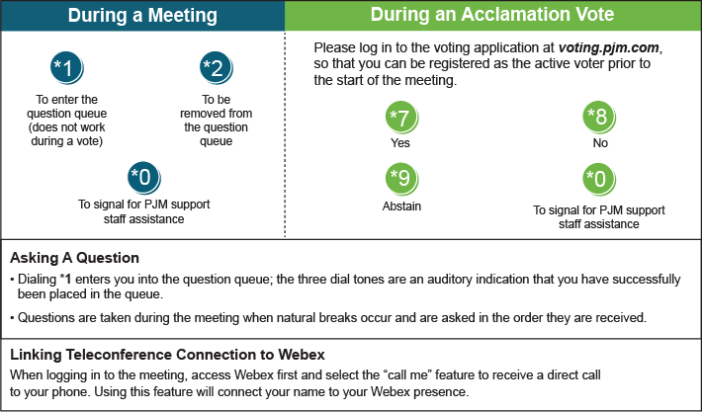

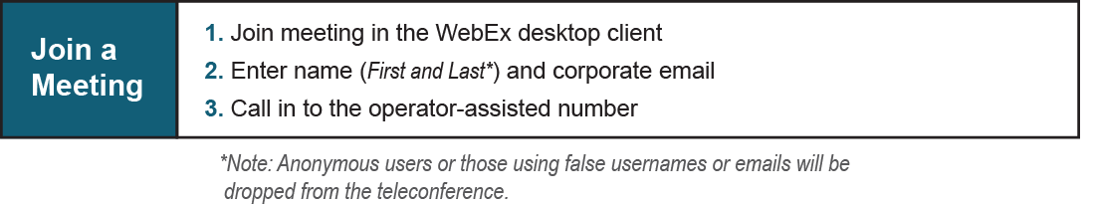

Provide feedback on the progress of this group: [*Facilitator Feedback Form*](https://www.pjm.com/committees-and-groups/committees/form-facilitator-feedback.aspx)   
Visit [*learn.pjm.com*](https://learn.pjm.com/), an easy-to-understand resource about the power industry and PJM’s role.