Market Implementation Committee

WebEx Only

October 6, 2021

9:00 a.m. – 12:00 p.m. EPT

Administration (9:00 – 9:40)

Nicholas DiSciullo will review the Antitrust, Code of Conduct, Public Meetings/Media Participation and the WebEx Participant Identification Requirements.

The Committee will be asked to approve the draft minutes from the September 9, 2021 Market Implementation Committee meeting and the September 23, 2021 MIC Special Session on MSOC and Net ACR.

1. The Committee will review the MIC Charter.

X. MOPR-Related Activity Deadlines for 2023/2024 BRA (9:10 – 9:25)

Pete Langbein will review a timeline of new MOPR-related activities that must be completed by all Capacity Market Sellers for the 2023/2024 Base Residual Auction.

Y. SOO Green Complaint Update (9:25 – 9:40)

Tim Horger will provide an update on the SOO Green complaint associated with PJM’s external capacity rules.

Endorsements/Approvals (9:40 – 10:30)

1. ARR/FTR Market Task Force Update (9:40 – 10:10)
2. Brian Chmielewski will review the PJM/Joint Stakeholder proposal.
3. Joe Bowring, IMM, will review the IMM proposal.
4. Erik Heinle, DC OPC, will review the DC OPC proposal.
5. Jau Guo, AEP, will review the AEP proposal.

The committee will be asked to endorse the proposals at this meeting.

1. Energy Efficiency (EE) Addback (10:10 – 10:30)

Jeff Bastian will review the IMM/PJM proposal addressing the calculation of the EE Addback.

The committee will be asked to endorse the IMM/PJM proposal at this meeting.

[Issue Tracking: Energy Efficiency Addback](https://www.pjm.com/committees-and-groups/issue-tracking/issue-tracking-details.aspx?Issue=38674ff9-a78e-4b7d-b8ab-96d05bd7ef21)

First Readings (10:30 – 11:10)

1. Start-Up Cost Offer Development (10:30 – 11:10)
2. Nicole Scott and Tom Hauske will provide a first read of the two Packages addressing Start-Up Cost Offer Development developed through the Cost Development Subcommittee.
3. Tom Hyzinski, GT Power Group, will provide additional information of the Clarification Package addressing Start-Up Cost Offer Development developed through the Cost Development Subcommittee.

The committee will be asked to endorse the proposals at its next meeting.

Working Items (11:10 – 12:00)

1. Regulation for Virtual Combined Cycles (11:10 – 11:30)

Jim Gluck will facilitate a discussion to review the solution options and begin the process of developing packages on the Regulation for Virtual Combined Cycles matrix as part of the Consensus Based Issue Resolution process. Additional interests, design components, and solution options can be provided in advance of the meeting or during the meeting.

[Issue Tracking: Regulation for Virtual Combined Cycles](https://www.pjm.com/committees-and-groups/issue-tracking/issue-tracking-details.aspx?Issue=4156560d-cfb4-45e6-aacd-33ec5c9447ed)

1. Market Suspension (11:30 – 12:00)

Stefan Starkov will lead a discussion regarding additional considerations related to the Market Suspension issue based on discussion at the September 29, 2021 Markets and Reliability Committee meeting.

[Issue Tracking: Rules Related to Market Suspension](https://www.pjm.com/committees-and-groups/issue-tracking/issue-tracking-details.aspx?Issue=214df9c5-db87-4a02-84be-b917c118d6ed)

Informational Section

**Manual 03 Updates**

Updates to PJM Manual 03, Revision 60 – Transmission Operations are posted as informational only with meeting materials

**Fast Start Pricing Monthly Metrics Update**

Materials are posted as informational only.

**Q3 2021 Net Energy Injections Quarterly Report**

Materials are posted as informational only.

**ARR FTR Market Task Force (AFMTF)**   
Meeting materials are posted to the [AFMTF website](https://www.pjm.com/committees-and-groups/task-forces/afmtf).

**Cost Development Subcommittee (CDS)**   
Meeting materials are posted to the [CDS website](https://www.pjm.com/committees-and-groups/subcommittees/cds).

**Demand Response Subcommittee (DRS)**   
Meeting materials are posted to the [DRS website](http://www.pjm.com/committees-and-groups/subcommittees/drs.aspx).

**DER & Inverter-based Resources Subcommittee (DIRS)**

Meeting materials are posted to the [DIRS website.](https://www.pjm.com/committees-and-groups/subcommittees/dirs.aspx)

**Market Settlements Subcommittee (MSS)**

Meeting materials are posted to the [MSS website](http://www.pjm.com/committees-and-groups/subcommittees/mss.aspx).

Report on Market Operations

The Report on Market Operations will be reviewed during the [MC Webinar](http://www.pjm.com/committees-and-groups/committees/mc.aspx).

|  |  |  |  |  |
| --- | --- | --- | --- | --- |
| **Future Meeting Dates and Materials** | | | **Materials Due  to Secretary** | **Materials Published** |
| Date | Time | Location | 5 p.m. | 4 p.m. |
| November 3 | 9 a.m. | WebEx | October 22 | October 27 |
| December 1 | 9 a.m. | WebEx | November 19 | November 24 |

Author: Nicholas DiSciullo

Antitrust:

You may not discuss any topics that violate, or that might appear to violate, the antitrust laws including but not limited to agreements between or among competitors regarding prices, bid and offer practices, availability of service, product design, terms of sale, division of markets, allocation of customers or any other activity that might unreasonably restrain competition. If any of these items are discussed the chair will re-direct the conversation. If the conversation still persists, parties will be asked to leave the meeting or the meeting will be adjourned.

Code of Conduct:

As a mandatory condition of attendance at today's meeting, attendees agree to adhere to the PJM Code of Conduct as detailed in PJM Manual M-34 section 4.5, including, but not limited to, participants' responsibilities and rules regarding the dissemination of meeting discussion and materials.

Public Meetings/Media Participation:

Unless otherwise noted, PJM stakeholder meetings are open to the public and to members of the media. Members of the media are asked to announce their attendance at all PJM stakeholder meetings at the beginning of the meeting or at the point they join a meeting already in progress. Members of the Media are reminded that speakers at PJM meetings cannot be quoted without explicit permission from the speaker. PJM Members are reminded that "detailed transcriptional meeting notes" and white board notes from "brainstorming sessions" shall not be disseminated. Stakeholders are also not allowed to create audio, video or online recordings of PJM meetings. PJM may create audio, video or online recordings of stakeholder meetings for internal and training purposes, and your participation at such meetings indicates your consent to the same.

Participant Identification in WebEx:

When logging into the WebEx desktop client, please enter your real first and last name as well as a valid email address. Be sure to select the “call me” option.

PJM support staff continuously monitors WebEx connections during stakeholder meetings. Anonymous users or those using false usernames or emails will be dropped from the teleconference.

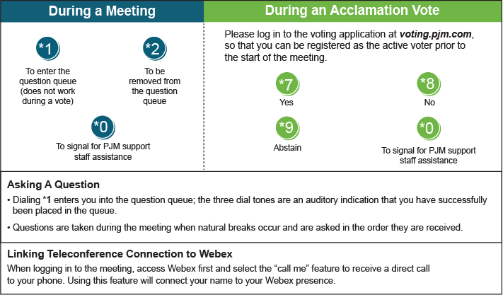

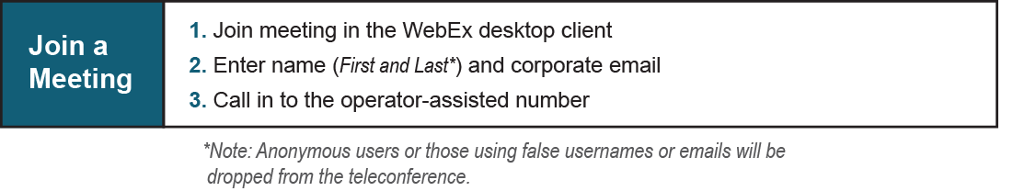

Provide feedback on the progress of this group: [*Facilitator Feedback Form*](https://www.pjm.com/committees-and-groups/committees/form-facilitator-feedback.aspx)   
Visit [*learn.pjm.com*](https://learn.pjm.com/), an easy-to-understand resource about the power industry and PJM’s role.