Market Implementation Committee

WebEx Only

August 11, 2021

9:00 a.m. – 4:00 p.m. EPT

Administration (9:00 – 9:05)

Nicholas DiSciullo will review the Antitrust, Code of Conduct, Public Meetings/Media Participation and the WebEx Participant Identification Requirements.

The Committee will be asked to approve the draft minutes from the July 14, 2021 Market Implementation Committee meeting.

Endorsements/Approvals (9:05 – 11:15)

1. Manual 11 Revisions – 5-Minute Dispatch and Pricing (9:05 – 9:20)

Aaron Baizman will review revisions to Manual 11: Energy & Ancillary Services Market Operations. The changes address Five Minute Long Term Changes and Transparency.

The committee will be asked to endorse the revisions at this meeting.

1. Manual 11, Manual 18, and Manual 28 Revisions – Fast Start Pricing (9:20 – 10:25)
2. Phil D’Antonio will review revisions to Manual 11: Energy & Ancillary Services Market Operations, Manual 18: PJM Capacity Market, and Manual 28: Operating Agreement Accounting. The changes address the implementation of Fast Start Pricing.
3. Catherine Tyler will provide an overview of IMM concerns with the formation of Ancillary Service Market Clearing Prices under some Fast Start conditions.
4. Zhenyu Fan and Phil D’Antonio will review Fast Start implementation and metrics.

The committee will be asked to endorse the revisions at this meeting.

1. Solar-Battery Hybrid Resources (10:30 – 10:50)
2. Andrew Levitt will review Package A that was developed in the DER and Inverter-based Resources Subcommittee (DIRS).
3. Jim Davis, Dominion Energy, will review Package C that was developed in the DIRS.

The committee will be asked to endorse the proposals at this meeting.

1. Energy Efficiency (EE) Addback (10:45 – 11:15)
2. Joe Bowring, IMM, will review a Problem Statement and Issue Charge addressing the calculation of the EE Addback.
3. Jeff Bastian will provide education on RPM Auction Participation by EE Resources.
4. Lisa Morelli will facilitate a discussion on the development of the CBIR matrix.

The committee will be asked to approve the issue charge at this meeting.

First Readings – Part 1 (11:15 – 12:10)

1. Manual 15~~, OA, and OATT~~ Revisions - Incremental & No Load Energy Offer (11:15 – 11:45)
2. Heather Reiter will provide an overview of Cost Development Subcommittee (CDS) work plan.
3. Tom Hauske will provide a first read of the Manual 15: Cost Development Guidelines~~, OA, and OATT~~ revisions that were developed in the CDS. OA and OATT revisions will be provided as an informational only update. The committee will be asked to endorse the Manual 15 revisions at its next meeting.
4. Regional Transmission and Energy Scheduling Practices Revisions (11:45 – 12:10)

Chris Pacella will provide a first read of revisions to the Regional Transmission and Energy Scheduling Practices document. The committee will be asked to endorse the revisions at its next meeting.

Lunch (12:10 – 12:40)

First Readings – Part 2 (12:40 – 1:30)

1. RPM Capacity Transfer Rights (12:40 – 1:30)
2. Lisa Morelli will facilitate a discussion to gather solution options from the committee and develop packages. Additional interests, design components, solution options and packages can be provided in advance of the meeting or during the meeting.
3. Kevin Zemanek, Buckeye Power, will provide a first read of the Buckeye proposal.
4. Jeff Bastian will review the MW quantity of qualified requests by zone to assist participants in evaluating the impact of the Buckeye proposal.

The committee will be asked to endorse the proposal at its next meeting.

[Issue Tracking: Capacity](https://www.pjm.com/committees-and-groups/issue-tracking/issue-tracking-details.aspx?Issue=%7b459A68BA-82B9-4199-8CCF-950FA0C74DDF%7d) Transfer Rights in RPM

Working Items (1:30 – 3:05)

1. Regulation for Virtual Combined Cycles (1:30 – 2:20)
2. Michael Olaleye will provide education on the causes of virtual combined cycle units not clearing equally in the regulation market, how this issue differs from regulation awards for combined cycles that are modeled differently, and education on prior-used solutions.
3. Lisa Morelli will facilitate a discussion to identify interests and design components for the Regulation for Virtual Combined Cycles issue charge as part of the Consensus Based Issue Resolution process.

[Issue Tracking: Regulation for Virtual Combined Cycles](https://www.pjm.com/committees-and-groups/issue-tracking/issue-tracking-details.aspx?Issue=4156560d-cfb4-45e6-aacd-33ec5c9447ed)

1. Undefined Regulation Mileage Ratio Calculation (2:20 – 3:05)
2. Michael Olaleye will provide education on the Undefined Regulation Mileage Ratio Calculation issue.
3. Joe Bowring, IMM, will provide education on the Undefined Regulation Mileage Ratio Calculation issue.
4. Lisa Morelli will facilitate a discussion on the development of the CBIR matrix.

[Issue Tracking: Undefined Regulation Mileage Ratio Calculation](https://www.pjm.com/committees-and-groups/issue-tracking/issue-tracking-details.aspx?Issue=8f567a45-cd61-4d1c-97dd-cc2d3bd772ee)

Additional Items (3:05 – 4:00)

1. Real-Time Values / Parameter Limited Schedules (3:05 – 4:00)
2. Lauren Strella Wahba will review a straw proposal for Real-Time Values.
3. Keyur Patel will continue to discuss options for Parameter Limited Schedules.

Informational Section

**PJM Manual 03 Attachment E Automatic Sectionalizing Schemes**  
Materials are posted as informational only.

**ARR FTR Market Task Force (AFMTF)**   
Meeting materials are posted to the [AFMTF website](https://www.pjm.com/committees-and-groups/task-forces/afmtf).

**Cost Development Subcommittee (CDS)**   
Meeting materials are posted to the [CDS website](https://www.pjm.com/committees-and-groups/subcommittees/cds).

**Demand Response Subcommittee (DRS)**   
Meeting materials are posted to the [DRS website](http://www.pjm.com/committees-and-groups/subcommittees/drs.aspx).

**DER & Inverter-based Resources Subcommittee (DIRS)**

Meeting materials are posted to the [DIRS website.](https://www.pjm.com/committees-and-groups/subcommittees/dirs.aspx)

**Market Settlements Subcommittee (MSS)**

Meeting materials are posted to the [MSS website](http://www.pjm.com/committees-and-groups/subcommittees/mss.aspx).

Report on Market Operations

The Report on Market Operations will be reviewed during the [MC Webinar](http://www.pjm.com/committees-and-groups/committees/mc.aspx).

|  |  |  |  |  |
| --- | --- | --- | --- | --- |
| **Future Meeting Dates and Materials** | | | **Materials Due  to Secretary** | **Materials Published** |
| Date | Time | Location | 5 p.m. | 4 p.m. |
| September 9 | 9 a.m. | WebEx | August 30 | September 2 |
| October 6 | 9 a.m. | WebEx | September 24 | September 29 |
| November 3 | 9 a.m. | WebEx | October 22 | October 27 |
| December 1 | 9 a.m. | WebEx | November 19 | November 24 |

Author: Nicholas DiSciullo

Antitrust:

You may not discuss any topics that violate, or that might appear to violate, the antitrust laws including but not limited to agreements between or among competitors regarding prices, bid and offer practices, availability of service, product design, terms of sale, division of markets, allocation of customers or any other activity that might unreasonably restrain competition. If any of these items are discussed the chair will re-direct the conversation. If the conversation still persists, parties will be asked to leave the meeting or the meeting will be adjourned.

Code of Conduct:

As a mandatory condition of attendance at today's meeting, attendees agree to adhere to the PJM Code of Conduct as detailed in PJM Manual M-34 section 4.5, including, but not limited to, participants' responsibilities and rules regarding the dissemination of meeting discussion and materials.

Public Meetings/Media Participation:

Unless otherwise noted, PJM stakeholder meetings are open to the public and to members of the media. Members of the media are asked to announce their attendance at all PJM stakeholder meetings at the beginning of the meeting or at the point they join a meeting already in progress. Members of the Media are reminded that speakers at PJM meetings cannot be quoted without explicit permission from the speaker. PJM Members are reminded that "detailed transcriptional meeting notes" and white board notes from "brainstorming sessions" shall not be disseminated. Stakeholders are also not allowed to create audio, video or online recordings of PJM meetings. PJM may create audio, video or online recordings of stakeholder meetings for internal and training purposes, and your participation at such meetings indicates your consent to the same.

Participant Identification in WebEx:

When logging into the WebEx desktop client, please enter your real first and last name as well as a valid email address. Be sure to select the “call me” option.

PJM support staff continuously monitors WebEx connections during stakeholder meetings. Anonymous users or those using false usernames or emails will be dropped from the teleconference.

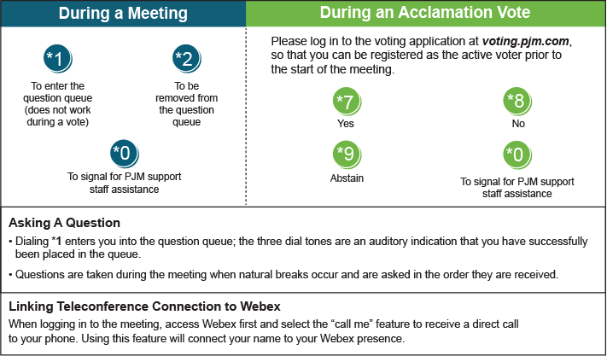

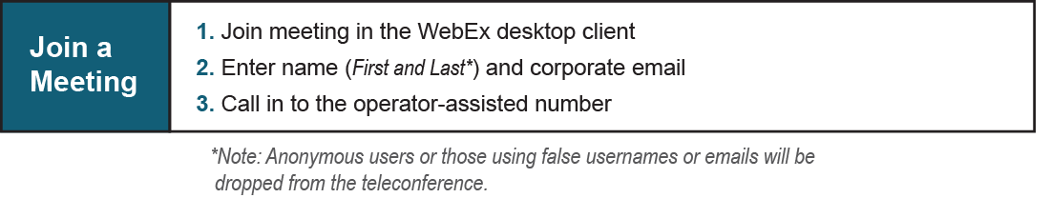

Provide feedback on the progress of this group: [*Facilitator Feedback Form*](https://www.pjm.com/committees-and-groups/committees/form-facilitator-feedback.aspx)   
Visit [*learn.pjm.com*](https://learn.pjm.com/), an easy-to-understand resource about the power industry and PJM’s role.