Market Implementation Committee

WebEx Only

May 13, 2021

9:00 a.m. – 2:00 p.m. EPT

Administration (9:00 – 9:10)

Nicholas DiSciullo will review the Antitrust, Code of Conduct, Public Meetings/Media Participation and the WebEx Participant Identification Requirements.

The Committee will be asked to approve the draft minutes from the April 21, 2021 MIC Special Session on Market Seller Offer Cap and the draft minutes from the April 10, 2021 Market Implementation Committee meeting.

Nicholas DiSciullo will provide an update on the MIC Work Plan.

Endorsements/Approvals (9:10 – 10:00)

1. Reactive Supply and Voltage Control Compensation (9:10 – 9:40)
2. Jim Davis, Dominion Energy, will review Dominion Energy’s Problem Statement and Issue Charge addressing Compensation for Reactive Supply and Voltage Control service.
3. Joe Bowring, IMM, will review the IMM’s Problem Statement and Issue Charge addressing Compensation for Reactive Supply and Voltage Control service.

The committee will be asked to vote on all the issue charges.

1. Regulation for Virtual Combined Cycles (9:40 – 10:00)

Becky Robinson, Vistra, will review the Problem Statement and Issue Charge addressing Regulation for Virtual Combined Cycles.

The committee will be asked to approve the Issue Charge at this meeting.

First Readings (10:00 – 10:40)

1. Regulation Mileage Ratio (10:00 – 10:20)

Michael Olaleye will provide a first read of a Problem Statement and Issue Charge addressing Regulation Mileage Ratio. The committee will be asked to approve the issue charge and endorse the solution as part of the Quick Fix process outlined in Section 8.6.1 of Manual 34 at its next meeting.

1. Market Suspension (10:20 – 10:40)

Stefan Starkov will provide a first read of the PJM package.

The committee will be asked to vote on the PJM package at its next meeting.

[Issue Tracking: Rules Related to Market Suspension](https://www.pjm.com/committees-and-groups/issue-tracking/issue-tracking-details.aspx?Issue=%7b214DF9C5-DB87-4A02-84BE-B917C118D6ED%7d)

Additional Items – Part 1 ~~(11:10 – 11:40)~~ (10:40 – 11:35)

1. **Fast-Start Pricing Update ~~(11:10 – 11:20)~~ (10:40 – 10:50)**

Phil D’Antonio will provide an update on the revised implementation plan for Fast-Start Pricing.

1. Real Time Values (RTV) Markets Gateway Process Update ~~(11:20 – 11:25)~~ (10:50 – 10:55)

Tong Zhao will provide a review of the recent change to the RTV submittal process in Markets Gateway following the change to the RTV market rules.

1. Update on FERC Order Rejecting ELCC Proposal ~~(11:25 – 11:40)~~ (10:55 – 11:10)

Thomas DeVita and Andrew Levitt will describe the FERC Order rejecting the ELCC proposal, FERC’s deadlines for a paper hearing on current capacity accreditation rules, the option to file a revised ELCC proposal, and potential next steps.

Materials have been updated to provide consistency with Pardot communications and add additional context and details on the governing document authority.

1. PJM Administrative Rate Review ~~(12:20 – 12:45)~~ (11:10 – 11:35)

Jim Snow will provide an update on the PJM Administrative Rate review initiative.

Lunch ~~(11:40 – 12:20)~~ (11:35 – 12:15)

Additional Items – Part 2 ~~(12:20 – 2:00)~~ (12:15 – 1:30)

1. Reserve Price Formation ORDCs ~~(12:45 – 1:25)~~ (12:15 – 12:55)

Patricio Rocha Garrido and Angelo Marcino will provide education on the new Reserve Price Formation Operating Reserve Demand Curves (ORDCs).

1. Shortage Pricing ~~(1:25 – 2:00)~~ (12:55 – 1:30)

Damon Fereshetian will provide education on Shortage Pricing.

Working Items ~~(10:40 – 11:10)~~ (1:30 – 2:00)

1. RPM Capacity Transfer Rights ~~(10:40 – 11:10)~~ (1:30 – 2:00)

Lisa Morelli will facilitate a discussion to identify interests and design components for the RPM Capacity Transfer Rights issue charge.

[Issue Tracking: Capacity](https://www.pjm.com/committees-and-groups/issue-tracking/issue-tracking-details.aspx?Issue=%7b459A68BA-82B9-4199-8CCF-950FA0C74DDF%7d) Transfer Rights in RPM

Informational Section

**Interregional Coordination Update**

Materials are posted as informational only.

**South IMP/EXP Interface Consolidation**

Materials are posted as informational only.

**Q1 2021 Net Energy Injections Quarterly Report**

Materials are posted as informational only.

**ARR FTR Market Task Force (AFMTF)**   
Meeting materials are posted to the [AFMTF website](https://www.pjm.com/committees-and-groups/task-forces/afmtf).

**Cost Development Subcommittee (CDS)**   
Meeting materials are posted to the [CDS website](https://www.pjm.com/committees-and-groups/subcommittees/cds).

**Demand Response Subcommittee (DRS)**   
Meeting materials are posted to the [DRS website](http://www.pjm.com/committees-and-groups/subcommittees/drs.aspx).

**DER & Inverter-based Resources Subcommittee (DIRS)**

Meeting materials are posted to the [DIRS website.](https://www.pjm.com/committees-and-groups/subcommittees/dirs.aspx)

**Market Settlements Subcommittee (MSS)**

Meeting materials are posted to the [MSS website](http://www.pjm.com/committees-and-groups/subcommittees/mss.aspx).

Report on Market Operations

The Report on Market Operations will be reviewed during the [MC Webinar](http://www.pjm.com/committees-and-groups/committees/mc.aspx).

|  |  |  |  |  |
| --- | --- | --- | --- | --- |
| **Future Meeting Dates and Materials** | | | **Materials Due  to Secretary** | **Materials Published** |
| Date | Time | Location | 5 p.m. | 4 p.m. |
| June 9 | 9 a.m. | WebEx | May 27 | June 2 |
| July 14 | 9 a.m. | WebEx | July 1 | July 7 |
| August 11 | 9 a.m. | WebEx | July 30 | August 4 |
| September 9 | 9 a.m. | WebEx | August 30 | September 2 |
| October 6 | 9 a.m. | WebEx | September 24 | September 29 |
| November 3 | 9 a.m. | WebEx | October 22 | October 27 |
| December 1 | 9 a.m. | WebEx | November 19 | November 24 |

Author: Nicholas DiSciullo

Antitrust:

You may not discuss any topics that violate, or that might appear to violate, the antitrust laws including but not limited to agreements between or among competitors regarding prices, bid and offer practices, availability of service, product design, terms of sale, division of markets, allocation of customers or any other activity that might unreasonably restrain competition. If any of these items are discussed the chair will re-direct the conversation. If the conversation still persists, parties will be asked to leave the meeting or the meeting will be adjourned.

Code of Conduct:

As a mandatory condition of attendance at today's meeting, attendees agree to adhere to the PJM Code of Conduct as detailed in PJM Manual M-34 section 4.5, including, but not limited to, participants' responsibilities and rules regarding the dissemination of meeting discussion and materials.

Public Meetings/Media Participation:

Unless otherwise noted, PJM stakeholder meetings are open to the public and to members of the media. Members of the media are asked to announce their attendance at all PJM stakeholder meetings at the beginning of the meeting or at the point they join a meeting already in progress. Members of the Media are reminded that speakers at PJM meetings cannot be quoted without explicit permission from the speaker. PJM Members are reminded that "detailed transcriptional meeting notes" and white board notes from "brainstorming sessions" shall not be disseminated. Stakeholders are also not allowed to create audio, video or online recordings of PJM meetings. PJM may create audio, video or online recordings of stakeholder meetings for internal and training purposes, and your participation at such meetings indicates your consent to the same.

Participant Identification in WebEx:

When logging into the WebEx desktop client, please enter your real first and last name as well as a valid email address. Be sure to select the “call me” option.

PJM support staff continuously monitors WebEx connections during stakeholder meetings. Anonymous users or those using false usernames or emails will be dropped from the teleconference.

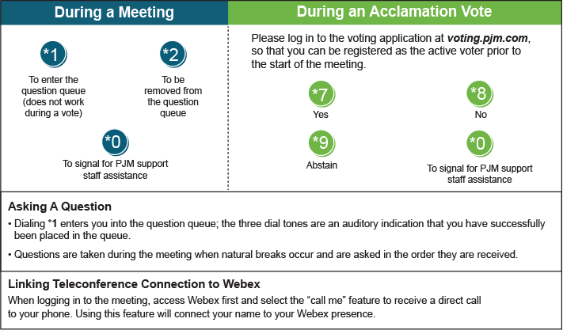

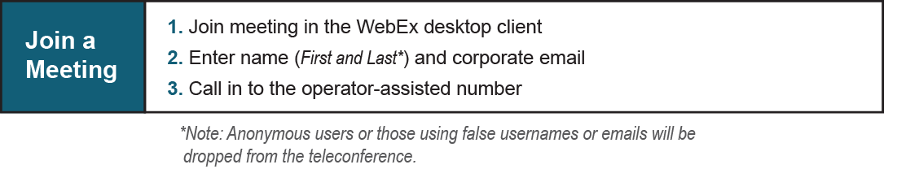

Provide feedback on the progress of this group: [*Facilitator Feedback Form*](https://www.pjm.com/committees-and-groups/committees/form-facilitator-feedback.aspx)   
Visit [*learn.pjm.com*](https://learn.pjm.com/), an easy-to-understand resource about the power industry and PJM’s role.