MIC Special Session: Behind the Meter Generation Business Rules on Status Changes
Webex Only
April 30, 2021
9:00 a.m. – 12:00 p.m. EPT

Administration (9:00-9:05)
Nicholas Disciullo, facilitator, will welcome participants, review the agenda, and review the work timeline
Andrea Yeaton, secretary, will review the Antitrust, Code of Conduct, and Public Meetings/Media Participation Guidelines.
The Special Session of the Market Implementation Committee: Behind the Meter Generation Business Rules on Status Changes will be requested to approve the draft minutes from the March 30, 2021 meeting.

Working Discussion – Designate Capability as Generation Capacity Resource/Energy Resource (9:05-10:00)
- Terri Esterly, PJM, will review PJM-proposed OATT, M14G, and M14D updates that address gaps in the in the “Designate Capability as Generation Capacity Resource and/or Energy Resource” area of the Gap Analysis Matrix. PJM will be soliciting feedback during the meeting on the initial proposed changes.

Education – BTMG & PJM Load Response (10:00-10:30)
Pete Langbein, PJM, will present education on BTMG participating as PJM Load Response.

Break (10:30-10:40)

Working Discussion –Designate Capability as PJM Load Response (10:40-11:15)
- Terri Esterly, PJM, will discuss the gaps identified in the existing business rules included in the area of the Gap Analysis Matrix titled ”Designate Capability as PJM Load Response” and review PJM’s initial proposed updates to address gaps. PJM will be soliciting feedback during the meeting on the initial proposed changes.

Education – Load Impacts (11:15-12:00)
- Terri Esterly, PJM, will present education on existing business rules in the area of the Gap Analysis Matrix titled “Load Impacts”.

Future Agenda Items

Future Meeting Dates
Thursday, June 03, 2021 | 9:00 a.m. to 12:00 p.m. | Webex
Author: Andrea Yeaton

Antitrust:
You may not discuss any topics that violate, or that might appear to violate, the antitrust laws including but not limited to agreements between or among competitors regarding prices, bid and offer practices, availability of service, product design, terms of sale, division of markets, allocation of customers or any other activity that might unreasonably restrain competition. If any of these items are discussed the chair will re-direct the conversation. If the conversation still persists, parties will be asked to leave the meeting or the meeting will be adjourned.

Code of Conduct:
As a mandatory condition of attendance at today's meeting, attendees agree to adhere to the PJM Code of Conduct as detailed in PJM Manual M-34 section 4.5, including, but not limited to, participants' responsibilities and rules regarding the dissemination of meeting discussion and materials.

Public Meetings/Media Participation:
Unless otherwise noted, PJM stakeholder meetings are open to the public and to members of the media. Members of the media are asked to announce their attendance at all PJM stakeholder meetings at the beginning of the meeting or at the point they join a meeting already in progress. Members of the Media are reminded that speakers at PJM meetings cannot be quoted without explicit permission from the speaker. PJM Members are reminded that "detailed transcriptional meeting notes" and white board notes from "brainstorming sessions" shall not be disseminated. Stakeholders are also not allowed to create audio, video or online recordings of PJM meetings. PJM may create audio, video or online recordings of stakeholder meetings for internal and training purposes, and your participation at such meetings indicates your consent to the same.
Participant Identification in Webex:
When logging into the Webex desktop client, please enter your real first and last name as well as a valid email address. Be sure to select the “call me” option.
PJM support staff continuously monitors Webex connections during stakeholder meetings. Anonymous users or those using false usernames or emails will be dropped from the teleconference.



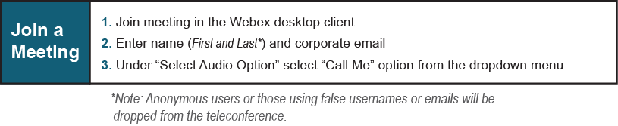

Provide feedback on the progress of this group: Facilitator Feedback Form
Visit learn.pjm.com, an easy-to-understand resource about the power industry and PJM’s role.

