Market Implementation Committee
WebEx Only
November 5 2020
9:00 a.m. – 4:00 p.m. EPT

Administration (9:00-9:05)
Nicholas DiSciullo will review the Antitrust, Code of Conduct, Public Meetings/Media Participation and the WebEx Participant Identification Requirements.

The Committee will be asked to approve the draft minutes from the October 7, 2020 Market Implementation Committee meeting.

Endorsements/Approvals (9:05 – 10:30)
- Fuel Cost Policy Enhancements (9:05 – 9:35)
- Bhavana Keshavamurthy will review the PSEG proposal addressing Key Work Activity 4 of the Fuel Cost Policy Enhancements Issue Charge.
- Catherine Tyler, Monitoring Analytics, will present the IMM’s comments.
The committee will be asked to endorse the proposal at this meeting. If the package receives greater than 50%, a second non-binding poll will be taken asking whether participants prefer the package over the status quo.
Issue Tracking: Fuel Cost Policy

- Real Time Values Market Rules (9:35 – 10:15)
- Laura Walter will review the PJM package from the Real Time Values Market Rules matrix.
- Monitoring Analytics staff will review the details of their package on the Real Time Values issue.
The committee will be asked to vote on these packages at this meeting. If any of the packages receive greater than 50%, a second non-binding poll will be taken asking whether participants prefer that package over the status quo.
Issue Tracking: Real Time Market Values

- Manual 11 Revisions (10:15 – 10:30)
Vijay Shah will review proposed updates to Manual 11: Energy & Ancillary Services Market Operations. The changes are around increasing transparency and conforming to current PJM process as part of the 5 minute Dispatch and Pricing Problem Statement.
The committee will be asked to endorse the Manual 11 revisions at this meeting.
Issue Tracking: Five Minute Dispatch and Pricing

First Readings – Part 1 (10:30 - 11:05)
- Manual 6: FTR Bid Limits Changes (10:30 – 10:40)
Brian Chmielewski will provide a first read of updates to Manual 6: Financial Transmission Rights. The changes address the enforcement of FTR Bid Limits at the corporate entity level. The committee will be asked to endorse these changes at the next MIC meeting.

- Manual 11 and Manual 18: Public Distribution Microgrids Changes (10:40 – 11:05)
Natalie Tacka will review a proposal on Public Distribution Microgrids and provide a first read of updates to Manual 11: Energy & Ancillary Services Market Operations and Manual 18: PJM Capacity Market. The committee will be asked to endorse these changes at the next MIC meeting.

Working Items – Part 1 (11:05 - 12:05)
- PRD Credits Disposition (11:05 – 11:35)
Lisa Morelli will facilitate a discussion to gather solution options from the committee. Additional design components and solution options can be provided in advance of the meeting or during the meeting.
Issue Tracking: Price Responsive Demand (PRD) Credits Disposition

- Market Suspension (11:35 – 12:05)
- Stefan Starkov will provide education on the Market Suspension issue, addressing PJM Manual Dispatch.
- Lisa Morelli will facilitate a discussion to identify interests and design components for the Market Suspension issue charge.
Issue Tracking: Rules Related to Market Suspension

Lunch (12:05 – 12:45)

First Readings – Part 2 (12:45 - 12:55)
- Manual 28: UTC Uplift Changes (12:45 – 12:55)
Ray Fernandez will provide a first read of updates to Manual 28: Operating Agreement Accounting conforming with the changes to FERC Order EL-14-37-000. The changes address the allocation of real-time uplift and day-ahead uplift to UTCs. The committee will be asked to endorse these changes at the next MIC meeting.

Working Items – Part 2 (12:55 - 2:05)
- Transparency in Performance Assessment Interval Settlements (12:55 – 1:45)
- Monitoring Analytics staff will provide their perspective on the topic of Transparency in Performance Assessment Interval Settlements.
- Susan Kenney and Terri Esterly will review some of the governing document sections related to Performance Assessment Interval (PAI) settlements that have been identified as requiring additional clarity and transparency. Suggested manual revisions to address these needs will also be reviewed.
Issue Tracking: Transparency in Performance Assessment Interval Settlements

Additional Items (1:45 – 2:50)
- Stability Limits in Markets and Operations (1:45 – 2:05)
Joe Ciabattoni will review and solicit feedback on proposed updates to Manual 3: Transmission Operations and Manual 28: Operating Agreement Accounting to reflect the Capacity Constraint package, which was endorsed at the September MIC and will proceed to the October MRC as the main motion.
Issue Tracking: Stability Limits in Markets and Operations
- Long-Term 5-Minute Dispatch & Pricing Work Plan (2:05 – 2:15)
Aaron Baizman will provide an update on the PJM Long-Term 5-Minute Dispatch & Pricing effort.
Issue Tracking: Five Minute Dispatch and Pricing
- Fast Start Pricing Implementation (2:15 – 2:20)
Phil D’Antonio will provide an update on the tentative plan for the Fast Start Pricing implementation.
- Minimum Offer Price Rule Update (2:20-2:50)
PJM staff will provide an update on Base Residual Auction activities that may voluntarily commence prior to a firm auction schedule. PJM and IMM staffwill also provide an update on the State Subsidy guidance process.

Informational Section
CP Unit Specific Parameter Update
Materials are posted as informational only.

Q3 2020 Net Energy Injections Quarterly Report
Materials are posted as informational only.

Interregional Coordination Update
Materials are posted as informational only.

Credit Subcommittee (CS)
Meeting materials are posted to the CS website.

Demand Response Subcommittee (DRS)
Meeting materials are posted to the DRS website.

DER & Inverter-based Resources Subcommittee (DIRS)
Meeting materials are posted to the DIRS website.

Market Settlements Subcommittee (MSS)
Meeting materials are posted to the MSS website.

Report on Market Operations
The Report on Market Operations will be reviewed during the MC Webinar.

Future Meeting Dates
December 2, 2020 | 9:00 a.m. | WebEx
Author: Nick DiSciullo

Antitrust:
You may not discuss any topics that violate, or that might appear to violate, the antitrust laws including but not limited to agreements between or among competitors regarding prices, bid and offer practices, availability of service, product design, terms of sale, division of markets, allocation of customers or any other activity that might unreasonably restrain competition. If any of these items are discussed the chair will re-direct the conversation. If the conversation still persists, parties will be asked to leave the meeting or the meeting will be adjourned.

Code of Conduct:
As a mandatory condition of attendance at today's meeting, attendees agree to adhere to the PJM Code of Conduct as detailed in PJM Manual M-34 section 4.5, including, but not limited to, participants' responsibilities and rules regarding the dissemination of meeting discussion and materials.

Public Meetings/Media Participation:
Unless otherwise noted, PJM stakeholder meetings are open to the public and to members of the media. Members of the media are asked to announce their attendance at all PJM stakeholder meetings at the beginning of the meeting or at the point they join a meeting already in progress. Members of the Media are reminded that speakers at PJM meetings cannot be quoted without explicit permission from the speaker. PJM Members are reminded that "detailed transcriptional meeting notes" and white board notes from "brainstorming sessions" shall not be disseminated. Stakeholders are also not allowed to create audio, video or online recordings of PJM meetings. PJM may create audio, video or online recordings of stakeholder meetings for internal and training purposes, and your participation at such meetings indicates your consent to the same.
Participant Identification in WebEx:
When logging into the WebEx desktop client, please enter your real first and last name as well as a valid email address. Be sure to select the “call me” option.
PJM support staff continuously monitors WebEx connections during stakeholder meetings. Anonymous users or those using false usernames or emails will be dropped from the teleconference.
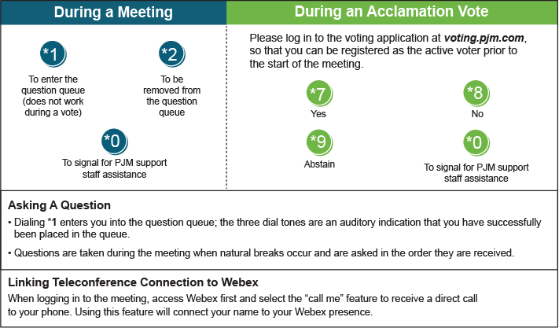

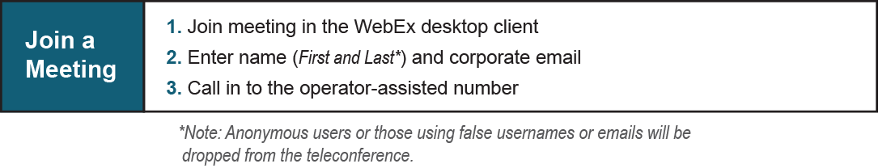
Provide feedback on the progress of this group: Facilitator Feedback Form
Visit learn.pjm.com, an easy-to-understand resource about the power industry and PJM’s role.

