Market Implementation Committee
PJM Conference & Training Center, Audubon, PA
December 13, 2017
9:00 a.m. – 1:00 p.m. EPT

Administration (9:00-9:10)
Welcome, announcements and review of the Antitrust, Code of Conduct, and Public Meetings/Media Participation Guidelines – Ms. Christina Stotesbury and Ms. Chantal Hendrzak

The committee will be asked to approve the draft minutes from the November 8, 2017 Market Implementation Committee meeting.

Ms. Christina Stotesbury, PJM, will review the active MIC issues on Issue Tracking.

Ms. Jennifer Tribulski, PJM, will provide a brief update on the FERC Order addressing Remand in the MOPR Proceeding.

Endorsements/Approvals (9:10-10:10)
- FTR Modeling, Performance & Surplus (9:10-9:50)
Mr. Brian Chmielewski, PJM, will review proposals that have been worked in the FTRMPS Special Sessions of the MIC. The committee will be asked to endorse a proposal for each issue.
- Long Term FTR Modeling Enhancements for Future Transmission Expansions
- Monthly FTR Auction Case Performance
- Day-Ahead and FTR Auction Surplus

- Seasonal DR Aggregation Registration Rules – Problem Statement and Issue Charge (9:50-10:10)
Ms. Katie Guerry, EnerNOC, will review the problem statement and issue charge to address the aggregation of summer and winter Demand Response MWs for the Capacity Performance Annual Requirement. The committee will be asked to approve the problem statement and issue charge.

First Readings (10:10-12:00)
- FTR Nodal Remapping - Problem Statement & Issue Charge (10:10-10:30)
Mr. Brian Chmielewski, PJM, will present a first read of a problem statement and issue charge to address FTR nodal remapping. The committee will be asked to approve the problem statement and issue charge at the January meeting

Break (10:30-10:45)

- Market Path/Interface Pricing Point Alignment (10:45-11:40)
- Mr. John Dadourian, Monitoring Analytics, and Mr. Tim Horger, PJM, will present a first read of the PJM-IMM joint proposal to address the Market Path/Interface Pricing Point Alignment issue.
- Stakeholders will present an alternative proposal for consideration and discussion.
The committee will be asked to endorse a proposal at the January meeting.

- RERRA Review of Energy Efficiency Participation (11:40-12:00)
Mr. Pete Langbein, PJM, will provide an update on the FERC Order regarding the Declaratory Order for the RERRA review of Energy Efficiency participation in wholesale markets, and will provide a first read of the Demand Response Subcommittee proposal for the RERRA review of Energy Efficiency resource participation in the Capacity Market.

Working Issues (12:00-12:20)
- Transmission Penalty Factors (12:00-12:20)
Ms. Lisa Morelli, PJM, will provide an update on discussions between PJM and the Market Monitor to modify the Transmission Penalty Factor during scarcity conditions. Stakeholders will be given an opportunity to offer design components and solution options for consideration.

Additional Updates (12:20-1:00)
- Operationalizing Gas Pipeline Contingencies (12:20-12:40)
Mr. Joe Ciabattoni, PJM, and Mr. Augustine Caven, PJM, will provide an update on energy market implications associated with the Operationalizing Gas Pipeline Contingencies initiative.

- Resilience Roadmap (12:40-1:00)
Ms. Stephanie Monzon, PJM, will provide an update on Resilience Roadmap.

Lunch (1:00-2:00)

Informational Section
Credit Subcommittee (CS)
Meeting materials will be posted to the CS website.

Demand Response Subcommittee (DRS)
Meeting materials will be posted to the DRS web site.

Intermittent Resources Subcommittee (IRS)
Meeting materials will be posted to the IRS web site.

Interregional Coordination Activity
Materials are posted for informational purposes only. Mr. Phil D’Antonio, PJM, will be available in-person to answer any questions.

Market Settlements Subcommittee (MSS)
Meeting materials are posted to the MSS web site.

Report on Market Operations
The Report on Market Operations will be reviewed during the MC Webinar.

Future Meeting Dates
January 10, 2018 | 9:00 a.m. | PJM Interconnection – Conference & Training Center
February 7, 2018 | 9:00 a.m. | PJM Interconnection – Conference & Training Center
March 7, 2018 | 9:00 a.m. | PJM Interconnection – Conference & Training Center
April 4, 2018 | 9:00 a.m. | PJM Interconnection – Conference & Training Center
May 2, 2018 | 9:00 a.m. | PJM Interconnection – Conference & Training Center
June 6, 2018 | 9:00 a.m. | PJM Interconnection – Conference & Training Center
July 11, 2018 | 9:00 a.m. | PJM Interconnection – Conference & Training Center
August 8, 2018 | 9:00 a.m. | PJM Interconnection – Conference & Training Center
September 12, 2018 | 9:00 a.m. | PJM Interconnection – Conference & Training Center
October 10, 2018 | 9:00 a.m. | PJM Interconnection – Conference & Training Center
November 7, 2018 | 9:00 a.m. | PJM Interconnection – Conference & Training Center
December 12, 2018 | 9:00 a.m. | PJM Interconnection – Conference & Training Center

Author: Christina Stotesbury

Antitrust:
You may not discuss any topics that violate, or that might appear to violate, the antitrust laws including but not limited to agreements between or among competitors regarding prices, bid and offer practices, availability of service, product design, terms of sale, division of markets, allocation of customers or any other activity that might unreasonably restrain competition. If any of these items are discussed the chair will re-direct the conversation. If the conversation still persists, parties will be asked to leave the meeting or the meeting will be adjourned.

Code of Conduct:
As a mandatory condition of attendance at today's meeting, attendees agree to adhere to the PJM Code of Conduct as detailed in PJM Manual 34 Section 4.5, including, but not limited to, participants' responsibilities and rules regarding the dissemination of meeting discussion and materials.

Public Meetings/Media Participation:
Unless otherwise noted, PJM stakeholder meetings are open to the public and to members of the media. Members of the media are asked to announce their attendance at all PJM stakeholder meetings at the beginning of the meeting or at the point they join a meeting already in progress. Members of the Media are reminded that speakers at PJM meetings cannot be quoted without explicit permission from the speaker. PJM Members are reminded that "detailed transcriptional meeting notes" and white board notes from "brainstorming sessions" shall not be disseminated. Stakeholders are also not allowed to create audio, video or online recordings of PJM meetings. PJM may create audio, video or online recordings of stakeholder meetings for internal and training purposes, and your participation at such meeting indicates your consent to the same.

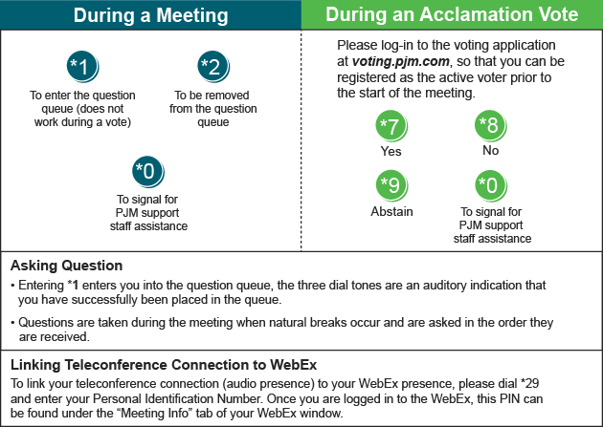
Provide feedback on the progress of this group: Facilitator Feedback Form
Visit learn.pjm.com, an easy-to-understand resource about the power industry and PJM’s role.

